VIETNAM NATIONAL UNIVERSITY HO CHI MINH CITY
HO CHI MINH CITY UNIVERSITY OF TECHNOLOGY
FACULTY OF APPLIED SCIENCES
DEPARTMENT OF BIOMEDICAL ENGINEERING PHYSICS



Capstone Project
Design and Realtime Quality Assessment of an IoT-based PPG Wearable System

Student’s name: | Student’s no:
Phan Quang Danh | 2152460

HO CHI MINH CITY – 2026
VIETNAM NATIONAL UNIVERSITY HO CHI MINH CITY
HO CHI MINH CITY UNIVERSITY OF TECHNOLOGY
FACULTY OF APPLIED SCIENCES
DEPARTMENT OF BIOMEDICAL ENGINEERING PHYSICS 
CAPSTONE PROJECT
Design and Realtime Quality Assessment of an IoT-based PPG Wearable System

Student’s name : Phan Quang Danh - 2152460
Instructor : Assoc. Prof. Dr. Huynh Quang Linh

HO CHI MINH CITY – 2026

ACKNOWLEDGEMENT
I would like to express my sincere gratitude to my supervisor, Assoc. Prof. Dr. Huynh Quang Linh, for his guidance, constructive feedback, and continuous support throughout the development of this thesis. His expertise and insightful suggestions have been invaluable in shaping both the technical direction and the academic quality of this research.
I would also like to thank the lecturers and faculty members of the Faculty of Applied Sciences and the Department of Biomedical Engineering for providing a solid foundation in biomedical engineering and signal processing, which greatly contributed to the completion of this project.
Special thanks are extended to my friends and colleagues for their encouragement, insightful discussions, and assistance throughout this challenging project.
Finally, I would like to express my deepest appreciation to my family for their unwavering support, patience, and motivation throughout my academic journey. This work would not have been possible without their understanding and encouragement.

Abstract
Wearable photoplethysmography (PPG) enables continuous extraction of four cardiovascular parameters: heart rate (HR), heart-rate variability (HRV), peripheral oxygen saturation (SpO₂), and cuff-less blood pressure (BP) from a single optical channel. Under realistic wearable conditions, however, reflectance PPG is routinely corrupted by motion, sensor decoupling, and perfusion variability; without a quality gate, downstream estimators degrade silently and report unreliable values without alerting the user.
This thesis designs and evaluates a real-time signal quality assessment (SQA) framework as the primary contribution of an end-to-end IoT wearable PPG system.
- The hardware comprises a MAX30102 dual-wavelength reflectance sensor driven by an ESP32 NodeMCU-32S microcontroller at 100 Hz, with data streamed over Wi-Fi to a FastAPI cloud back-end on Render and visualised by an Android client.
- The SQA framework extracts seven engineered features: six batch-level spectral, temporal, amplitude, and distributional indices, and one per-beat template-correlation index, and classifies each five-second window into three quality tiers using a multinomial logistic-regression classifier trained on a pseudo-labelled corpus of 12,603 windows from 54 subjects across six datasets. Feature-extraction latency is 1.17 ms per batch.
The classifier achieves a macro ROC AUC of 0.87 under five-fold subject-level cross-validation and 0.59 under leave-one-dataset-out evaluation, with the cross-modality generalisation gap characterised through the minimax domain-generalisation framework. Downstream evaluation across the four estimators reveals a two-layer quality-control architecture: HR, HRV, and SpO₂ accuracies stratify monotonically with signal quality tiers —a 6.6-fold MAE spread on PPG-DaLiA HR and a 51.9-percentage-point SpO₂ plausibility gap, whereas BP error correlates with per-subject population offset (r = 0.877) rather than signal quality (r = −0.023), requiring Layer 2 per-subject anchor calibration. One-anchor calibration on n = 14 follow-up sessions achieves SBP MAE 6.50 mmHg (95% bootstrap CI [4.14, 9.21]) and DBP MAE 5.93 mmHg (95% CI [4.57, 7.43]), exceeding the AAMI ±5 mmHg threshold (SBP by 1.50 mmHg, DBP by 0.93 mmHg) with both bootstrap CIs straddling the threshold (pilot n=14 not sized for AAMI compliance).
The work is framed as a pilot study (N = 15 unique persons, 24 paired sessions) and does not claim AAMI/ESH/ISO 81060-2 compliance or FDA clearance.

Keywords:
Photoplethysmography, IoT wearable, multinomial logistic regression, two-layer quality-control architecture, heart-rate variability, cuff-less blood pressure, ESP32, MAX30102

Tóm tắt
Phương pháp quang thể tích đồ (PPG) dạng đeo cho phép trích xuất liên tục bốn thông số tim mạch: bao gồm nhịp tim (HR), độ biến thiên nhịp tim (HRV), độ bão hòa oxy trong máu ngoại vi (SpO₂), và huyết áp không dùng bao đo (BP) chỉ từ một kênh quang học duy nhất. Tuy nhiên, trong các điều kiện sử dụng thực tế, tín hiệu PPG phản xạ thường xuyên bị nhiễu do chuyển động của người dùng, sự mất tiếp xúc cơ học giữa cảm biến - da và sự thay đổi độ tưới máu. Nếu không có sự kiểm soát chất lượng phù hợp, các thông số tính toán sẽ bị giảm độ chính xác và đưa ra các giá trị không đáng tin cậy mà không hề cảnh báo cho người dùng. Luận văn này thiết kế và đánh giá một khung đánh giá chất lượng tín hiệu (SQA) thời gian thực, đây là đóng góp chính cho một hệ thống thiết bị đeo PPG dựa trên IoT hoàn chỉnh (end-to-end).
- Về phần cứng: Hệ thống bao gồm một cảm biến phản xạ bước sóng kép MAX30102 được điều khiển bởi vi điều khiển ESP32 NodeMCU-32S ở tần số quét 100 Hz. Dữ liệu được truyền phát (stream) qua Wi-Fi đến một back-end đám mây FastAPI lưu trữ trên nền tảng Render và được trực quan hóa bằng một ứng dụng khách (client) trên Android.
- Khung SQA: Thực hiện trích xuất bảy đặc trưng được thiết kế riêng: bao gồm sáu chỉ số cấp độ lô (batch-level) về phổ (spectral), thời gian (temporal), biên độ (amplitude), phân phối (distributional), và một chỉ số tương quan khuôn mẫu trên mỗi nhịp (per-beat template-correlation). Khung này phân loại mỗi cửa sổ dữ liệu 5 giây thành ba mức chất lượng bằng bộ phân loại hồi quy logistic đa thức (multinomial logistic regression), được huấn luyện trên một tập ngữ liệu gán nhãn giả (pseudo-labelled) gồm 12.603 cửa sổ từ 54 đối tượng thử nghiệm thuộc sáu bộ dữ liệu khác nhau. Độ trễ trích xuất đặc trưng đạt mức 1,17 ms mỗi lô.
Bộ phân loại đạt được chỉ số macro ROC AUC là 0,87 dưới kiểm định chéo 5 phần ở cấp độ đối tượng (five-fold subject-level cross-validation) và đạt 0,59 dưới đánh giá loại-bỏ-một-bộ-dữ-liệu (leave-one-dataset-out). Khoảng cách tổng quát hóa chéo phương thức (cross-modality generalisation gap) được đặc tả thông qua khung tổng quát hóa miền minimax (minimax domain-generalisation). Đánh giá thông số kỹ thuật trên bốn bộ tính toán cho thấy một kiến trúc kiểm soát chất lượng hai lớp:
- Lớp 1: Độ chính xác của các thông số HR, HRV và SpO₂ phân tầng một cách đơn điệu theo các mức chất lượng tín hiệu, thể hiện qua mức chênh lệch sai số tuyệt đối trung bình (MAE) gấp 6,6 lần đối với thông số HR trên bộ dữ liệu PPG-DaLiA, và khoảng cách về độ hợp lý của SpO₂ lên tới 51,9 điểm phần trăm.
- Lớp 2: Ngược lại, sai số huyết áp (BP) tương quan chặt chẽ với độ lệch quần thể theo từng đối tượng (r = 0,877) chứ không phụ thuộc vào chất lượng tín hiệu (r = -0,023). Điều này đòi hỏi phải có hiệu chuẩn mốc (anchor calibration) theo từng đối tượng ở Lớp 2.
Phương pháp hiệu chuẩn một mốc (one-anchor calibration) thực hiện trên n = 14 phiên theo dõi đã đạt được MAE của huyết áp tâm thu (SBP) là 6,50 mmHg (95% khoảng tin cậy bootstrap [4,14; 9,21]) và MAE của huyết áp tâm trương (DBP) là 5,93 mmHg (95% CI [4,57; 7,43]), vượt ngưỡng ±5 mmHg của tiêu chuẩn AAMI (SBP vượt 1,50 mmHg, DBP vượt 0,93 mmHg).
Nghiên cứu này được định hình như một nghiên cứu thí điểm (N = 15 cá nhân riêng biệt, 24 phiên ghép cặp) và không tuyên bố tuân thủ các tiêu chuẩn AAMI/ESH/ISO 81060-2 hoặc đạt chứng nhận từ FDA.
Từ khóa:
Quang thể tích đồ (PPG), Thiết bị đeo IoT, Hồi quy logistic đa thức, Kiến trúc kiểm soát chất lượng hai lớp, Độ biến thiên nhịp tim (HRV), Huyết áp không dùng bao đo, ESP32, MAX30102.

TABLE OF CONTENTS
ACKNOWLEDGEMENT i
Abstract ii
Tóm tắt iv
TABLE OF CONTENTS vi
TABLE OF FIGURES xii
LIST OF ABBREVIATIONS xvi
Chapter 1 — Introduction 1
1.1 Background and Motivation 1
1.2 Problem Statement 1
1.3 Objectives 3
1.4 Scope and Contributions 4
1.4.1 Scope and limitations 4
1.4.2 Contributions 4
1.5 Thesis Structure 5
Chapter 2 — Theoretical Background 7
2.1 PPG Physiology and Signal Model 7
2.1.1 Optical principle and the Beer-Lambert framing 7
2.1.2 Reflectance versus transmission modalities 8
2.1.3 Spectral structure and the standard bandpass 9
2.1.4 Motion artefacts and the cadence-locked failure mode 9
2.2 Signal Quality Assessment Literature 10
2.2.1 Motivation: why SQA gates everything downstream 10
2.2.2 Classical multi-criterion signal-quality indices 11
2.2.3 Template-correlation per-beat metrics 11
2.2.4 Pseudo-labelling methodology 11
2.2.5 Deep-learning approaches and the domain-generalisation gap 11
2.2.6 The open challenge that frames Chapter 4 12
2.3 Downstream Estimation Primer 12
2.3.1 Heart Rate 12
2.3.2 Heart-Rate Variability 13
2.3.3 Peripheral Oxygen Saturation 14
2.3.4 Cuff-less Blood Pressure 15
Chapter 3 — System Design 18
3.1 Hardware Platform 18
3.1.1 Three-Tier Architecture 18
3.1.2 MAX30102 Optical Front-End 19
3.1.3 ESP32 Host Microcontroller — Testing and Final Target 22
3.1.4 Reference Cuff Device — Omron HEM-7143T1 23
3.2 Embedded Firmware 24
3.3 Cloud Back-End — FastAPI Server 25
3.4 Mobile Application 26
3.5 Chapter summary 27
Chapter 4 — Realtime Signal Quality Assessment 29
4.1 Multi-feature Signal Quality Index 29
4.1.1 Feature definitions 29
4.1.2 Cross-server parity and runtime budget 32
4.1.3 Cross-hardware caveat for kSQI 32
4.2 Per-beat Template Signal Quality Index 33
4.3 Pseudo-labelling Methodology 34
4.3.1 Four-rule criteria 35
4.3.2 Cross-dataset corpus 35
4.3.3 Manual spot-check infrastructure 37
4.3.4 Pseudo-label noise and downstream recovery 38
4.4 Multinomial Logistic Regression Classifier 39
4.4.1 Architecture 40
4.4.2 Subject-level cross-validation 40
4.4.3 Feature importance 43
4.5 Cross-dataset Generalisation under Leave-One-Dataset-Out 45
4.5.1 Known BIDMC peak-doubling artefact 47
4.5.2 Scope of generalisation claim 48
4.6 Two-Layer Quality-Control Architecture 48
4.6.1 Two paradigms of quality control 48
4.6.2 Quantitative justification of the separation 49
4.6.3 Architectural alignment with industry practice 50
4.7 Chapter summary 50
Chapter 5 — Downstream Estimation under QA Gating 52
5.1 Two-Layer Quality-Control Architecture Rationale 52
5.2 Base Signal-Processing Pipeline 52
5.2.1 Bandpass Filtering 52
5.2.2 Peak Detection (HeartPy) 53
5.2.3 RR-Interval Extraction and Two-Stage Outlier Rejection 54
5.2.4 Cross-Batch Overlap Buffer 55
5.3 Heart Rate under Layer 1 Gating 55
5.3.1 Methodology 55
5.3.2 Headline result — PPG-DaLiA 56
5.3.3 BIDMC dual transparency 57
5.3.4 LR beats Orphanidou on bidmc_04 58
5.3.5 Summary 58
5.4 Heart-Rate Variability under Layer 1 Gating 59
5.4.1 Methodology 59
5.4.2 Headline result — Method E 60
5.4.3 Method B as control comparison 61
5.4.4 Matched-N drift disclosure 61
5.4.5 RMSSD parity caveat 62
5.4.6 Summary 62
5.5 SpO₂ under Layer 1 Gating 62
5.5.1 Methodology 62
5.5.2 Headline — BP-protocol LR tier 63
5.5.3 Cross-dataset inconsistency 64
5.5.4 LR vs. Orphanidou pseudo-label 65
5.5.5 S01 five-protocol stress test 65
5.5.6 Summary 67
5.6 Blood Pressure under Layer 2 Calibration Gating 68
5.6.1 Feature engineering 68
5.6.2 Cross-domain training pool 69
5.6.3 LOSO N = 15 baseline 70
5.6.4 Per-subject calibration drift 76
5.6.5 Calibration paradigm: industry context 80
5.6.6 Summary 81
Chapter 6 — Discussion, Limitations, and Future Work 82
6.1 Cross-module Synthesis: SQA Framework Value across Four Modules 82
6.2 Two-Layer Quality-Control Architecture: Empirical Interpretation 84
6.3 Industry Parallel Comparison 87
6.4 Comparison vs Literature 89
6.5 Limitations 92
6.5.1 SQA Framework Limitations 92
6.5.2 Cohort Limitations 93
6.5.3 Hardware Limitations 95
6.5.4 BP One-Anchor Calibration Limit 95
6.5.5 Demographic and Physiological Scope of the Pipeline 96
6.6 Future Work 98
6.6.1 Deep-Learning SQA Replacement of the Linear Classifier 98
6.6.2 Averaged-Anchor Calibration 99
6.6.3 Cohort Expansion and Hardware Migration 100
6.6.4 Persistent Storage and Multi-Device Deployment 100
6.6.5 Hypoxic-Range SpO₂ Validation 101
Chapter 7 — Conclusion 102
References 107
APPENDIX A — Firmware Implementation Details 112
A.1 LED current calibration procedure 112
A.2 Wi-Fi upload retry policy and queue depth 112
A.3 FreeRTOS task stack budgets 112
A.4 Concurrency rationale and empirical motivation 113
A.5 HTTP/HTTPS auto-detection 113
A.6 REST API endpoint schema 114
A.7 Pydantic validation layer 114
A.8 Operational concerns 115
APPENDIX B — Protocols, Specifications, and Reproducibility 116
B.1 Blood-Pressure Measurement Protocol 116
B.2 MAX30102 Register-Level Configuration 118
B.3 Welch Power-Spectral-Density Configuration for LF/HF 119
B.4 SpO₂ Calibration Derivation and Validity Guards 120
B.5 Software Environment, Versions, and Reproducibility Artefacts 121
B.6 Full 38-Feature BP Catalogue 123

TABLE OF FIGURES
Figure 3-1: Three-tier architecture diagram — ESP32 edge node, Render FastAPI cloud, Android client. 19
Figure 3-2: Custom enclosure embedded MAX30102 reflectance sensor visible inside the repurposed commercial pulse-oximeter housing used as light shield. 21
Figure 3-3: Acquisition module wiring: ESP32 NodeMCU-32S to the MAX30102 module mounted in the custom enclosure (opened view). 23
Figure 3-4: Sequential contralateral BP and PPG acquisition protocol: Omron HEM-7143T1 cuff on the left arm, MAX30102 sensor clip on the right index finger; measurements taken sequentially with a gap of at most two minutes. 24
Figure 3-5: Live acquisition session with serial-monitor verification — ESP32 streaming 5-second batches to the FastAPI back-end, with upload status and signal-statistics logs visible on the laptop terminal. 25
Figure 3-6: Android client real-time dashboard 27
Figure 4-1: SQA pipeline block diagram 33
Figure 4-2: Per-beat tSQI degradation across the four-protocol motion stress test. 34
Figure 4-3: Cross-dataset distribution of pseudo-labels. Stacked bar chart showing the percentage of windows in each tier (excellent / acceptable / unfit) for the six datasets (BIDMC, BP-protocol, S10-SQA, S01-SQA, S04-SQA, PPG-DaLiA) 39
Figure 4-4: ROC curves for the multinomial classifier, one-vs-rest, three classes, under 5-fold subject-level GroupKFold. 44
Figure 4-5: Cross-dataset Generalisation under Leave-One-Dataset-Out 45
Figure 4-6: Two-layer quality-control architecture. Block diagram showing the SQA classifier output feeding two parallel branches: Layer 1 (HR, HRV, SpO₂, gated by predicted SQA tier) and Layer 2 (BP, calibrated by per-subject anchor offset). 50
Figure 5-1: HR ablation MAE × tier × dataset bar chart with bootstrap CI. 57
Figure 5-2: HRV ablation 5-method comparison and component contribution decomposition. 61
Figure 5-3: SpO₂ validity rate and in-range plausibility per tier × dataset. 64
Figure 5-4: S01 five-protocol panel: five sub-panels showing IR trace + R-ratio + LR tier + production SpO₂ for P1–P5. 67
Figure 5-5: BP LOSO per-subject scatter, truth vs. predicted, with y = x line and ±AAMI 5 mmHg band. 72
Figure 5-5a: (SBP panel): Bland–Altman plots for SBP and DBP (LOSO N = 15). 74
Figure 5-5b: (DBP panel): Bland–Altman plots for SBP and DBP (LOSO N = 15). 74
Figure 5-5c: Per-window error histogram for SBP and DBP (LOSO N = 15), with vertical reference lines at ±5 mmHg (AAMI), ±10 mmHg, and ±15 mmHg (BHS thresholds). 75
Figure 5-6: Per-subject 1-anchor drift (model drop), drift SBP and DBP per multi-session subject with the AAMI ±5 mmHg reference band overlaid. 78
Figure 6-1: Industry comparison table-as-figure, device, regulatory clearance, cohort size, recalibration interval, and SQA-gating status for the three numeric-BP cuff-less reference systems. Source: synthesised from references [21], [22], [32], FDA databases 89

TABLE OF TABLES
Table 1-1: Summary of thesis contributions in priority order. 4
Table 4-1: Six raw batch-level SQI features computed every 5 seconds. 31
Table 4-2: Per-beat tSQI on a four-protocol motion stress test (single subject, MAX30102 reflectance, 5-second batches concatenated). 34
Table 4-3: Pseudo-labelled corpus (12,603 five-second windows, 54 unique subjects). 36
Table 4-4: Headline classification metrics under 5-fold subject-level GroupKFold — balanced multinomial LR vs unweighted LR vs heuristic baseline. 40
Table 4-4b: Per-class precision, recall, and F1 of the balanced multinomial classifier under 5-fold subject-level GroupKFold. 41
Table 4-4c: In-sample confusion matrix of the balanced multinomial classifier (fit on the 12,603-window corpus). 41
Table 4-5: Feature importance under 5-fold GroupKFold (sum of absolute coefficients across three classes after StandardScaler). 43
Table 4-6: Cross-dataset generalisation under leave-one-dataset-out evaluation. 45
Table 4-7: Per-subject pseudo-label spread under the most informative protocol (P4 pressure variation) of the identical five-protocol stress-test design (MAX30102 reflectance, finger). 46
Table 5-1: HR MAE per Layer 1 SQA tier on PPG-DaLiA (pseudo-label tier, ground truth = RespiBAN ECG R-peaks) 56
Table 5-2: HR MAE on BIDMC: full cohort vs. bidmc_04 excluded (pseudo-label tier) 57
Table 5-3: HRV ablation, five methods, PPG-DaLiA unfit pseudo-tier 60
Table 5-4: SpO₂ validity and plausibility per Layer 1 SQA tier, BP-protocol cleaned, Wilson 95 % CI: 63
Table 5-5: LR-unfit in-range plausibility, BP-protocol vs S10-SQA 64
Table 5-6: In-range plausibility per tier, pseudo-label vs. LR classifier (BP-protocol cleaned) 65
Table 5-7: S01 five-protocol SpO₂ outcomes 66
Table 5-8: Summary of 38-feature BP catalogue by category 68
Table 5-9: LOSO N = 15 baseline vs. naive baselines 70
Table 5-10: Per-subject LOSO errors, selected 71
Table 5-11: AAMI/ANSI/ISO 81060-2:2018 [28] compliance check (calibration-free LOSO N = 15). 75
Table 5-12: British Hypertension Society (BHS) protocol grading (O’Brien et al. 1993 [27]). 76
Table 5-13: Per-subject 1-anchor drift (model drop), n = 14 follow-up sessions across 11 multi-session subjects (drift in mmHg) 77

LIST OF ABBREVIATIONS
AAMI | Association for the Advancement of Medical Instrumentation
AHA | American Heart Association
AUC | Area Under the Curve
BP | Blood Pressure
BPM | Beats Per Minute
CI | Confidence Interval
DBP | Diastolic Blood Pressure
ECG | Electrocardiography
ESH | European Society of Hypertension
FDA | Food and Drug Administration
HR | Heart Rate
HRV | Heart-Rate Variability
IoT | Internet of Things
ISO | International Organization for Standardization
LODO | Leave-One-Dataset-Out
LOSO | Leave-One-Subject-Out
LR | Logistic Regression
MAE | Mean Absolute Error
PPG | Photoplethysmography
ROC | Receiver Operating Characteristic
SBP | Systolic Blood Pressure
SpO₂ | Peripheral Oxygen Saturation
SQA | Signal Quality Assessment
SQI | Signal Quality Index
SVR | Support Vector Regression

Chapter 1 — Introduction

1.1 Background and Motivation
Photoplethysmography is a non-invasive optical technique for inferring the volumetric pulsation of arterial blood from the time-varying intensity of light reflected from or transmitted through a peripheral tissue bed. The technique is now widely deployed: every consumer smartwatch and fitness tracker on the contemporary market integrates at least one reflectance-mode PPG channel, and the clinical pulse oximeter, a transmission-mode PPG device has been a standard of care since the 1980s [1]. The low component cost, small package footprint, and non-invasive acquisition profile of PPG make it the dominant optical modality for wearable cardiovascular monitoring.
Beyond pulse oximetry, a single optical channel can in principle yield heart rate from inter-peak intervals, heart-rate variability from the statistical structure of those intervals, peripheral oxygen saturation from a dual-wavelength ratio of ratios, and cuff-less blood pressure from waveform morphology. This four-estimator architecture on a single front-end is the strategy adopted by the principal commercial cuffless BP wearables of the present decade.
The central technical obstacle is that reflectance PPG is fragile: motion, sensor decoupling, contact-force variation, perfusion drift, and ambient-light intrusion routinely corrupt the waveform. Each downstream estimator operates under an implicit clean-signal assumption and carries no internal mechanism for refusing an output on a corrupted input; the pipeline inherits corruption silently and the user receives no indication that the reported parameter is unreliable. A deployable wearable system must decide in real time whether each window is fit for analysis — the signal-quality-assessment problem this thesis addresses.

1.2 Problem Statement
No closed-loop, real-time signal-quality-assessment framework currently exists for the commodity reflectance PPG wearables that are now deployed at consumer scale. The signal-quality-index literature, notably Elgendi 2016 [5] and Orphanidou et al. 2015 [6], establishes multi-criterion batch-level scoring, but the indices were developed on transmission-mode clinical corpora and have not been integrated into a real-time pipeline that couples quality decisions directly to downstream physiological estimators on low-cost hardware.
In the absence of such a framework, consumer wearables report heart rate, SpO₂, and blood pressure regardless of waveform state, with no signal to the application layer that a reported parameter is unreliable. The cuff-less BP error band quantified in §1.1 is the direct consequence. Closing this gap requires addressing three concurrent technical challenges, each of which is unsolved in the form required by the wearable deployment context.
Signal quality variability: Reflectance PPG on consumer-grade front-ends exhibits an order-of-magnitude swing in pulsatile amplitude between resting and motion-corrupted conditions, and the perfusion index can drift two- to threefold within a single recording. Classical single-feature indices fail on cadence-locked motion inside the cardiac band. This thesis addresses the gap through a learned multi-feature classifier (Chapter 4).
Domain shift: The principal public PPG corpora — BIDMC (transmission-mode ICU) and PPG-DaLiA (reflectance wrist) — differ from the target deployment domain (fingertip MAX30102 reflectance) in hardware geometry, anatomy, and motion regime. A classifier trained on any finite source collection exhibits a residual cross-dataset gap; this thesis measures the gap explicitly via leave-one-dataset-out evaluation (§4.5) and reports it as a primary result.
Downstream module heterogeneity: The four downstream estimators differ in how their accuracy depends on signal quality. Heart rate, HRV, and SpO₂ degrade smoothly with within-window noise and benefit from window-level gating. Cuff-less BP is dominated by per-subject offsets that within-window signal quality does not resolve; a uniform window-level gate is insufficient. This thesis adopts a two-layer architecture (§4.6): SQA gating for HR/HRV/SpO₂, per-subject calibration gating for BP.
The thesis addresses this three-part problem in a pilot scope: a single hardware platform (MAX30102 in reflectance mode, finger-tip placement, 100 Hz sampling), a single cohort (15 unique persons with paired sessions, Vietnamese demographic), a single deployment topology (a cloud-hosted FastAPI back-end). The pilot scope is deliberate and is the appropriate scope for a thesis of the present scale; the multi-site, multi-platform, AAMI/ISO-grade validation that would be required for a clinical instrument is identified as out-of-scope future work in Chapter 6.

1.3 Objectives
Five research objectives are pursued, of which the SQA framework is primary and the four downstream estimators are evidence channels validating the value of the SQA framework.
O1. SQA framework. Design and implement a real-time multi-criterion signal-quality-assessment framework for reflectance PPG combining batch-level multi-feature SQIs and per-beat template indices, achieving sub-5 ms feature-extraction latency per five-second batch. This is the principal contribution of the thesis.
O2. Cross-dataset validation. Validate the framework across heterogeneous datasets spanning finger-tip reflectance, transmission ICU, and wrist-worn ambulatory modalities under leave-one-dataset-out evaluation, disclosing the cross-modality gap as a load-bearing observation.
O3. Downstream evidence channels. Demonstrate, across HR, HRV, SpO₂, and BP estimators, that accuracy varies systematically with the predicted SQA tier on modules to which window-level gating applies.
O4. BP module under calibration gating. For cuff-less BP, evaluate whether SQA gating closes the cross-subject accuracy gap and quantify per-subject calibration as a Layer-2 mechanism orthogonal to SQA gating.
O5. End-to-end IoT realisation. Document a complete IoT realization: ESP32-class microcontroller firmware driving the MAX30102 front-end, FastAPI cloud back-end on Render, and Android polling client sufficient to support the real-time, hardware-coupling, and edge-deployment claims of the thesis.

1.4 Scope and Contributions

1.4.1 Scope and limitations
The thesis is a pilot study and is positioned as such throughout. The cohort comprises 15 unique persons contributing 24 paired sessions on the self-collected channel, augmented by 219 PPG-BP subjects on the public-corpus channel for the BP module training set and 39 BIDMC and PPG-DaLiA subjects on the SQA classifier corpus. The acquisition platform is a single reflectance front-end (MAX30102 finger-tip placement at 100 Hz), and the data path is single-device.
The term “real-time” in this thesis denotes feature-extraction latency below 5 ms per five-second batch (1.17 ms achieved on the cloud back-end, see Chapter 4 §4.1.2); end-to-end user-perceived latency includes the 5 s acquisition batch and the 5 s Android polling interval and is therefore near-real-time at the application layer rather than hard-real-time per IEC 60601 clinical standards. This convention is consistent with the wearable-PPG literature, in which the real-time qualifier customarily refers to per-batch processing latency rather than to deterministic end-to-end response under a hard deadline. Detailed limitations along the SQA framework, cohort, hardware, calibration, and demographic axes are deferred to Section 6.5.

1.4.2 Contributions
Three contributions are claimed, in priority order:
Table 1-1: Summary of thesis contributions in priority order.
ID | Contribution | Evidence
C1  (Primary) | Realtime multi-criterion SQA framework: seven engineered features (six batch-level spectral_purity, hr_bpm, amplitude_ratio, sSQI, kSQI, entropy_amp_dist and one per-beat tsqi_median) and multinomial logistic-regression classifier on a pseudo-labelled corpus of 12 603 windows / 54 subjects / 6 datasets. | GroupKFold macro AUC 0.8664; LODO aggregate 0.5906; feature-extraction latency 1.174 ms per 5-second batch (§4.1.2, §4.4).
C2  (Secondary) | Two-layer quality-control architecture decoupling batch-level SQA gating (Layer 1: HR / HRV / SpO₂) from subject-level calibration gating (Layer 2: BP). | Confounder analysis: r = +0.877 (n=15 LOSO per-subject) distance from population mean vs r = −0.023 (n=15 LOSO per-window) excellent SQA fraction; convergent industry practice Aktiia / Samsung / Biobeat (§4.6.2, §6.3).
C3  (Enabling) | End-to-end IoT realisation: ESP32-class microcontroller firmware driving MAX30102 reflectance front-end at 100 Hz, FastAPI cloud back-end on Render with HTTP/HTTPS auto-detection, Android polling client with HRV and signal-quality dashboards. | NodeMCU-32S empirical validation across 24 paired sessions / 15 unique subjects; FastAPI cloud back-end LIVE on Render (ppg-ml.onrender.com + ppg-backend-udze.onrender.com); 4 per-subject calibration REST endpoints with thread-safe JSON persistence (Sec. 3.3, Sec. 3.4); 535-test backend regression suite (Sec. 3.6).

1.5 Thesis Structure
Chapter 2 surveys PPG physiology and SQA literature. Chapter 3 documents the IoT realisation: hardware, firmware, back-end, and client. Chapter 4 presents the SQA framework: features, classifier, and two-layer quality-control architecture. Chapter 5 evaluates four downstream estimators under their respective gating layers. Chapter 6 discusses results, limitations, and future work. Chapter 7 concludes.
These objectives and contributions define the scope of the present thesis. Chapter 2 surveys the theoretical background, photoplethysmography signal model, heart-rate and HRV estimation, ratio-of-ratios SpO₂, and cuff-less blood-pressure literature, that the remainder of the thesis instantiates.

Chapter 2 — Theoretical Background
Section 2.1 introduces PPG physiology and the signal model. Section 2.2 surveys the SQA literature and positions the proposed framework. Section 2.3 primes the four downstream estimators.

2.1 PPG Physiology and Signal Model

2.1.1 Optical principle and the Beer-Lambert framing
Photoplethysmography is a non-invasive optical method that measures the time-varying volume of arterial blood in a small peripheral tissue bed by recording the intensity of light reflected from or transmitted through that tissue [1]. A monochromatic light source illuminates the skin, a photodetector records the returned light intensity, and the resulting time series carries a pulsatile component synchronous with the cardiac cycle. The two wavelengths customary in dual-channel pulse oximetry are red at approximately 660 nm and near-infrared at approximately 880 nm; the project sensor (MAX30102; see Chapter 3) emits at these two wavelengths and uses a single co-located silicon photodiode for both channels.
The standard interpretive frame for the recorded intensity is the Beer-Lambert relationship: under the modelling assumption of weakly scattering tissue and small variations of arterial volume around a baseline, the log-intensity of the photodetector output decomposes into a slowly varying component reflecting the constant absorption of bone, skin pigment, and the non-pulsatile vascular volume, and a small alternating component reflecting the systolic-diastolic modulation of arterial blood. By convention, the slowly varying component is denoted DC and the alternating component is denoted AC, even though both are baseband-confined and neither carries a literal direct-current component in the radio-frequency sense. The AC component is the pulsatile signal that all downstream estimators in this thesis consume.
Tissue is strongly scattering at 660 nm and 880 nm; the strict Beer-Lambert relationship is replaced in practice by the Modified Beer-Lambert Law (MBLL) introduced by Cope and Delpy [33], [34], in which a wavelength-dependent differential pathlength factor (DPF) absorbs the scattering correction. The additive scattering-loss term cancels in the ratio of ratios (§2.3.3), and the residual DPF wavelength-dependence is absorbed by the device-specific calibration polynomial reported in Section 2.3.3.
The ratio AC/DC, computed channel-wise, is the perfusion index (PI), customarily expressed as a percentage. Resting finger PPG with adequate sensor contact typically yields PI values in the range 0.5–5%, corresponding to AC modulations on the order of a few thousand counts on the eighteen-bit MAX30102 analogue-to-digital converter against a DC baseline on the order of one hundred thousand counts. The PI is a primary diagnostic of acquisition quality: severely under-perfused tissue (cold extremities, vasoconstriction, peripheral vascular disease) yields PI < 0.2% and produces signals too weak for reliable parameter estimation.

2.1.2 Reflectance versus transmission modalities
Two acquisition geometries are in widespread clinical and consumer use. In transmission mode, the LED and the photodetector are positioned on opposite sides of a thin tissue bed, typically a finger-tip or an ear-lobe in clinical pulse oximeters; the recorded intensity is the light that has traversed the tissue. In reflectance mode, the LED and the photodetector sit on the same side of the tissue, separated by a few millimetres on the sensor package; the recorded intensity is the backscattered light. Reflectance is the dominant geometry in wrist-worn and chest-worn wearables because no opposing surface is available, and it is the geometry of the MAX30102 sensor used in this thesis. As reported in the review of [1], reflectance signals are typically 10–20 dB weaker than transmission signals at comparable LED current and exhibit subtly different waveform morphology because the optical path samples a different ensemble of arteriolar segments. This morphological difference is one of several reasons why a signal quality classifier trained on a transmission-mode corpus does not transfer cleanly to a reflectance-mode corpus, a phenomenon documented quantitatively in Chapter 4.

2.1.3 Spectral structure and the standard bandpass
The cardiac component of the PPG occupies a narrow band centred on the heart rate. Adopting the heart-rate range [40, 200] beats per minute that bounds physiologically plausible values for resting through moderately exercised adults [1], the cardiac band is approximately [0.67, 3.3] Hz. The closely related range [30, 240] beats per minute, equivalently [0.5, 4.0] Hz, is the standard bandpass cut-off pair adopted across the PPG signal-processing literature [8] and is the band on which all batch-level signal-quality features in this thesis are computed. Below 0.5 Hz the signal contains slow baseline wander, respiration-modulated components, and slow vasomotor activity; above 4.0 Hz the residual energy is dominated by photodetector electronic noise, line-frequency interference, and high-frequency contact noise. A zero-phase fourth-order Butterworth bandpass filter is the standard implementation: the maximally flat passband of the Butterworth design preserves the systolic-upstroke morphology, the order-four roll-off is sufficient to attenuate baseline wander by approximately 24 dB per octave, and the zero-phase realisation (forward-backward filtering, scipy.signal.filtfilt) avoids the group-delay distortion that would shift detected peaks relative to the true systolic event. The same band and order are recommended in the foundational review of [8], adopted in the MAX30102 manufacturer reference firmware [12], and used uniformly across the four downstream estimators of this thesis.

2.1.4 Motion artefacts and the cadence-locked failure mode
Three categories of artefact corrupt finger-tip PPG in practice. Low-frequency baseline wander arises from posture changes, ambient temperature drift, and slow sensor decoupling and is largely removed by the high-pass corner of the standard bandpass at 0.5 Hz. High-frequency electrical and contact noise arises from photodetector shot noise, line-frequency pickup at 50 or 60 Hz, and abrupt sensor-tissue separation events; it is largely removed by the low-pass corner at 4.0 Hz. Cadence-locked motion, by contrast, is the most pernicious artefact category for ambulatory PPG because its dominant spectral content lies within the cardiac band. Walking and running cadences in adults span approximately 1.4–3 Hz at the step level and approximately 0.7–1.5 Hz at the gait-cycle level [15]; both lie inside the 0.5–4.0 Hz passband. A signal corrupted by cadence-locked motion exhibits a clean, narrow-band spectrum and a high spectral purity within the cardiac band, yet the peak frequency reflects locomotor rhythm rather than cardiac activity. This is the failure mode that motivates time-domain and morphological signal-quality features in addition to spectral features (Section 2.2 and Chapter 4): a single spectral statistic computed over a five-second window cannot, in principle, distinguish a clean cardiac waveform from a clean locomotor-cadence waveform if both lie in the heart-rate band.
The remaining sections of this chapter take this signal model as given and address the question that follows from it: given a finite five-second batch of bandpass-filtered PPG, how should one decide whether the batch carries reliable physiological information, and how should one then convert that information into the four downstream parameters of clinical interest?

2.2 Signal Quality Assessment Literature

2.2.1 Motivation: why SQA gates everything downstream
The downstream physiological estimators that consume the PPG waveform: peak detection for heart rate, RR-interval statistics for heart-rate variability, the red-to-infrared ratio of ratios for peripheral oxygen saturation, and morphological feature extraction for cuff-less blood pressure are all defined under an implicit clean-signal assumption. None of the four estimators carries an internal mechanism for distinguishing a clean waveform from a corrupted one; each will produce a numerical output whether the input is a pristine systolic-diastolic complex or a sample of motion-induced noise. The clinical literature on cuff-less BP devices in particular has documented that uncritical application of estimators to unfiltered waveforms is a primary driver of accuracy degradation: the systematic review of [2] reports that 42% of published cuff-less BP studies performed record splits without subject-level personalization (introducing data-leakage risk) and that only 27% report adequate statistical power, and the beat-detection benchmarking study of [11] shows that the F1 score of every open-source PPG peak detector stratifies sharply by signal-quality conditions, with the best detector losing 20–30 F1 points between clean resting and motion-corrupted segments. Without an SQA gate, the downstream estimators inherit the waveform corruption silently and the user receives no signal that the reported number is unreliable.
The principle that follows is that a deployable wearable PPG system requires a quality-assessment layer between the front-end acquisition and the downstream estimators. The literature on how to construct that layer divides into three traditions, summarised in the remainder of this section.

2.2.2 Classical multi-criterion signal-quality indices
The earliest tradition relies on hand-engineered signal-quality indices computed in closed form: spectral purity, skewness (sSQI), kurtosis (kSQI), and amplitude-distribution entropy are interpretable, sub-millisecond, and require no training set [5]. Single-feature thresholds admit cadence-locked counter-examples inside the cardiac band, and rule-combination logic requires hand-tuning per deployment context.

2.2.3 Template-correlation per-beat metrics
A second tradition operates at beat resolution [15]: template correlation per beat provides granularity — a window with one bad beat is not fully rejected — but requires a bootstrap of clean beats and inherits calibration-cohort conditions. The Orphanidou 2015 threshold r = 0.86 [6] is carried forward to the per-beat tSQI of §4.2.

2.2.4 Pseudo-labelling methodology
A third tradition addresses the annotation cost of supervised SQA by generating pseudo-labels from deterministic rules [6]. The approach is scalable and reproducible but inherits rule-set coverage gaps: Rule 3 (rr_ratio > 2.2) misses uniform RR-doubling in ICU patients with prominent secondary waves, accounting for the BIDMC artefact described in §4.5.2.

2.2.5 Deep-learning approaches and the domain-generalisation gap
End-to-end deep-learning classifiers reach high in-corpus AUC but exhibit substantial cross-dataset degradation [7]; their inference latency also exceeds the real-time per-window budget of §4.1.2. This thesis therefore constrains itself to classical features and template correlation combined in a logistic-regression classifier that remains interpretable and fast.

2.2.6 The open challenge that frames Chapter 4
Across all four traditions, in-corpus evaluation does not substitute for cross-dataset generalisation; the number of training domains is the binding constraint on out-of-distribution accuracy [7]. These limitations motivate the seven-feature classifier of Chapter 4 with explicit leave-one-dataset-out evaluation (§4.5).

2.3 Downstream Estimation Primer
The four downstream estimators evaluated under SQA gating in Chapter 5 are surveyed at concept level in this section. The objective is to fix the literature-level definitions and to expose the boundaries of what is achievable in principle, so that the Chapter 5 results can be read as evidence channels validating the SQA framework rather than as primary contributions in their own right.

2.3.1 Heart Rate
Heart rate from PPG is the inverse of the mean RR-interval, where the RR-interval series is the inter-event time between successive systolic peaks. Given the bandpass-filtered waveform of Section 2.1, the algorithmic chain is peak detection followed by interval differencing:
$${HR}_{bpm}=\frac{60 000}{⟨{RR}_{ms}⟩}, {RR}_{k}=(p_{k+1}-p_{k})/f_{s}⋅1000 (2.1)$$
where p_{k} are the systolic-peak sample indices and f_{s} is the sampling rate. The detection step is the source of most algorithmic variability in HR pipelines. The HeartPy framework of [10] is the reference implementation adopted in this thesis: HeartPy applies a moving-average smoother to the bandpass-filtered signal, computes an adaptive threshold from the smoothed signal’s local mean, locates candidate peaks above that threshold with a minimum refractory distance derived from the sampling rate, and refines the peak position by spline interpolation to sub-sample resolution. A two-stage RR-rejection step then removes interval outliers: a Stage 1 physiological gate rejects RR-intervals outside [300, 2000] ms following the Task Force 1996 standards [14], corresponding to instantaneous heart rates outside [30, 200] beats per minute; a Stage 2 median-quotient gate rejects RR-intervals deviating from the local median by more than 20%, the HeartPy default of [10].
The downstream HR error budget under good signal quality is sub-1 beat per minute on resting recordings; under motion-corrupted conditions the error can exceed 20 beats per minute on five-second windows, as Chapter 5 reports for the unfit tier of the PPG-DaLiA corpus.

2.3.2 Heart-Rate Variability
Heart-rate variability (HRV) is the beat-to-beat fluctuation in the RR-interval series; it is a non-invasive surrogate for autonomic nervous-system regulation of cardiac rhythm and is reported in two domains. The time-domain metrics, as standardised by the Task Force of the European Society of Cardiology and the North American Society of Pacing and Electrophysiology in 1996 [14], are:
- SDNN: the standard deviation of the RR-interval series, expressed in milliseconds. The Task Force convention specifies the population standard deviation (denominator N, equivalently ddof=0 in SciPy/NumPy nomenclature) rather than the sample standard deviation (denominator N − 1).
- RMSSD: the root-mean-square of successive RR-interval differences, reflecting short-term parasympathetic variability.
- pNN50: the proportion of successive RR-interval differences exceeding 50 ms.
- pNN20: the proportion of successive RR-interval differences exceeding 20 ms; the lower threshold provides finer resolution in low-variability cohorts and is documented in the pNNx generalisation of Mietus et al. 2002 [29].
The frequency-domain metrics require interpolation of the irregularly sampled RR-interval series onto a uniform time grid prior to spectral estimation. The conventional choice [14] is cubic-spline interpolation to a 4 Hz uniform grid followed by Welch’s method with a Hann window for power-spectral-density estimation. The two clinically reported bands are LF (low frequency, 0.04–0.15 Hz) and HF (high frequency, 0.15–0.40 Hz), with the LF/HF ratio used as a (debated) sympathovagal-balance proxy. The Task Force standards specify a minimum recording length sufficient for reliable estimation; the project pipeline enforces a guard requiring at least 60 RR-intervals before reporting LF, HF, or LF/HF.
A frequent implementation error worth flagging at the literature level is the application of frequency-domain HRV analysis to the bandpass-filtered PPG signal itself rather than to the RR-tachogram. The two spectra are physically different: the PPG spectrum is dominated by the cardiac fundamental near the heart rate and its harmonics, while the RR-tachogram spectrum is dominated by sub-cardiac autonomic oscillations in the LF and HF bands. Chapter 3 documents the project pipeline as computing LF/HF on the RR-tachogram, consistent with the Task Force 1996 specification [14].

2.3.3 Peripheral Oxygen Saturation
Peripheral oxygen saturation (SpO₂) is the percentage of haemoglobin in arterial blood that is oxygen-bound. The PPG-based estimator exploits the wavelength-dependent absorption of oxyhaemoglobin and deoxyhaemoglobin: oxygenated blood absorbs less red light (~660 nm) and more infrared light (~880 nm) than deoxygenated blood, so the ratio of ratios R derived from a dual-wavelength PPG carries the oxygenation information:
$$R=\frac{{AC}_{red}/{DC}_{red}}{{AC}_{IR}/{DC}_{IR}} (2.2)$$
In transmission-mode clinical pulse oximetry on calibrated 660/940 nm pairs, the R → SpO₂ map is an empirical calibration curve derived from hypoxia-chamber co-oximetry on healthy subjects. In reflectance-mode consumer hardware on 660/880 nm wavelengths the canonical curve does not strictly apply; the MAX30102 reference firmware (MAXREFDES117 source distribution [12]) supplies a device-specific quadratic polynomial for the 660/880 nm pair on finger-tip reflectance acquisition. Derivation history, the migration from a three-segment piecewise variant to the present C¹-continuous form, and the validity-guard rationale are documented in Appendix B.4. The polynomial is:
$${SpO}_{2}=-45.060 R^{2}+30.354 R+94.845 (2.3)$$
valid for finger-tip placement under typical perfusion. The output is clipped to the physiological range [85, 100]%. This expression is an approximation, not a clinically validated calibration, and the thesis does not claim FDA-cleared accuracy.
Two validation guard rails are imposed before an R-to-SpO₂ conversion is reported. The R range guard, derived from the critical analysis of [13], rejects values outside [0.4, 1.4] as physiologically implausible; values outside this range are diagnostic of sensor-decoupling events or motion artefacts. The PI guard rejects readings with PI < 0.2%, a conservative project threshold lying below the clinical PI-of-interest threshold of 0.6% reported in the perfusion-index review of [17]. Both guards return an explicit null rather than a degraded numerical estimate when triggered.

2.3.4 Cuff-less Blood Pressure
Cuff-less blood pressure (BP) estimation from PPG is the most ambitious of the four downstream tasks and the one with the most active regulatory and methodological debate. Three approaches dominate the literature. Pulse-transit-time (PTT) methods estimate BP from the time delay between an electrical fiducial (ECG R-peak) and an optical fiducial (PPG foot or peak) measured at a peripheral site; the inverse relationship between PTT and BP is well-established physiologically, but the method requires a synchronised second sensor and is therefore awkward to wearable form factors. Feature-based methods extract morphological features from the PPG waveform alone, systolic upstroke time, pulse width, area ratios, first- and second-derivative extrema, and train a regression model from those features to cuff-measured BP labels; this is the approach adopted in Chapter 5. End-to-end deep learning methods feed raw PPG segments to convolutional or recurrent architectures trained on large public corpora.
The systematic review of [2] documents that 42% of published cuff-less BP studies performed record splits without subject-level personalization (introducing data-leakage risk), that only 27% report adequate statistical power relative to the validation standard, and that almost none meet the AAMI/ANSI/ISO 81060-2 cuff-device validation standard of [28], a standard developed for cuff-based oscillometric devices and adapted as the de facto reference for cuff-less wearables in the absence of a dedicated cuff-less standard. The AAMI/ANSI/ISO 81060-2:2018 standard requires a minimum N = 85 subjects, a mean error within ±5 mmHg, and a standard deviation of error within 8 mmHg; the dedicated ISO 81060-7 cuff-less wearable validation standard remains in development as of 2025 [4], and the FDA Draft Guidance for cuff-less BP devices was released in January 2026 [30]. These three regulatory threads define the boundary between research-grade pilot work, in which the present thesis is positioned, and clinically validated commercial product.
The architectural feature that distinguishes commercially deployed cuff-less BP wearables from their research-grade predecessors is per-subject calibration: a reference cuff measurement at session onset serves as an anchor, and subsequent model predictions are reported as deviations from that anchor rather than as absolute BP values. The anchor absorbs subject-level confounds: skin pigmentation, vascular compliance, sensor placement variability, that pure morphological regression cannot capture in finite training data. The principal commercial cuff-less devices currently deployed converge on this calibration architecture; a per-device comparison is deferred to Chapter 6 §6.3. The development trajectories of those devices (six to twenty-four months of multi-site cohorts) also bound what is plausibly achievable within the pilot scope reported here.
The Chapter 5 evaluation will demonstrate that, in the present pilot cohort, the cross-subject morphological signal is insufficient to outperform a naive subject-mean baseline on systolic BP under leave-one-subject-out evaluation, and that per-subject calibration substantially reduces the calibration-free error on the small subset of paired sessions available, exceeding the AAMI ±5 mmHg reference threshold by 1.50 mmHg on the SBP point estimate, with the bootstrap CI [4.14, 9.21] straddling the threshold. The implication, anticipated in Chapter 4 and confirmed in Chapter 5, is that the appropriate quality-control mechanism for cuff-less BP is calibration gating rather than the SQA gating that suffices for the other three downstream modules. This distinction motivates the two-layer quality-control architecture that constitutes the secondary contribution of the thesis.
Having surveyed the algorithmic surface, PPG signal model, heart-rate and HRV estimation, ratio-of-ratios SpO₂, and the cuff-less blood-pressure literature, the remainder of the thesis specifies how these algorithms are instantiated. Chapter 3 documents the hardware platform, embedded firmware, and cloud back-end that produce and consume the PPG signal stream.

Chapter 3 — System Design
Companion chapter to Chapter 4. Whereas Chapter 4 introduces the realtime signal-quality assessment (SQA) framework that constitutes the principal contribution of this thesis, the present chapter documents the engineering substrate on which that framework is built: the wearable hardware platform, the embedded firmware, the cloud back-end, the Android client, and the base digital-signal-processing pipeline (bandpass filtering, peak detection, and RR-interval extraction) that supplies every downstream module with a clean, validated waveform. The downstream estimators themselves, heart rate, heart-rate variability, peripheral oxygen saturation, and blood pressure, together with their SQA-gated or calibration-gated evaluation, are reserved for Chapters 4 and 5.

3.1 Hardware Platform
This section documents the physical components of the PPG Monitor and motivates the choice of each. Section 3.1.1 introduces the three-tier topology that separates acquisition, processing, and visualisation; Section 3.1.2 specifies the MAX30102 optical front-end; Section 3.1.3 specifies the ESP32 host microcontroller, distinguishing the testing platform used during the engineering pilot from the migration target intended for the final thesis demonstrator; and Section 3.1.4 introduces the Omron HEM-7143T1 reference cuff used as the ground-truth source for the supervised blood-pressure module of Chapter 5.

3.1.1 Three-Tier Architecture
The proposed system follows a three-tier architecture in which acquisition, processing, and visualisation are separated across distinct devices, as illustrated in Figure 3-1. The edge layer is a wearable node consisting of an ESP32 microcontroller paired with a MAX30102 dual-wavelength optical sensor; this layer acquires reflectance PPG at 100 Hz and transmits five-second batches over Wi-Fi to the cloud tier. The cloud layer is a FastAPI server deployed on Render (EU-central region) that performs validation, filtering, and parameter extraction; the same code base also runs locally as log_ppg_local.py during the data-collection phase to avoid the cold-start latency of a free-tier deployment. The application layer is an Android application that polls the /api/ppg/latest/{device_id} endpoint every five seconds over HTTP and renders the parameters on a single-screen dashboard.
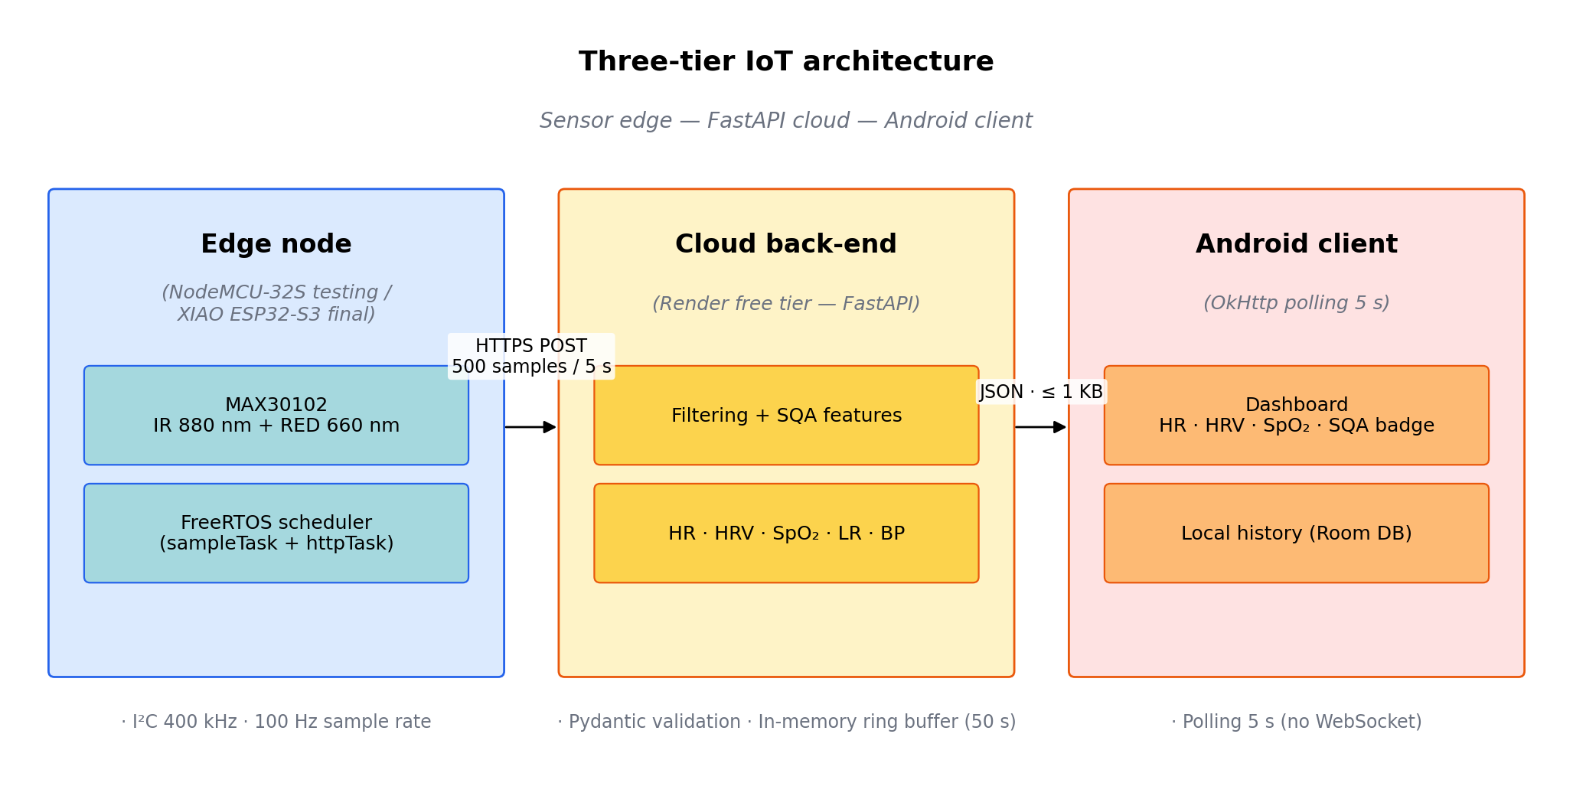
Figure 3-1: Three-tier architecture diagram — ESP32 edge node, Render FastAPI cloud, Android client.
Three engineering considerations justify the choice of a server-side processing pipeline over an edge-only design. First, the ESP32 provides only 520 KB of SRAM, which is sufficient for buffering five seconds of raw PPG samples (approximately 4 KB) but insufficient for hosting a Random Forest with 100 trees, a Welch power-spectral-density estimator with a 256-point Hann window, or any non-trivial deep-learning model; off-loading computation to the cloud is therefore a hardware constraint rather than a stylistic preference. Second, the separation of acquisition firmware from inference logic permits calibration coefficients and regression models to be retrained and redeployed without re-flashing the field device. Third, the client-server design admits straightforward extension to multi-device deployments in which several wearable units share a single back-end.

3.1.2 MAX30102 Optical Front-End
The optical front-end is the Maxim Integrated MAX30102 dual-wavelength reflectance sensor integrating two LEDs (660 nm Red and 880 nm Infrared), a single photodiode, and an 18-bit Sigma-Delta analogue-to-digital converter on a 5.6 mm × 2.8 mm package. Communication with the host microcontroller is over a 400 kHz I²C bus, with the sensor configured for 100 Hz dual-channel acquisition at the highest available sensitivity setting. The full register-level configuration: sample-rate generator, LED pulse width, LED current sweep range, ADC range, channel mode, and the finger-detection threshold applied by the firmware, is enumerated in Appendix B.2.
The MAX30102 was chosen because it is among the most widely deployed reflectance-mode optical front-ends in research wearables and consumer-electronics prototyping, with industry teardown reports identifying its integration in commercial wearable platforms such as the Samsung Galaxy S7; higher-end commercial smartwatches such as the Apple Watch and Fitbit Charge series typically employ proprietary optical front-ends that are not commercially available to academic projects. Its wide adoption makes the present prototype representative of consumer-grade hardware and ensures that the methodology developed here is transferable. The dual-wavelength configuration satisfies the Beer-Lambert requirements for SpO₂ estimation through the ratio-of-ratios method [1], and the unit cost (approximately five US dollars) is compatible with the budget of a graduation thesis. The physical assembly used in the prototype is shown in Figure 3-2(a–b), and the device in measurement position is illustrated in Figure 3-3.
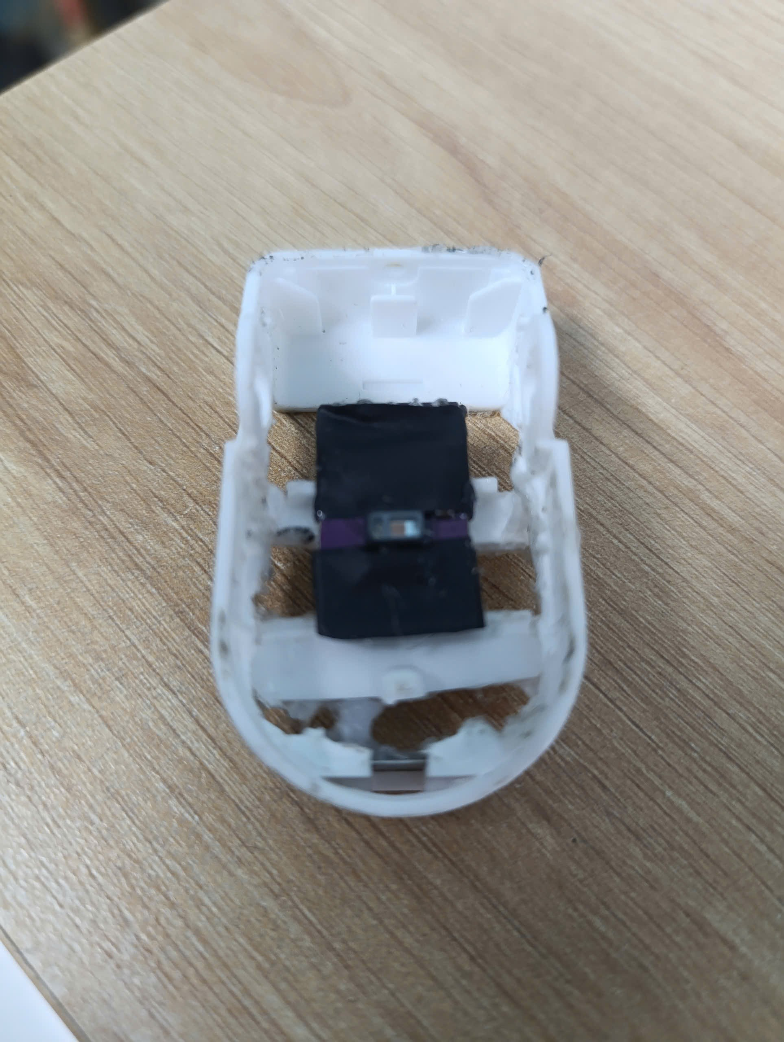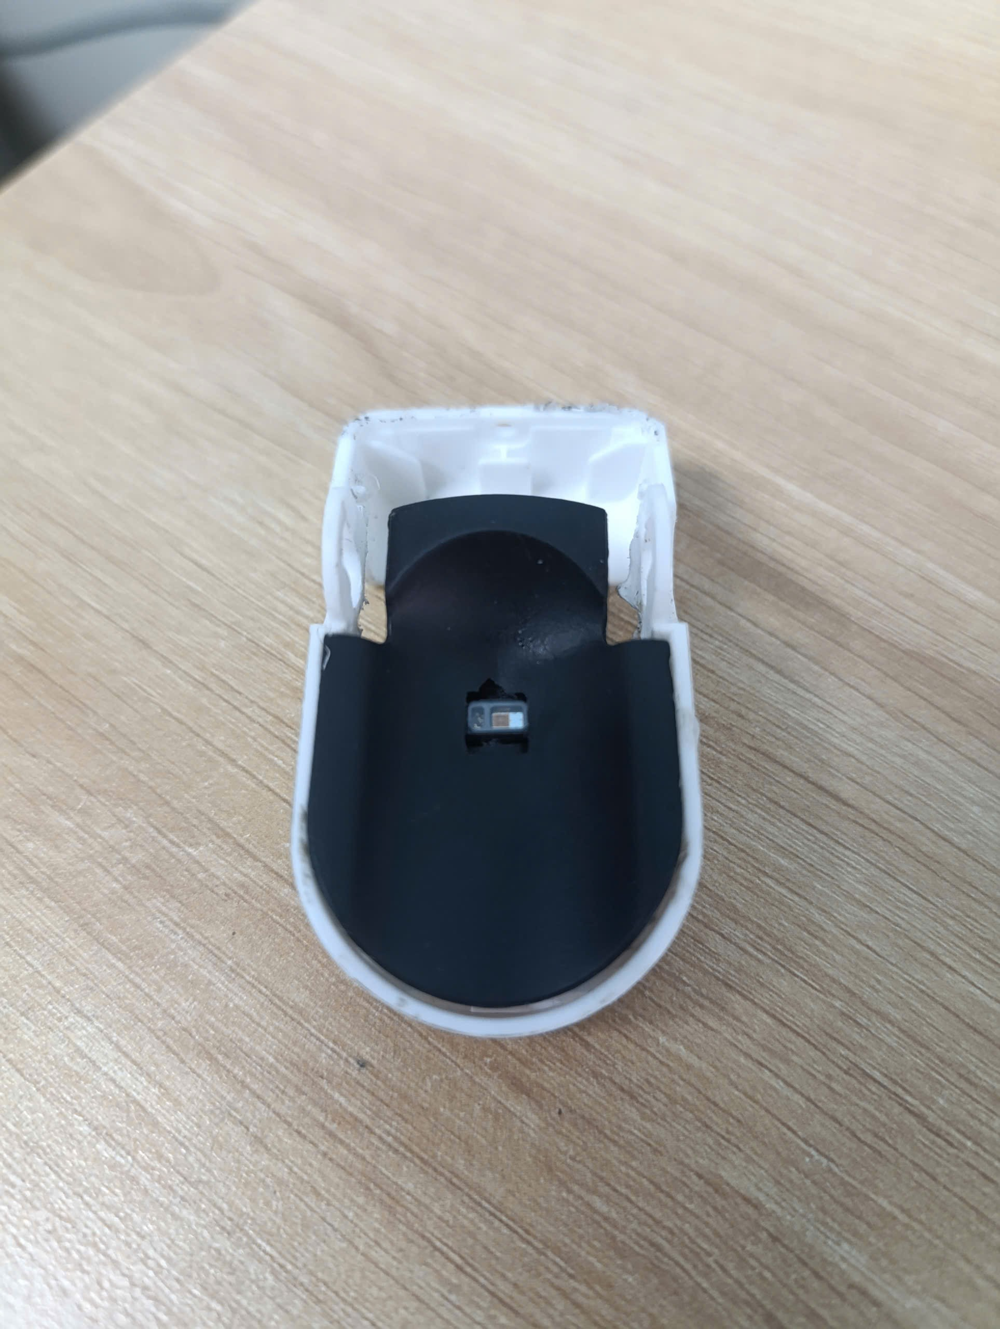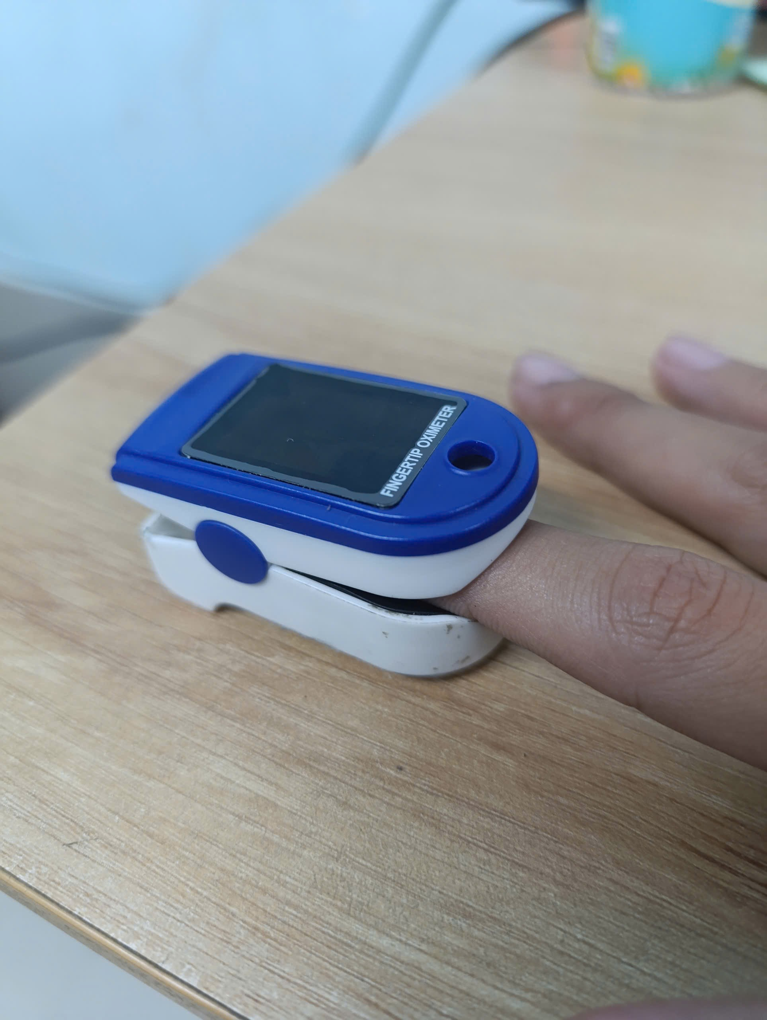
Figure 3-2: Custom enclosure embedded MAX30102 reflectance sensor visible inside the repurposed commercial pulse-oximeter housing used as light shield.

A known limitation of the chosen front-end, treated more fully in Chapter 6, is its operation in reflectance mode, in which the LED and the photodetector are co-located on the same side of the tissue. Reflectance signals are typically 10 to 20 dB weaker than transmission signals [1] and exhibit different waveform morphology. The relevance of this constraint to the supervised blood-pressure module is the subject of Chapter 5.

3.1.3 ESP32 Host Microcontroller — Testing and Final Target
The host microcontroller used during the engineering pilot is the ESP32 NodeMCU-32S (Ai-Thinker module), built around the Xtensa LX6 dual-core CPU clocked at 240 MHz, with 520 KB of on-chip SRAM, 4 MB of external Flash, and an integrated Wi-Fi 2.4 GHz radio. The dual-core architecture is essential to the firmware design described in Section 3.2 because it allows the time-critical sensor-sampling task and the bandwidth-intensive Wi-Fi upload task to run on different cores without contention. The 4 MB Flash partition hosts the firmware image and a small number of NVS records used to persist Wi-Fi credentials, the device token, and the back-end URL across reboots. The thirty-pin form factor exposes every relevant GPIO and simplifies probing during firmware bring-up, which made the NodeMCU-32S a convenient development platform for the present pilot. The wiring between the ESP32 host and the MAX30102 sensor module is shown in Figure 3-4.
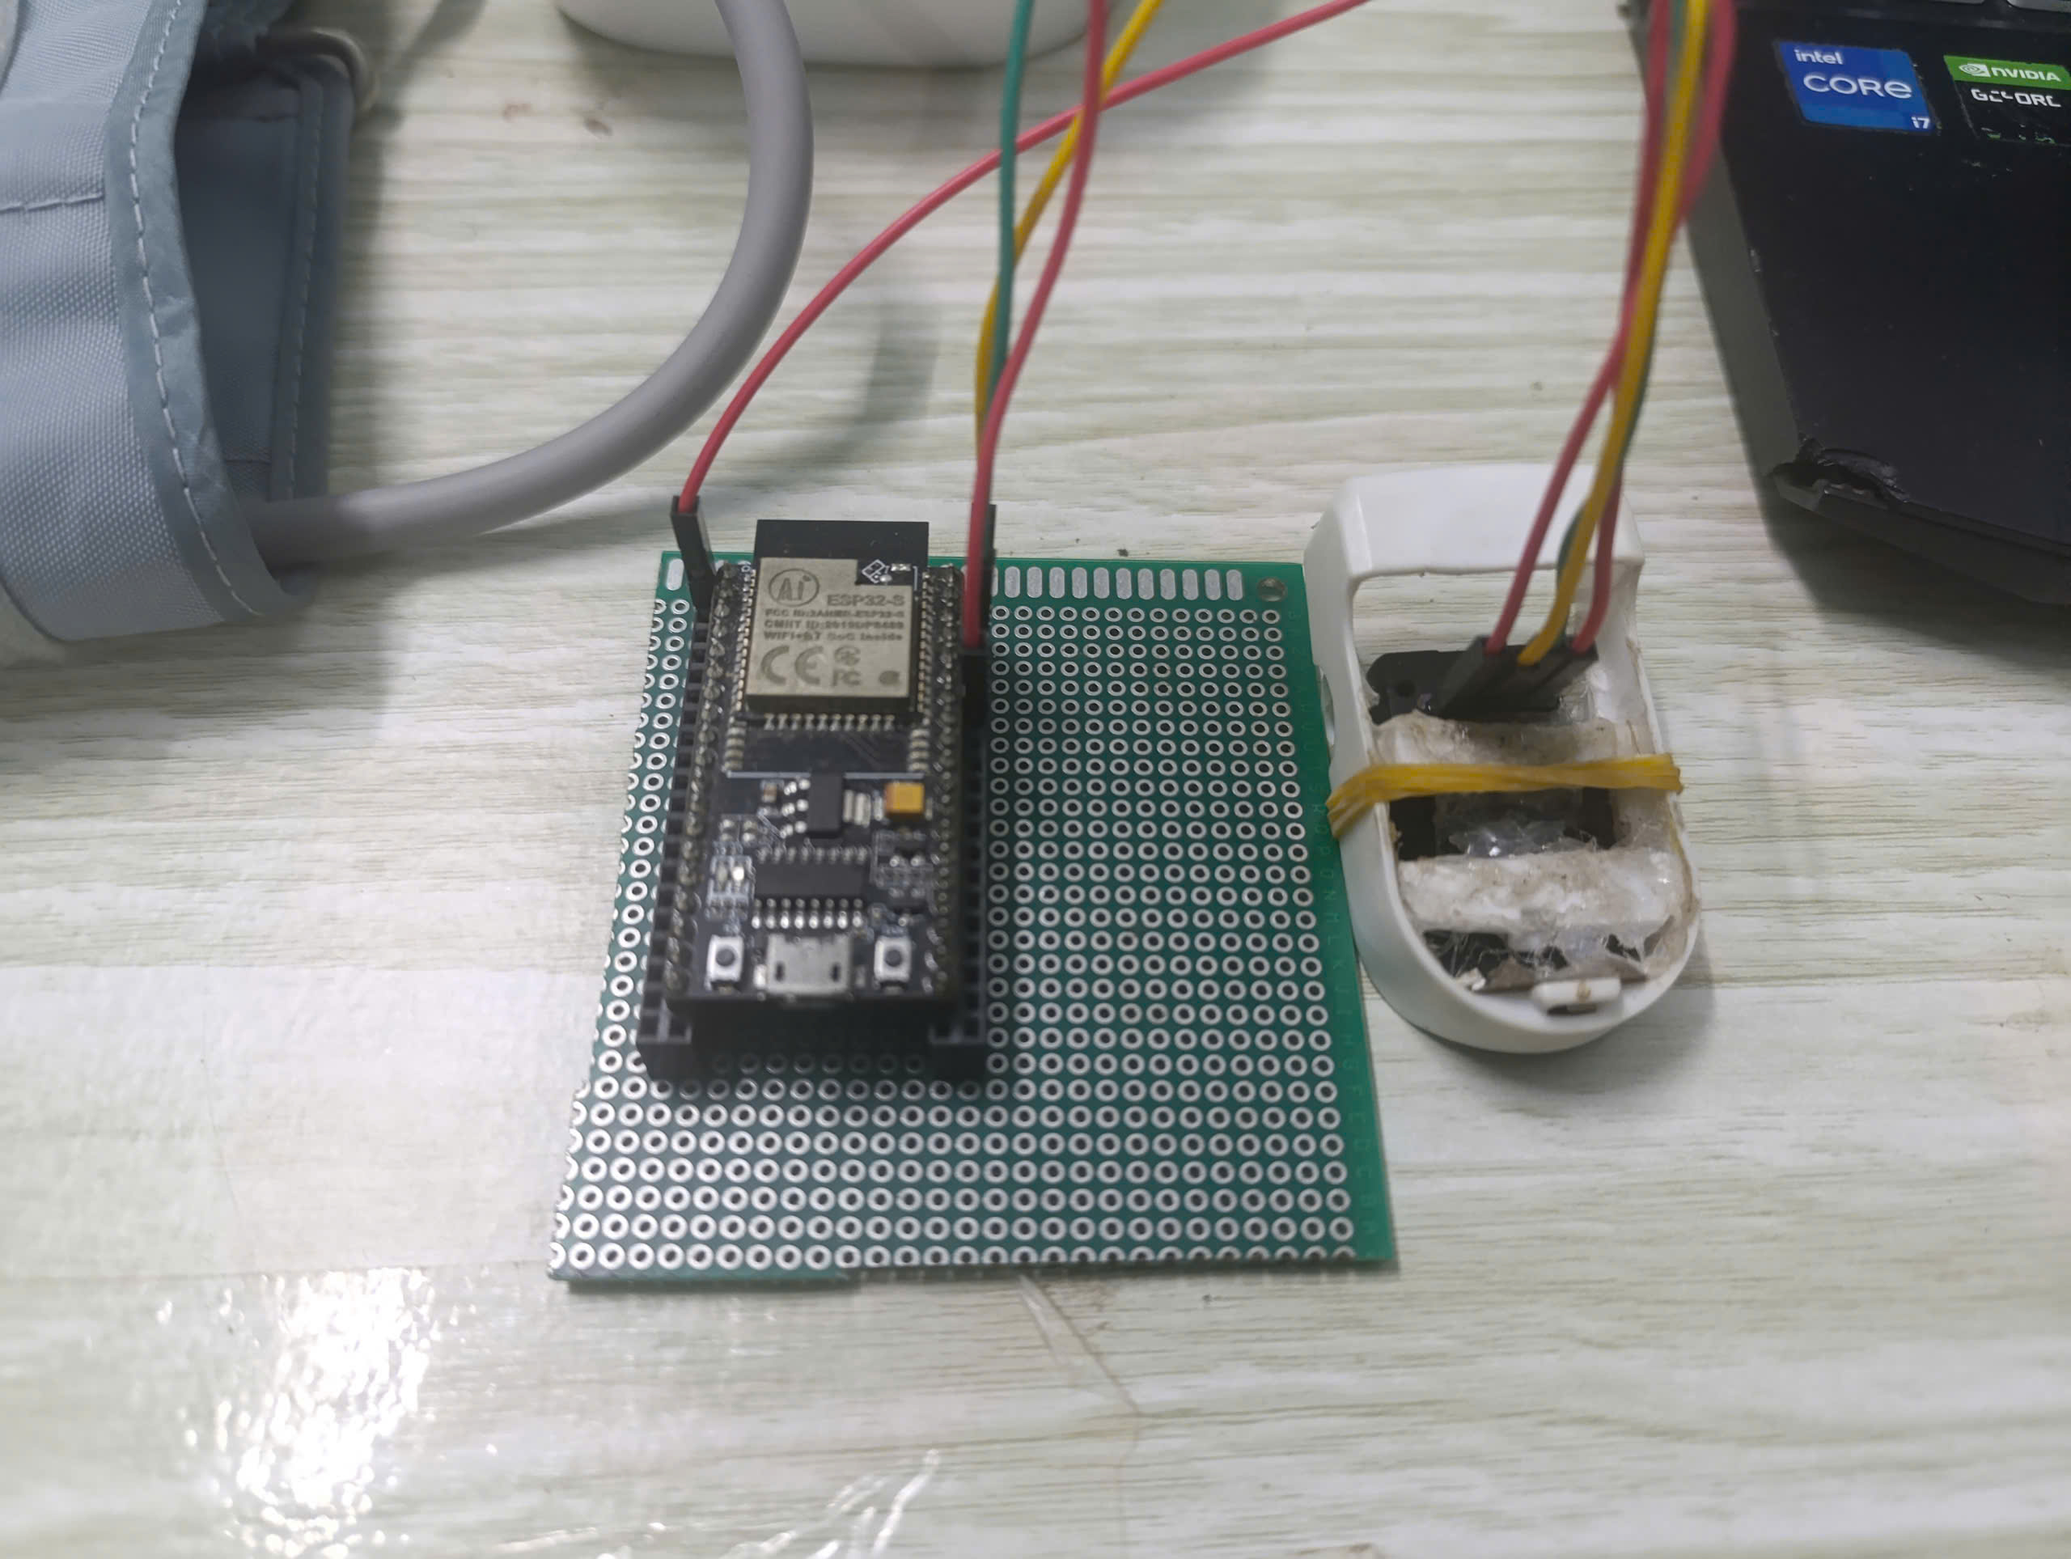
Figure 3-3: Acquisition module wiring: ESP32 NodeMCU-32S to the MAX30102 module mounted in the custom enclosure (opened view).

3.1.4 Reference Cuff Device — Omron HEM-7143T1
The ground-truth source for the supervised blood-pressure module of Chapter 5 is an Omron HEM-7143T1 oscillometric cuff sphygmomanometer (Intellisense platform, 22–32 cm arm cuff, datasheet accuracy ±3 mmHg). The Intellisense oscillometric algorithm of this product family has been independently validated against the European Society of Hypertension protocol and the AAMI/ANSI/ISO 81060-2:2018 standard [28], which makes the device suitable as a reference for a small-cohort engineering study. The cuff sphygmomanometer is used solely as the label-generation instrument for the supervised BP module; it is not part of the wearable signal chain and does not appear in Sections 3.2 to 3.4. The sequential contralateral acquisition protocol used during data collection is illustrated in Figure 3-4.
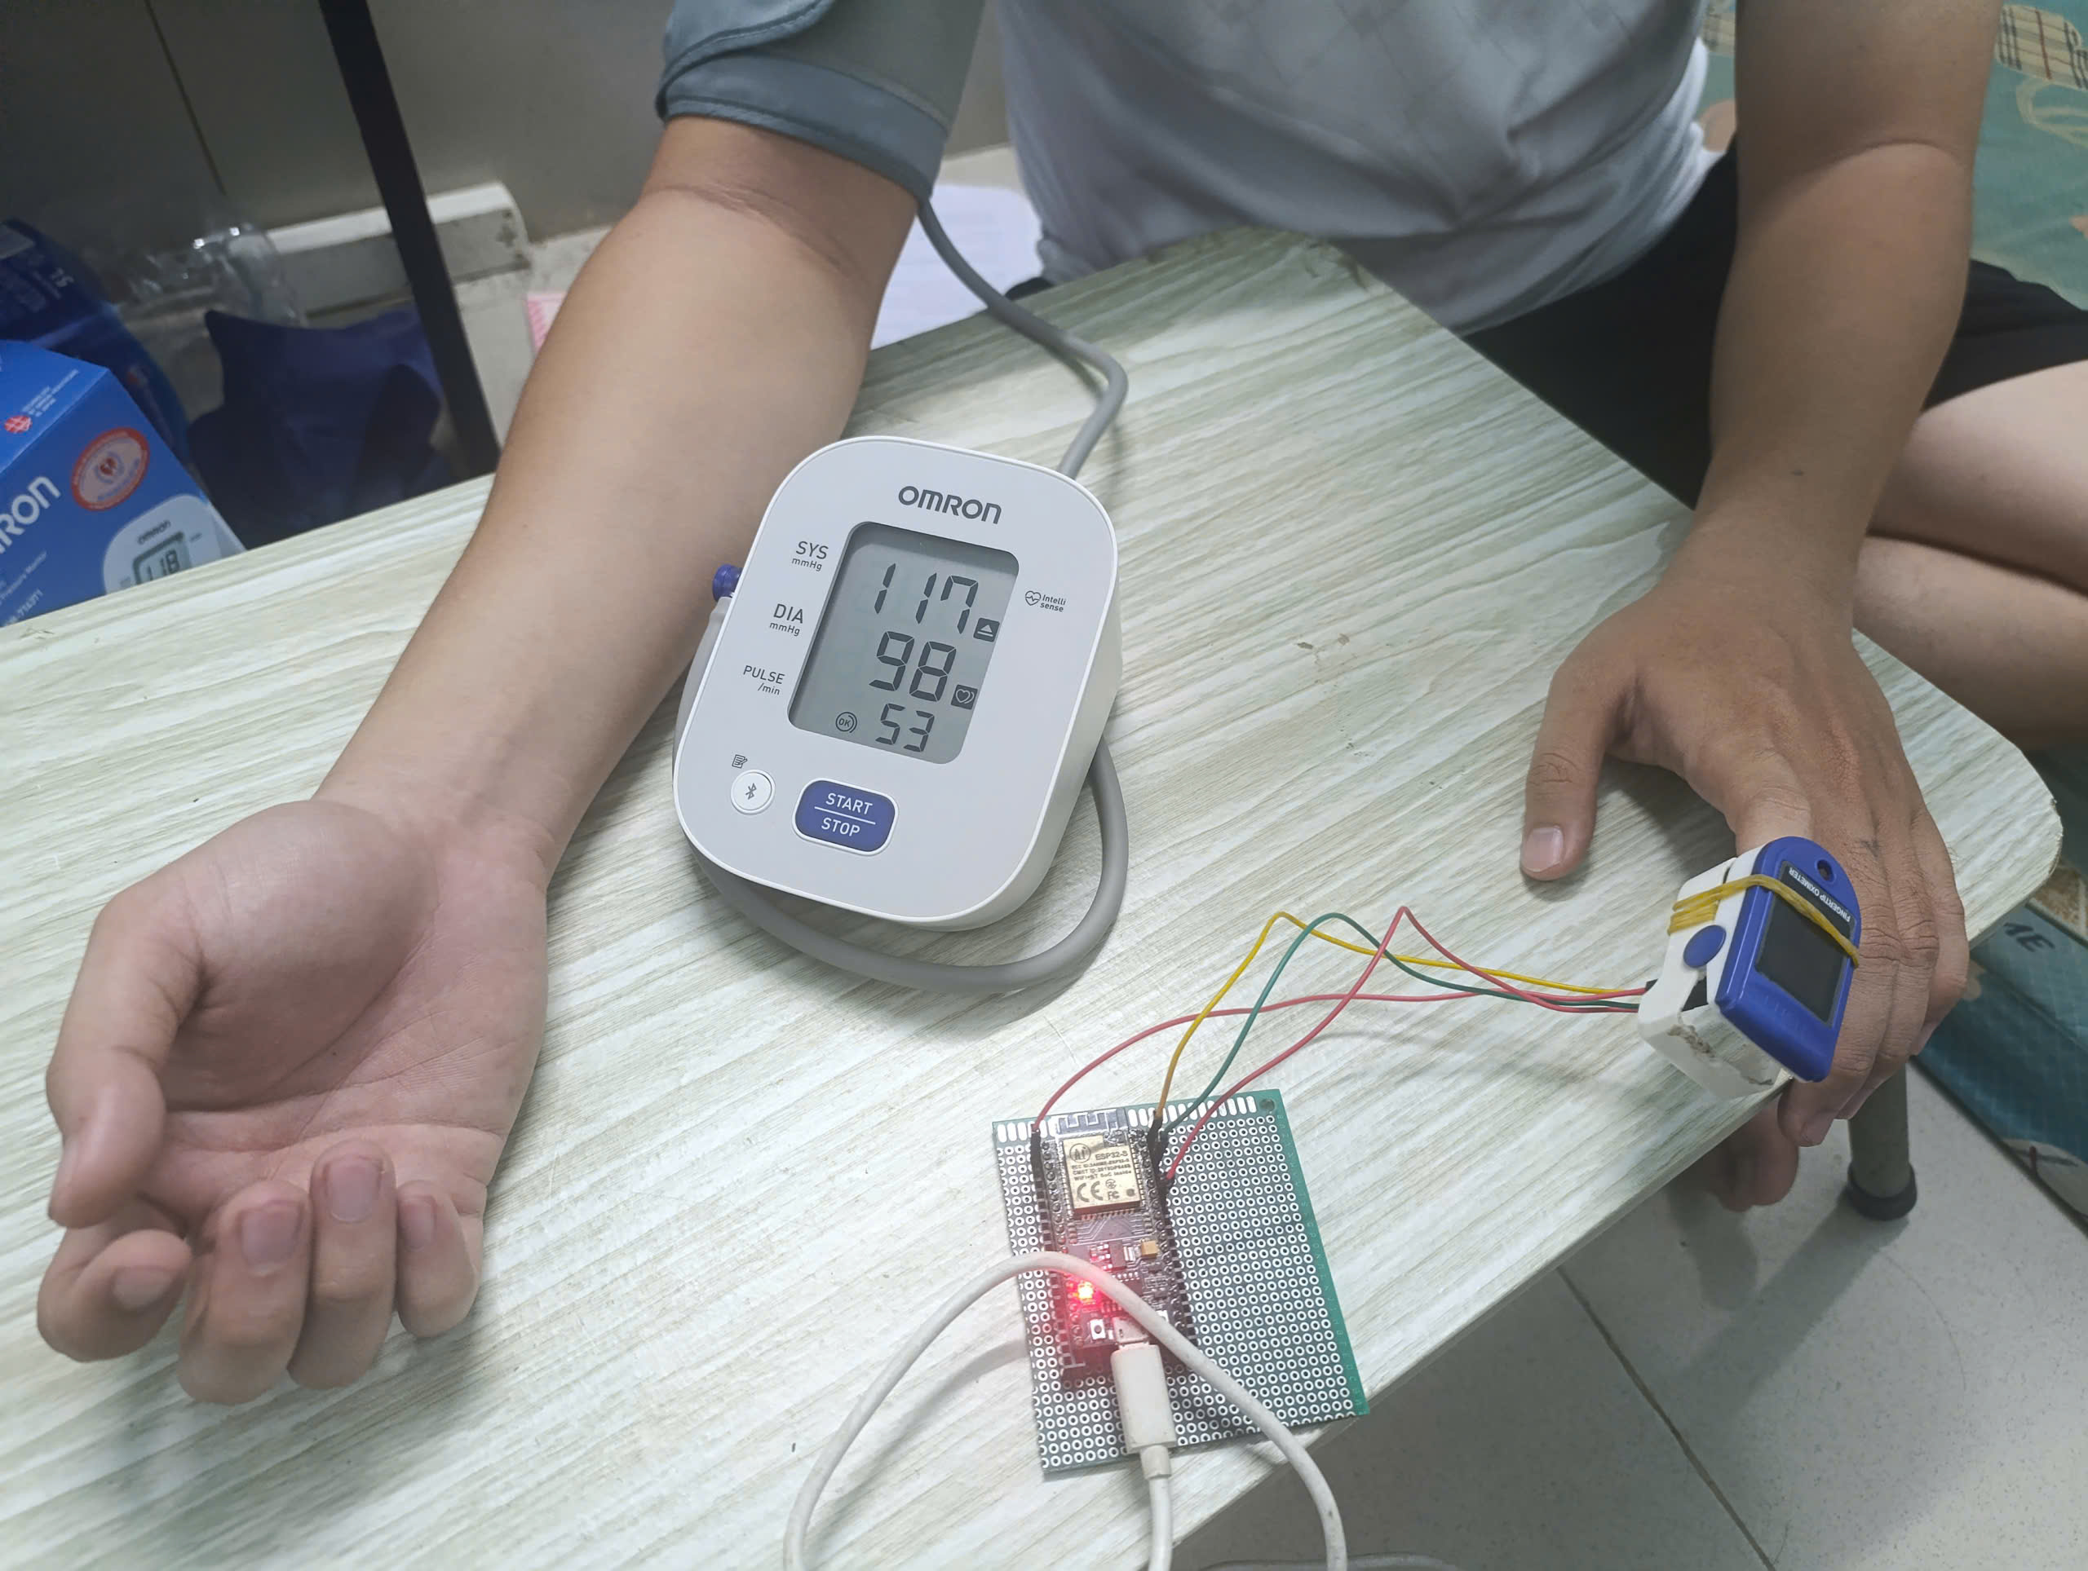
Figure 3-4: Sequential contralateral BP and PPG acquisition protocol: Omron HEM-7143T1 cuff on the left arm, MAX30102 sensor clip on the right index finger; measurements taken sequentially with a gap of at most two minutes.

3.2 Embedded Firmware
The ESP32 edge node runs a multi-task FreeRTOS firmware that samples the MAX30102 infrared and red channels at 100 Hz, accumulates 5 s batches in a ping-pong buffer, and uploads each batch over Wi-Fi to the cloud back-end of Section 3.3. A single-loop firmware is inadequate for this application because the I²C sensor read and the Wi-Fi HTTP POST cannot be safely interleaved on one thread; the chosen mitigation is a multi-task split across the two cores of the ESP32. The data-transfer protocol is Wi-Fi HTTP. The full implementation, task pinning and stack budgets, automatic LED-current calibration, HTTP/HTTPS transport detection, NTP bypass for self-collect mode, and the in-RAM upload-retry queue, is documented in Appendix A.1–A.5. A live acquisition session showing batch uploads to the back-end and serial-monitor logs is presented in Figure 3-5.
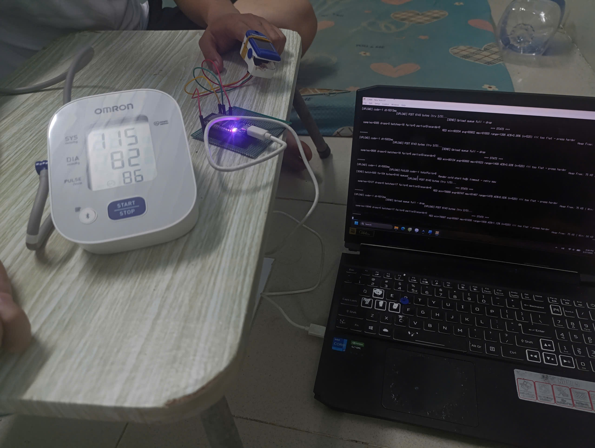
Figure 3-5: Live acquisition session with serial-monitor verification — ESP32 streaming 5-second batches to the FastAPI back-end, with upload status and signal-statistics logs visible on the laptop terminal.

3.3 Cloud Back-End — FastAPI Server
The cloud back-end is a FastAPI application deployed on Render (production) with a parallel laptop deployment under uvicorn for data collection; both deployments share the same code base. The principal endpoint, POST /api/ppg/upload, accepts a JSON payload (device_id, ir_values, red_values, sample_rate), validates the payload against a Pydantic model, and dispatches the validated batch to the Chapter 5 signal-processing pipeline. The full REST endpoint schema, Pydantic validation rules, and operational hardening mechanisms (token authentication, sliding-window rate limiting, CORS allow-list, per-device locking, and single-uvicorn-worker rationale) are documented in Appendix A.6–A.8.

3.4 Mobile Application
The mobile client is an Android application written in Kotlin that connects to the back-end through the OkHttp library. The application polls the /api/ppg/latest/{device_id} endpoint every five seconds, which matches the firmware’s batch-emission cadence and produces a perceived measurement-update frequency of 0.2 Hz on the screen. The polling cadence was chosen over a WebSocket-based push design because it does not require a persistent connection on the back-end and is therefore compatible with the free-tier Render deployment, and because it simplifies the offline behaviour of the client (a missed poll is recovered on the next poll without retransmission logic).
Three intentional design decisions scope the client to the engineering-pilot brief. First, the client communicates exclusively with the FastAPI back-end through the REST poll, so that the back-end owns the canonical state and no second source of truth is introduced. Second, the client does not render the raw 100 Hz waveform on the screen, because rendering at 100 Hz on an Android Canvas is a measurable battery drain and the diagnostic value of the waveform on a small phone display is limited compared to the per-batch parameter cards. Third, the BP card is hidden from the default view pending the per-subject calibration workflow (Chapter 5); users who opt in to the calibration workflow obtain access to a second screen that shows the BP estimate alongside an explicit calibration-validity timer.
The single-screen dashboard renders one card per parameter group: a Heart Rate card displays the current heart rate in beats per minute together with a zero-to-one confidence value; an HRV card displays SDNN, RMSSD, pNN50, pNN20, MeanNN, the RR-accumulator size, and the LF/HF ratio when available, with the reliability indicator rendered as a colour-coded badge (red for low, amber for medium, green for high); an SpO₂ card displays the temporally smoothed SpO₂ value, the raw single-batch SpO₂ value, the perfusion index, and the R-ratio; a Signal Quality badge renders the categorical verdict produced by the rule-based three-rule gate of the SQA framework at the top of the screen; integration of the multinomial logistic-regression classifier of Chapter 4 §4.4 into the Android display path is identified as future work in §6.6. A scrollable History list of the last twenty readings is rendered at the bottom of the screen. Figure 3-6 shows the live dashboard during a measurement session.
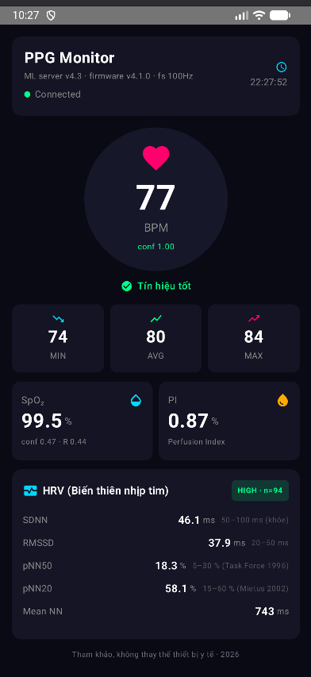
Figure 3-6: Android client real-time dashboard

3.5 Chapter summary
This chapter has presented the engineering substrate of the PPG monitor: the MAX30102 reflectance front-end paired with the ESP32 host (Section 3.1), the multi-task FreeRTOS firmware that produces five-second batches (Section 3.2), the FastAPI cloud back-end that consumes them (Section 3.3), and the Android dashboard that surfaces the results (Section 3.4). Implementation-level artefacts, task stack budgets, REST endpoint schema, Pydantic validators, are documented in Appendix A; protocol and reproducibility artefacts are in Appendix B. The signal-processing pipeline that consumes the data produced by this platform is the subject of the next two chapters: Chapter 4 introduces the signal-quality assessment framework that gates every downstream estimator, and Chapter 5 evaluates each estimator under that framework.

Chapter 4 — Realtime Signal Quality Assessment
This chapter objective is to construct a real-time signal quality assessment (SQA) framework for finger-tip photoplethysmography (PPG) acquired through the MAX30102 reflectance sensor and Wi-Fi-streamed by the ESP32 firmware described in Chapter 3. The framework is designed to gate the four downstream physiological estimators (heart rate, heart-rate variability, peripheral oxygen saturation, and blood pressure), whose evaluation is reported in Chapter 5.

4.1 Multi-feature Signal Quality Index
The first stage of the SQA framework operates at batch level. Each five-second batch of 500 IR samples (sample rate 100 Hz, single-channel infrared at 880 nm) is summarised by six raw features that are computed jointly in a single function compute_sqi_features().

4.1.1 Feature definitions
The six features were selected to span complementary signal characteristics: spectral, temporal, amplitude, distributional, and information-theoretic, rather than to maximise mutual information. Three features (spectral_purity, hr_bpm, amplitude_ratio) also feed a three-rule heuristic gate that provides a binary good/poor verdict (Table 4-4 baseline). Three additional features (sSQI, kSQI, entropy_amp_dist) extend this set to capture distributional and information-theoretic descriptors of the bandpass-filtered waveform.
Let the IR signal of length N sampled at f_{s} = 100 Hz be denoted x[n], and let the zero-phase Butterworth bandpass-filtered signal in the [0.5, 4.0] Hz band be y[n]. The six features are defined as follows:
spectral_purity: The ratio of power within the heart-rate band to the total power of y[n], computed from a Welch periodogram with Hann window:
SP=f∈[0.5, 4.0] Hz​Py(f)f​Py(f) (4.1)
where P_{y}(f) is the Welch power spectral density estimate of y[n]. SP lies in [0, 1]; values near 1 indicate a clean, narrow-band cardiac waveform.
hr_bpm: The naive heart-rate estimate from peak counting on y[n] using scipy.signal.find_peaks with minimum distance f_{s}·0.3 s, expressed in beats per minute. Implausible heart rates (outside [40, 180] bpm) are diagnostic of poor signal quality.
amplitude_ratio: The ratio of the filtered peak-to-peak amplitude to the mean absolute raw amplitude:
AR=maxy[n]-miny[n]1Nn​|x[n]| (4.2)
This feature is sensitive to under-perfusion and to saturation of the AC-coupling chain.
sSQI (skewness SQI): The third standardised moment of the filtered signal, following the standard skewness definition adopted by Elgendi 2016 [5]:
sSQI=1Nn​y[n]-μyσy3 (4.3)
PPG waveforms with a sharp systolic upstroke and slower diastolic decay typically yield positive sSQI; motion artefacts symmetrise the amplitude distribution and reduce |sSQI|.
kSQI (kurtosis SQI): Pearson kurtosis (raw, not excess), computed with scipy.stats.kurtosis(fisher=False) to match the formula reported by Elgendi 2016 [5]:
kSQI=1Nn​y[n]-μyσy4 (4.4)
Super-Gaussian waveforms with sharp peaks yield larger values (Pearson convention, Gaussian baseline 3.0; the SciPy default returns the excess-kurtosis variant with Gaussian baseline 0.0).
entropy_amp_dist: Shannon entropy of the normalised absolute amplitude distribution of y[n], treating each sample as a discrete probability mass (Cover and Thomas [18]):
H=-n=1Npnlog2pn, pn=|y[n]|m​|y[m]| (4.5)
This is the amplitude-distribution entropy of standard information theory, not the Sample Entropy of Elgendi 2016; the identifier entropy_amp_dist makes the distinction explicit in the codebase.
Table 4-1 summarises the six features.
Table 4-1: Six raw batch-level SQI features computed every 5 seconds.
# | Feature name | Domain | Reference
1 | spectral_purity | Frequency | Elgendi 2016 [5]
2 | hr_bpm | Time | — (HR plausibility)
3 | amplitude_ratio | Amplitude | — (perfusion plausibility)
4 | sSQI | Statistical (moments) | Elgendi 2016 [5]
5 | kSQI | Statistical (moments) | Elgendi 2016 [5]
6 | entropy_amp_dist | Information theory | Cover and Thomas 1991 [18]

4.1.2 Cross-server parity and runtime budget
The function compute_sqi_features() returns a Python dict of six floats and is invoked once per uploaded batch on both servers. A lightweight rule-based gate assess_signal_quality() consumes three of these features (spectral_purity, hr_bpm, amplitude_ratio) and emits a categorical good/poor verdict (Table 4-4 baseline) for fast batch-level rejection; the full six-feature vector is forwarded to the downstream multinomial classifier of Section 4.4 supplying the three-tier label used by the gating architecture. The two-tier design separates a low-latency veto path from the richer feature set used for fine-grained quality classification.
The runtime cost of feature extraction was measured on a 500-sample batch (5 s at 100 Hz) over 100 iterations on a development workstation; the mean latency was 1.174 ms per call. This is well below the 5 ms feature-budget allocated within the per-batch real-time target (50 ms total round-trip budget for HTTP ingest, feature extraction, classification, and downstream estimation).

4.1.3 Cross-hardware caveat for kSQI
A cross-dataset analysis (described fully in Section 4.3) revealed that kSQI is strongly sensor-dependent. On the BIDMC ICU corpus, acquired with the Philips IntelliVue MP-70 bedside monitor as documented in the MIMIC-II database publication of Saeed et al. [19], the median raw kurtosis is 2.19, the waveform is sub-Gaussian, with broad smooth peaks shaped by the manufacturer’s internal filtering. On self-collected BP-protocol data acquired with the MAX30102 reflectance sensor, the median raw kurtosis is 30.5, leading to the waveform is strongly super-Gaussian, with sharp systolic peaks unattenuated by clinical-grade smoothing. The factor of fifteen separation makes any threshold tuned on one platform inappropriate for the other; this caveat is documented explicitly in the codebase and is treated as a dataset-overfit hazard in Section 4.5.
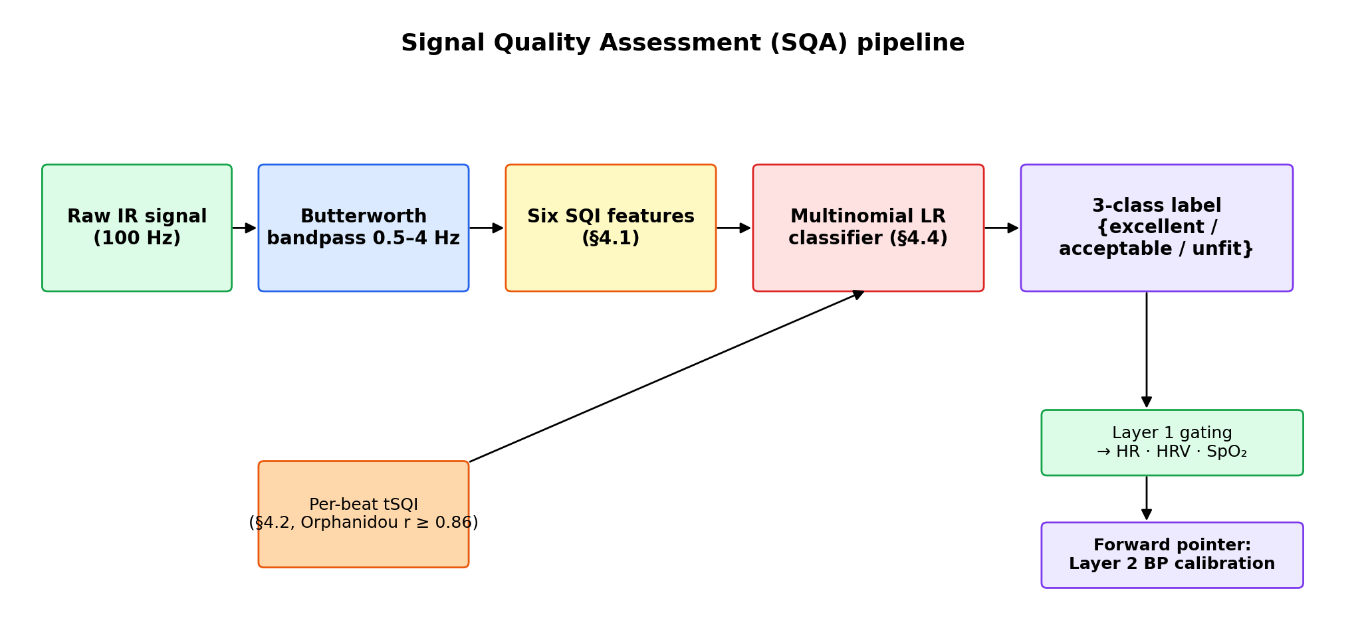
Figure 4-1: SQA pipeline block diagram

4.2 Per-beat Template Signal Quality Index
Batch-level features summarise five seconds of waveform with single scalars and may miss local morphology corruption confined to a few beats. A per-beat template Signal Quality Index (tSQI) is therefore added (Li and Clifford 2012, Orphanidou 2015). For each detected systolic peak located at sample index pk, a 600 ms beat window bk is extracted from the filtered IR signal y[n]. A running template t is maintained as the median of the last five beats. The per-beat tSQI is the Pearson correlation r(bk, t) clipped to [0, 1], and the batch-level summary is tsqi_median = median over all detected beats. Beats with r below the threshold 0.86 (Orphanidou 2015, PPG-tuned) are flagged as unfit.
Validation on a four-protocol motion stress test (single subject, MAX30102 reflectance, 5-second windows; Table 4-2) shows monotonic degradation in tsqi_median from P1 resting (0.995) through P3 clench fist (0.900) to P4 shake hand (0.812), consistent with the protocol-induced bad-beat ratio.
Table 4-2: Per-beat tSQI on a four-protocol motion stress test (single subject, MAX30102 reflectance, 5-second batches concatenated).
Protocol | Activity | tsqi_median | bad-beat ratio | Beat count
P1 | Resting baseline | 0.995 | 14.7% | 191
P2 | Light motion | 0.968 | 6.0% | 167
P3 | Clenched fist | 0.900 | 38.3% | 201
P4 | Arm swing | 0.940 | 33.8% | 237
The runtime cost of compute_tsqi_per_beat is 0.0039 ms per call on a 500-sample batch, three orders of magnitude under the 5 ms budget per upload.
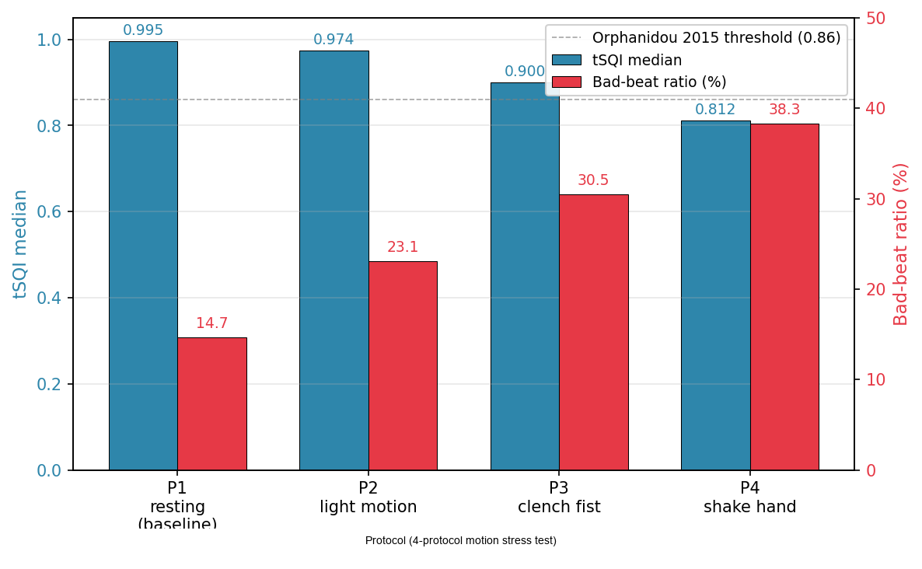
Figure 4-2: Per-beat tSQI degradation across the four-protocol motion stress test.

4.3 Pseudo-labelling Methodology
A supervised classifier requires labels. Manual annotation of 12,603 five-second windows by a clinician would have been infeasible within the project timeline, and would in any case have inherited the inter-rater variability that motivates algorithmic SQA in the first place. The strategy adopted here is therefore algorithmic pseudo-labelling: each window is assigned a quality tier by an established rule-based procedure, the classifier is trained on those labels, and a manual spot-check on a stratified subset is reserved as an independent agreement audit. The rule set chosen for pseudo-label generation is the four-criterion procedure of Orphanidou et al. [6], whose published per-criterion sensitivity and specificity provide an established algorithmic ground truth.

4.3.1 Four-rule criteria
Let p = (p₁, …, p_{K}) denote the systolic peak indices detected on the bandpass-filtered signal y[n], and let r_{tmpl} denote the template correlation as defined in Section 4.2. The four rules of Orphanidou et al. [6] are:
- Rule 1 (HR plausibility). f_{HR} = (K / Δt) · 60 must lie in [40, 180] bpm.
- Rule 2 (RR maximum gap). max(p_{k+1} − p_{k}) / f_{s} < 3.0 s.
- Rule 3 (RR ratio). max(Δp) / min(Δp) < 2.2.
- Rule 4 (template correlation). r_{tmpl} ≥ 0.86.
A window for which all four rules pass is labelled excellent. A window failing only Rule 4 with 0.66 ≤ r_{tmpl} < 0.86 is labelled acceptable; otherwise it is labelled unfit. The acceptable tier is a project extension over the binary scheme of [6], introduced to give the classifier middle-class training examples; the floor 0.66 is adapted from the ECG threshold reported in the same paper. This extension is documented explicitly in Backend code/generate_pseudo_labels.py and is treated as a project methodological choice rather than as an Orphanidou-derived definition.

4.3.2 Cross-dataset corpus
The corpus combines six datasets spanning three orthogonal axes: hardware grade (clinical bedside vs consumer wearable), acquisition modality (transmission vs reflectance), and recording condition (resting, motion-stress, and free-living ambulatory). Two same-hardware SQA-dedicated stress protocols (S01-SQA, S04-SQA) broaden the in-distribution motion-artefact coverage of the MAX30102 reflectance modality. Table 4-3 summarises the corpus.
Table 4-3: Pseudo-labelled corpus (12,603 five-second windows, 54 unique subjects).
Dataset | Hardware | Site | Conditions | Subjects | Windows | Excellent | Acceptable | Unfit
BP-protocol (self-collected) | MAX30102 reflectance | Finger | Controlled rest | 15 | 1,440 | 71.39% | 0.14% | 28.47%
S10-SQA (self-collected) | MAX30102 reflectance | Finger | Four motion protocols | 4 | 96 | 20.83% | 0.00% | 79.17%
S01-SQA (self-collected) | MAX30102 reflectance | Finger | Five motion-stress protocols | 5 | 126 | 18.25% | 12.70% | 69.05%
S04-SQA (self-collected) | MAX30102 reflectance | Finger | SQA-dedicated stress protocols | 5 | 124 | 26.61% | 0.81% | 72.58%
BIDMC ICU [19] | Philips IntelliVue MP-70 | Bedside transmission | ICU rest | 20 | 1,900 | 62.42% | 0.26% | 37.32%
PPG-DaLiA | Empatica E4 BVP | Wrist | Activities of daily living | 5 | 8,917 | 16.65% | 4.16% | 79.19%
Aggregate | — | — | — | 54 | 12,603 | 29.95% | 3.13% | 66.91%

Several patterns in the distribution merit comment. The BP-protocol exhibits a near-bimodal distribution (71.39% excellent and 0.14% acceptable) that is a real consequence of the controlled recording conditions: subjects sat still, the finger was pre-warmed, and sensor placement was checked before the recording started, so windows tend to be either fully clean or sharply corrupted by transient sensor-coupling events at the beginning of the recording, there is little gradation in between. S01-SQA is the only protocol with a meaningful acceptable tier population (12.70%); by design, the five-protocol stress procedure intentionally targets borderline-quality windows (loose sensor fit, ambient light interference, light pressure variation), which is the regime in which Orphanidou’s template correlation falls into the [0.66, 0.86) band that defines the acceptable tier. S04-SQA, BP-protocol, BIDMC, and S10-SQA all sit in the bimodal regime, consistent with their recording designs (clinical resting or pure motion stress) which drive windows toward either fully clean or hard-rejected. The PPG-DaLiA wrist BVP corpus, in contrast, is dominated by the unfit tier (79.19%); the dominant rejection reason in the unfit population is Rule 3 (RR ratio > 2.2), which alone explains the majority of unfit windows in the aggregate corpus. This is consistent with the high heart-rate variability induced by activities of daily living in the original PPG-DaLiA protocol.

4.3.3 Manual spot-check infrastructure
To bound the trust placed in the algorithmic labels, fifty windows were selected by stratified sampling across the six datasets and three tiers and rendered as PNG plots with blinded titles (a hash-derived dataset token replaces the dataset name in the plot title to mitigate rater bias toward known clinical contexts). A manifest associating each plot with the pseudo-label is retained for post-rating analysis, with linear-weighted Cohen’s κ as the planned ordinal agreement statistic (the linear weighting is appropriate for an ordered three-tier label scheme). The spot-check rating exercise is part of the validation programme reported in Chapter 5.

4.3.4 Pseudo-label noise and downstream recovery
Algorithmic pseudo-labelling inherits the rule-coverage limitations of the underlying Orphanidou four-rule procedure: any failure mode that the four rules do not capture is silently mislabelled in the training corpus, and the multinomial logistic-regression classifier of Section 4.4 is trained against a label set that is therefore noisy in the technical sense. This rule-induced label noise is partially absorbed by the L2-regularised classifier, consistent with the noisy-label learning literature. Frénay and Verleysen [35] survey the established methods for classification under label noise and document that linear classifiers with strong regularisation are among the most robust architectures to feature-conditional and class-conditional label noise, because the regulariser limits the capacity of the model to memorise individual mislabelled examples and forces it to recover the underlying signal from the aggregate feature-label correlation. Northcutt et al. [36] further demonstrate that pervasive label errors are observed even in established benchmark test sets and that the confidence statistics of a classifier trained on the noisy labels can be used to identify and partially correct those errors, suggesting that the classifier’s posterior is a complementary signal source rather than a mere replication of the input label set.
This literature-level observation has a direct empirical correlate in the present corpus. The cross-tier comparison reported in Section 5.3.4 on the BIDMC rhythmic-artefact subject bidmc_04 documents that the four-rule pseudo-label placed 37 of 95 windows into the excellent tier on that subject, whereas the multi-feature logistic-regression classifier correctly routed 24 of 25 evaluated windows into the unfit tier. The classifier is not merely mimicking the rule label set; it is recovering complementary signal from the multi-feature input, in line with the noisy-label-recovery mechanism documented by [35] and [36]. The pseudo-labelling methodology is therefore an appropriate methodological choice for the present thesis-scale corpus despite its rule-coverage limitations, and the load-bearing classifier-versus-rule comparisons of Sections 5.3.4 and 5.5.4 supply the empirical evidence that the residual rule-noise does not dominate the classifier’s behaviour.
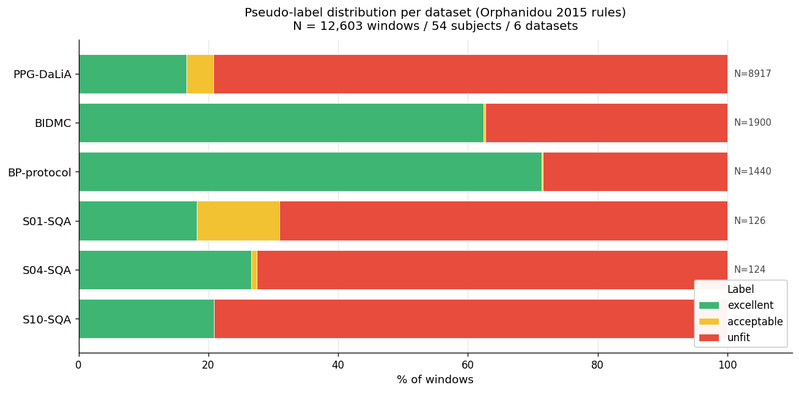
Figure 4-3: Cross-dataset distribution of pseudo-labels. Stacked bar chart showing the percentage of windows in each tier (excellent / acceptable / unfit) for the six datasets (BIDMC, BP-protocol, S10-SQA, S01-SQA, S04-SQA, PPG-DaLiA)

4.4 Multinomial Logistic Regression Classifier
Given the seven features defined in Sections 4.1 and 4.2 and the pseudo-labels of Section 4.3, the SQA classifier is a multinomial logistic regression model. Logistic regression was chosen over more expressive classifiers (random forests, gradient-boosted trees, multilayer perceptrons) for two reasons. First, the moderate corpus size (12,603 windows from 54 subjects across six datasets, 15 BP-protocol, 4 S10-SQA, 5 S01-SQA, 5 S04-SQA, 20 BIDMC, and 5 PPG-DaLiA) makes capacity-rich classifiers prone to dataset-overfit, a risk made concrete in Section 4.5. Second, the linear coefficients of a logistic regression model admit a direct interpretation as a per-feature contribution to the log-odds, which supports the methodological narrative of this chapter.

4.4.1 Architecture
The classifier is a sklearn.pipeline.Pipeline chaining StandardScaler to a multinomial LogisticRegression (class_weight='balanced', solver='lbfgs', max_iter=2000, random_state=42, L2 regularisation C=1.0). The seven features (Sections 4.1, 4.2) are z-standardised; class-balanced weighting addresses the rare acceptable tier (3.13% corpus), without which recall on that class falls below 0.05.

4.4.2 Subject-level cross-validation
The classifier is evaluated by 5-fold subject-level GroupKFold across the 54 corpus subjects (group = subject ID), avoiding within-subject leakage; this is non-trivial here because 5 PPG-DaLiA subjects contribute 8,917 of 12,603 windows. Table 4-4 reports headline metrics under three conditions: the full balanced model, the same without class weighting, and the three-rule heuristic gate as rule-based baseline.
Table 4-4: Headline classification metrics under 5-fold subject-level GroupKFold — balanced multinomial LR vs unweighted LR vs heuristic baseline.
Metric | LR (balanced) | LR (unweighted) | Heuristic baseline
Macro ROC AUC | 0.8664 | 0.8333 | n/a (binary gate)
Weighted ROC AUC | 0.8933 | 0.8898 | n/a
Accuracy | 0.6141 | — | 0.2870
Macro F1 | 0.5155 | — | 0.1487
Weighted F1 | 0.6753 | — | 0.1281

The balanced variant gains Δ +0.03 macro AUC over unweighted, confirming that class weighting recovers signal rather than inflating the metric. The heuristic baseline (three-rule gate predicting “good” 99.94% of the time) reaches macro F1 0.1487, establishing that hand-coded thresholds underfit this corpus. The F1–AUC gap is driven by the rare acceptable tier (Table 4-4b).
The per-class breakdown of the balanced classifier is reported in Table 4-4b.
Table 4-4b: Per-class precision, recall, and F1 of the balanced multinomial classifier under 5-fold subject-level GroupKFold.
Class | Precision | Recall | F1 | Support
excellent | 0.67 | 0.89 | 0.76 | 3,775
acceptable | 0.08 | 0.63 | 0.14 | 395
unfit | 0.94 | 0.49 | 0.64 | 8,433

The asymmetric F1 distribution aligns with the binary-gate operational role (Section 4.6): excellent → forwarded, unfit → rejected, acceptable → soft warning. The low F1 on acceptable is structural, class support 3.13% combined with the soft r_{tmpl} = 0.86 boundary inherited from [6] produces inherent ambiguity that class rarity amplifies into low precision; acceptable is a project-extension training-aid tier (Section 4.3.1), not a clinically grounded category.
Table 4-4c reports the in-sample confusion matrix of the balanced classifier on the full 12,603-window corpus (rows = pseudo-label ground truth, columns = LR prediction).
Table 4-4c: In-sample confusion matrix of the balanced multinomial classifier (fit on the 12,603-window corpus).
 | pred excellent | pred acceptable | pred unfit | Row total
true excellent | 3,360 | 311 | 104 | 3,775
true acceptable | 4 | 247 | 144 | 395
true unfit | 1,655 | 2,646 | 4,132 | 8,433
Column total | 5,019 | 3,204 | 4,380 | 12,603

A substantial portion of true unfit (2,646 windows, 31.4%) is misclassified as acceptable; the binary-gate framing absorbs this as soft warning rather than hard admission. The headline macro AUC 0.8664 (Table 4-4) is the GroupKFold cross-validation figure; the matrix above is in-sample for mechanism analysis only.
Mechanism analysis of false-excellent leak (1,655 windows, 19.6% of true-unfit). The safety-critical “unfit → predicted excellent” direction warrants closer examination. Cross-tabulation against the pseudo-label reason column shows that 97.7% of unfit windows are flagged via Rule 3 (rr_ratio>2.2 per Orphanidou 2015 [6]), and the false-excellent leak inherits this distribution. Four mechanisms contribute, identified by dataset breakdown (PPG-DaLiA 697 / BIDMC 479 / BP-protocol 329 / SQA-stress 150): (1) PPG-DaLiA cadence-locked motion artifacts (697 windows, 42.1%, dominant) in which walking/running cadence shares the 0.5–4 Hz spectral band with cardiac rhythm, inflating both spectral_purity (0.93–0.99) and tsqi_median (0.90–0.99) so the noise spectrum is indistinguishable from a clean PPG pulse despite amplitude_ratio differing by two orders of magnitude from the fingertip-excellent baseline; (2) BIDMC dicrotic-notch peak-doubling in subjects bidmc_04/06/13 (~107 windows, 6.5%) where alternating long–short RR violates Rule 3 but per-beat template correlation stays > 0.95 (mechanism documented in Section 4.5.1); (3) brief single-beat artifacts in long BP-protocol recordings (329 windows, 19.9%) where 9 of 10 beats correlate cleanly and the 10-second window-averaged features dilute the violating beat; (4) BIDMC non-peak-doubling subjects (372 windows, 22.5%) exhibiting the same window-averaging blind spot. Under Leave-One-Dataset-Out evaluation (Section 4.5) the classifier downgrades 741 / 1,655 (44.7%) of these to acceptable or unfit, indicating in-distribution over-confidence rather than feature inadequacy. The leak is operationally bounded by the downstream evidence reported in Chapter 5: the excellent tier still yields heart-rate MAE 2.60 BPM on PPG-DaLiA pseudo-truth and SpO₂ in-physiological-range rate 99.31% on BP-protocol (Wilson 95% CI [98.24, 99.73], non-overlapping with the unfit-tier 47.37%). This empirical bound, together with the calibration-gating fallback for blood pressure documented in Section 4.6, justifies the two-layer quality-control architecture rather than a more aggressive (and corpus-specific) unfit threshold.

4.4.3 Feature importance
The aggregate magnitude of the per-class coefficients, summed across the three classes after standardisation, ranks the seven features as in Table 4-5.
Table 4-5: Feature importance under 5-fold GroupKFold (sum of absolute coefficients across three classes after StandardScaler).
Rank | Feature | Σ |coef|
1 | tsqi_median | 5.4447
2 | entropy_amp_dist | 1.2863
3 | hr_bpm | 0.7409
4 | spectral_purity | 0.7065
5 | kSQI | 0.3852
6 | sSQI | 0.2048
7 | amplitude_ratio | 0.1684

The dominant feature is tsqi_median with Σ |coef| = 5.4447, approximately 4.23× larger than the next-ranked feature. This is the central empirical observation of Chapter 4: per-beat template correlation (Section 4.2) dominates the classifier; the six batch-level features collectively contribute less than tsqi_median’s alone. The motion-protocol stress test of Section 4.2 anticipated this finding, batch-level spectral_purity does not separate the four protocols whereas per-beat tSQI does. The S01-SQA and S04-SQA motion-stress protocols in particular contribute beats that are motion-corrupted but not fully template-collapsed, anchoring the coefficient mass on the per-beat feature without saturating it. Only the rank of tsqi_median is robust by margin; ranks 3–7 cluster within a tight 0.17–0.74 noise band.
Two SpO2-plausibility features (standard deviation of the red-to-infrared ratio and the cross-channel correlation) were evaluated but yielded near-zero coefficient magnitude and were dropped from the feature set.
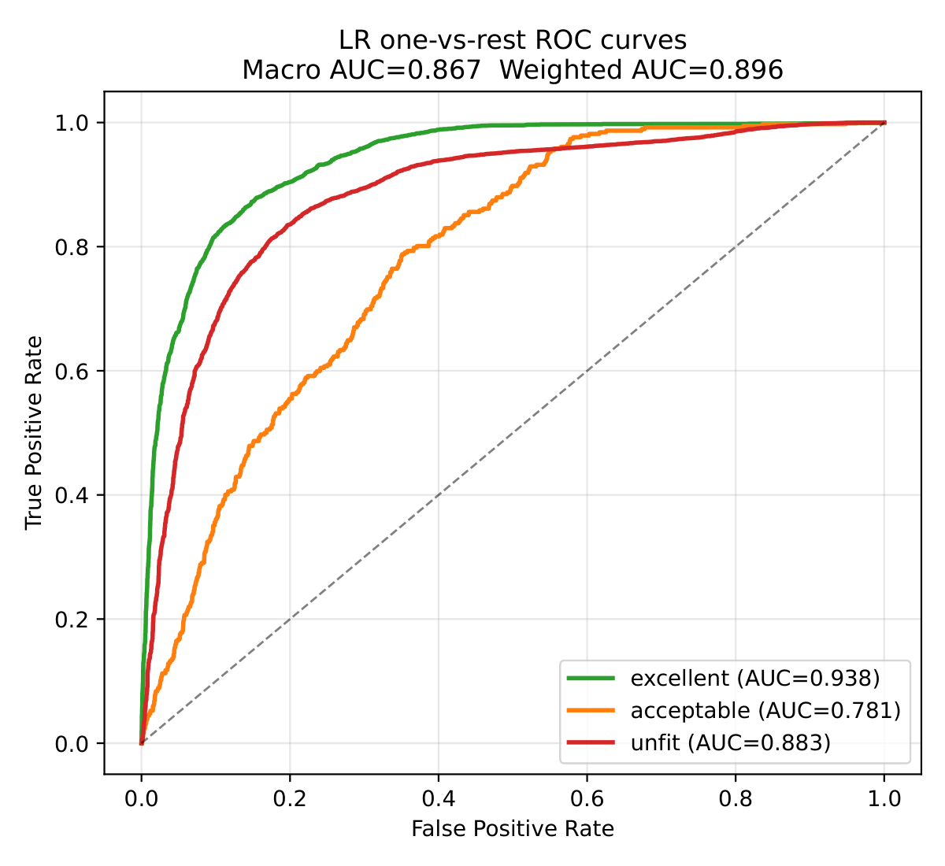
Figure 4-4: ROC curves for the multinomial classifier, one-vs-rest, three classes, under 5-fold subject-level GroupKFold.

4.5 Cross-dataset Generalisation under Leave-One-Dataset-Out
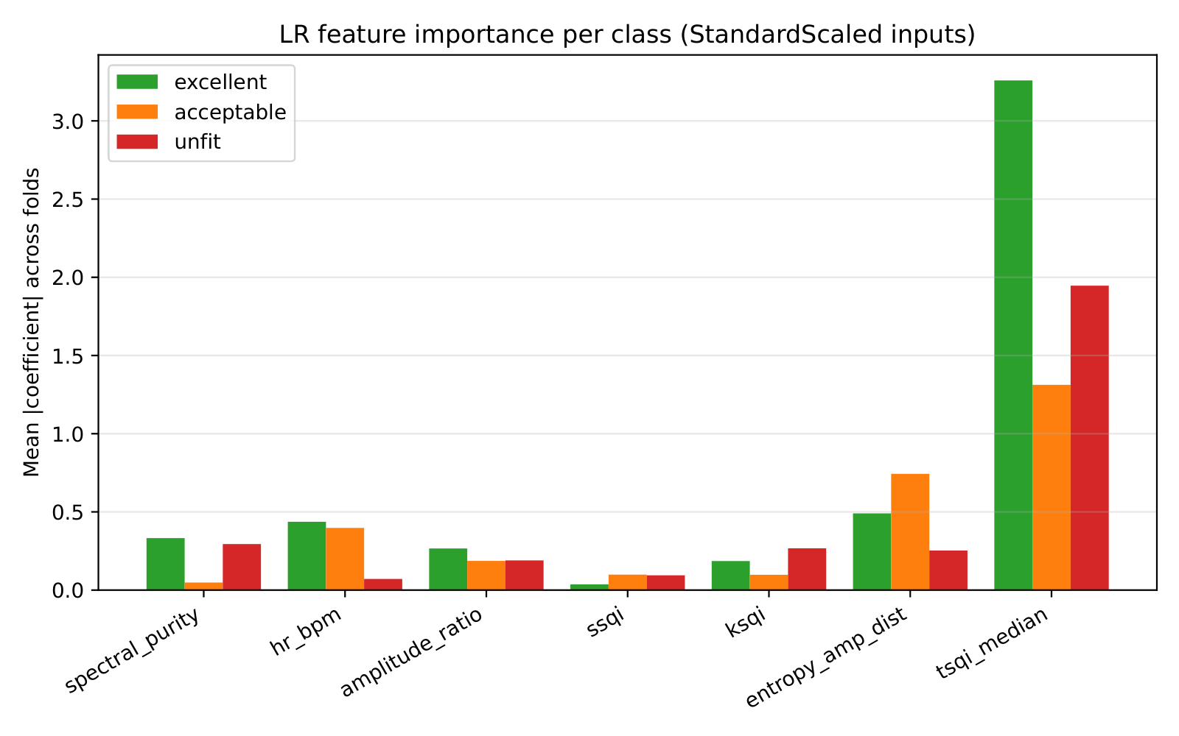
Figure 4-5: Cross-dataset Generalisation under Leave-One-Dataset-Out
GroupKFold cross-validation eliminates within-corpus subject leakage but leaves the classifier free to overfit dataset-level patterns. Because the six datasets differ in hardware, anatomical site, and recording protocol, a classifier that achieves macro ROC AUC 0.87 on subject-level held-out folds may nevertheless rely on dataset-specific signatures (the kSQI cross-hardware caveat of Section 4.1.3 is one mechanism). The leave-one-dataset-out (LODO) evaluation reported here is designed as a worst-case stress test: each fold holds out an entire dataset and refits the classifier on the remaining five. Aggregating across the six LODO folds yields a per-window prediction that is genuinely held-out at the dataset level.
Per-dataset LODO performance is summarised in Table 4-6.
Table 4-6: Cross-dataset generalisation under leave-one-dataset-out evaluation.
Held-out dataset | n_{test} | Macro ROC AUC | Macro F1
BIDMC ICU | 1,900 | 0.8198 | 0.4540
BP-protocol | 1,440 | 0.8927 | 0.4218
S10-SQA | 96 | 0.8691 | 0.2506
S01-SQA | 126 | 0.7564 | 0.3969
S04-SQA | 124 | 0.8375 | 0.2963
PPG-DaLiA | 8,917 | 0.5492 | 0.0266
Aggregate | 12,603 | 0.5906 | —

Three findings emerge. (i) Aggregate macro AUC drops from 0.8664 under GroupKFold to 0.5906 under LODO. (ii) PPG-DaLiA dominates the degradation (per-dataset AUC 0.5492, near chance), reflecting modality mismatch (wrist accelerometer-coupled vs fingertip reflectance). (iii) Contact-PPG transfer remains feasible across BIDMC bedside-transmission (AUC 0.8198) and BP-protocol fingertip-reflectance (AUC 0.8927), in contrast to wrist-band PPG-DaLiA.
An identical five-protocol stress test administered to two SQA-cohort subjects (S01 and S04) produced substantial inter-subject variation under matched instructions: S01 yielded 0/29 excellent windows while S04 yielded 22/28 (78.6%) in the P4 pressure-variation protocol (Table 4-7), indicating subject-specific signal characteristics rather than protocol noise.
Table 4-7: Per-subject pseudo-label spread under the most informative protocol (P4 pressure variation) of the identical five-protocol stress-test design (MAX30102 reflectance, finger).
Protocol | S01 excellent% (n) | S04 excellent% (n)
P4 pressure variation | 0.0% (0/29) | 78.6% (22/28)

This empirical pattern is consistent with the domain-generalisation framework of Wang, Wu, and Zhang [7], whose minimax lower bound shows that out-of-distribution accuracy scales monotonically with the number of training domains. The principle that within-modality coverage scales in-distribution support while cross-modality coverage is required to close cross-modality gaps motivates the inclusion of S01-SQA and S04-SQA and explains why BP-protocol LODO improves while PPG-DaLiA does not.
A methodological caveat applies to the per-dataset numbersfor S10-SQA, S04-SQA, and BP-protocol: held-out folds contain few or no acceptable windows, so reported AUC reduces to a binary discrimination task; PPG-DaLiA and BIDMC retain the three-class structure.

4.5.1 Known BIDMC peak-doubling artefact
Two distinct peak-doubling failure modes were observed in the BIDMC pseudo-labels. Mode 1 (alternating), scipy.signal.find_peaks intermittently catches the dicrotic notch, producing alternating long/short RR intervals with rr_ratio > 2.2; these windows are correctly flagged unfit by the existing Rule 3 of the Orphanidou four-rule framework [6]. Mode 2 (uniform doubling), the detector consistently catches both the systolic peak and the dicrotic notch for every beat, producing a uniform but doubled RR series (rr_ratio ≈ 1.4–1.7, hr_mean ≈ 2× ECG-truth); these windows slip through Rule 3 by design. The underlying mechanism is established in the arterial-waveform morphology literature: in vasodilated states (sepsis, reduced systemic vascular resistance), the delayed dicrotic notch “appears almost as a separate and distinct wave” [16]. Cross-referencing affected subjects against the PhysioNet bidmc_*_Numerics.csv ECG-derived ground truth confirmed the artefact in three BIDMC subjects: bidmc_04 (ECG HR 91.8 BPM versus scipy 155 BPM, 1.69×); bidmc_06 (82.0 versus 145, 1.77×); bidmc_13 (66.8 versus 125, 1.87×). Three control subjects (bidmc_01, bidmc_05, bidmc_11) matched the ECG exactly. Rule 3 mitigation across the three affected subjects covers approximately 81% of their windows; the remaining uniform-doubling false-negatives (~12% of affected-subject windows, ~2% of the BIDMC fold) are documented as a known boundary limitation of the Orphanidou rule design at the dicrotic-notch margin. The benchmarking study of Charlton et al. [11] reports HeartPy at F1 = 99.2% on BIDMC, suggesting an alternative reference detector at the dataset level; however, alternative detector configurations (HeartPy primary; hybrid scipy + HeartPy cross-check) over-reject genuinely degraded same-hardware stress-test windows (S01 and S04 P1–P5) and are not adopted. The scipy.find_peaks configuration (LODO BIDMC AUC 0.8198) is used throughout, with the remaining uniform-doubling false-negatives documented as a known boundary limitation of the Orphanidou rule design at the dicrotic-notch margin.

4.5.2 Scope of generalisation claim
The classifier provides within-corpus discrimination (macro AUC 0.87 under GroupKFold) and same-hardware transfer (BP-protocol LODO 0.89) but does not extend to wrist-band motion-coupled PPG. Cross-modality deployment requires either modality-specific retraining or per-subject calibration.

4.6 Two-Layer Quality-Control Architecture
The SQA framework of Sections 4.1 through 4.5 is a single-layer construction: features are extracted, a label is predicted, and a window is gated for or against downstream processing. Chapter 5 evaluates four downstream physiological estimators, heart rate, heart-rate variability, peripheral oxygen saturation, and blood pressure, under this gating regime. As reported in Chapter 5, three of the four modules respond to SQA gating in the manner one would expect: estimator accuracy stratifies cleanly by predicted SQA tier. The fourth module, blood pressure, does not. This section introduces the architectural distinction that frames the Chapter 5 evaluations and that constitutes the second methodological contribution of the thesis.

4.6.1 Two paradigms of quality control
Two paradigms emerge from the Chapter 5 results:
- Layer 1, SQA gating is the appropriate quality-control mechanism for estimators whose accuracy is determined primarily by the local quality of the input signal. Heart rate, heart-rate variability, and SpO₂ all fall in this class. A noisy window directly degrades the estimator output; a clean window directly enables it. The SQA classifier of Section 4.4 supplies the decision.
- Layer 2, Calibration gating is the appropriate quality-control mechanism for estimators whose accuracy is determined primarily by per-subject offsets that are not contained in the signal. Cuff-less blood pressure estimation falls in this class. Under the present model, the predicted blood pressure regresses to the population mean and the residual error tracks the distance of the subject’s true blood pressure from that mean rather than the local signal quality. Per-subject anchor calibration, capturing one cuff measurement at a known anchor session and subtracting the offset on subsequent sessions, is the correction that addresses this failure mode.

4.6.2 Quantitative justification of the separation
The Chapter 5 evaluation that motivates this two-layer separation is the blood pressure ablation under SQA stratification, reported in detail in Section 5.6. Anticipating that result, the central numbers are:
- The Pearson correlation between the per-window absolute SBP error and the per-subject fraction of excellent windows is r = −0.023, within statistical noise of zero. SQA quality has no predictive power over blood pressure error on this cohort.
- The Pearson correlation between the per-window absolute SBP error and BP_{true} − 118.3 mmHg (the distance of the subject’s true SBP from the population mean of the training corpus) is r = 0.877. Regression-to-mean dominates the residual.
- A tercile stratification of subjects by SQA quality score yielded SBP MAE 17.75 mmHg in the high-quality tercile, 11.35 mmHg in the medium tercile, and 13.56 mmHg in the low-quality tercile. The expected monotonic ordering does not hold; the high-quality tercile happens to contain subjects whose true blood pressures sit furthest from the population mean (Stage 2 BP-reading subjects and a hypotensive case in the same tercile), and their distance-from-mean dominates the per-tercile MAE.
These numbers indicate that, for blood pressure under the current model, SQA gating cannot improve accuracy because the dominant error mechanism does not lie on the signal-quality axis. The corollary is that the appropriate quality-control mechanism for blood pressure is not SQA gating but per-subject calibration; this is the architectural decision that defines Layer 2.

4.6.3 Architectural alignment with industry practice
The two-layer architecture proposed here is consistent with the convergent practice of commercially deployed cuff-less BP devices (Aktiia Hilo, Samsung Galaxy Watch BP, Apple Watch hypertension-notification [31], Biobeat BB-613), each of which relies on per-subject cuff calibration rather than SQA gating for BP. The detailed device-by-device comparison, regulatory status, and cohort scale are consolidated in §6.3 of Chapter 6 to avoid duplication.
Chapter 5 instantiates the two-layer architecture and reports the empirical evidence for the Layer-1 versus Layer-2 module assignment.
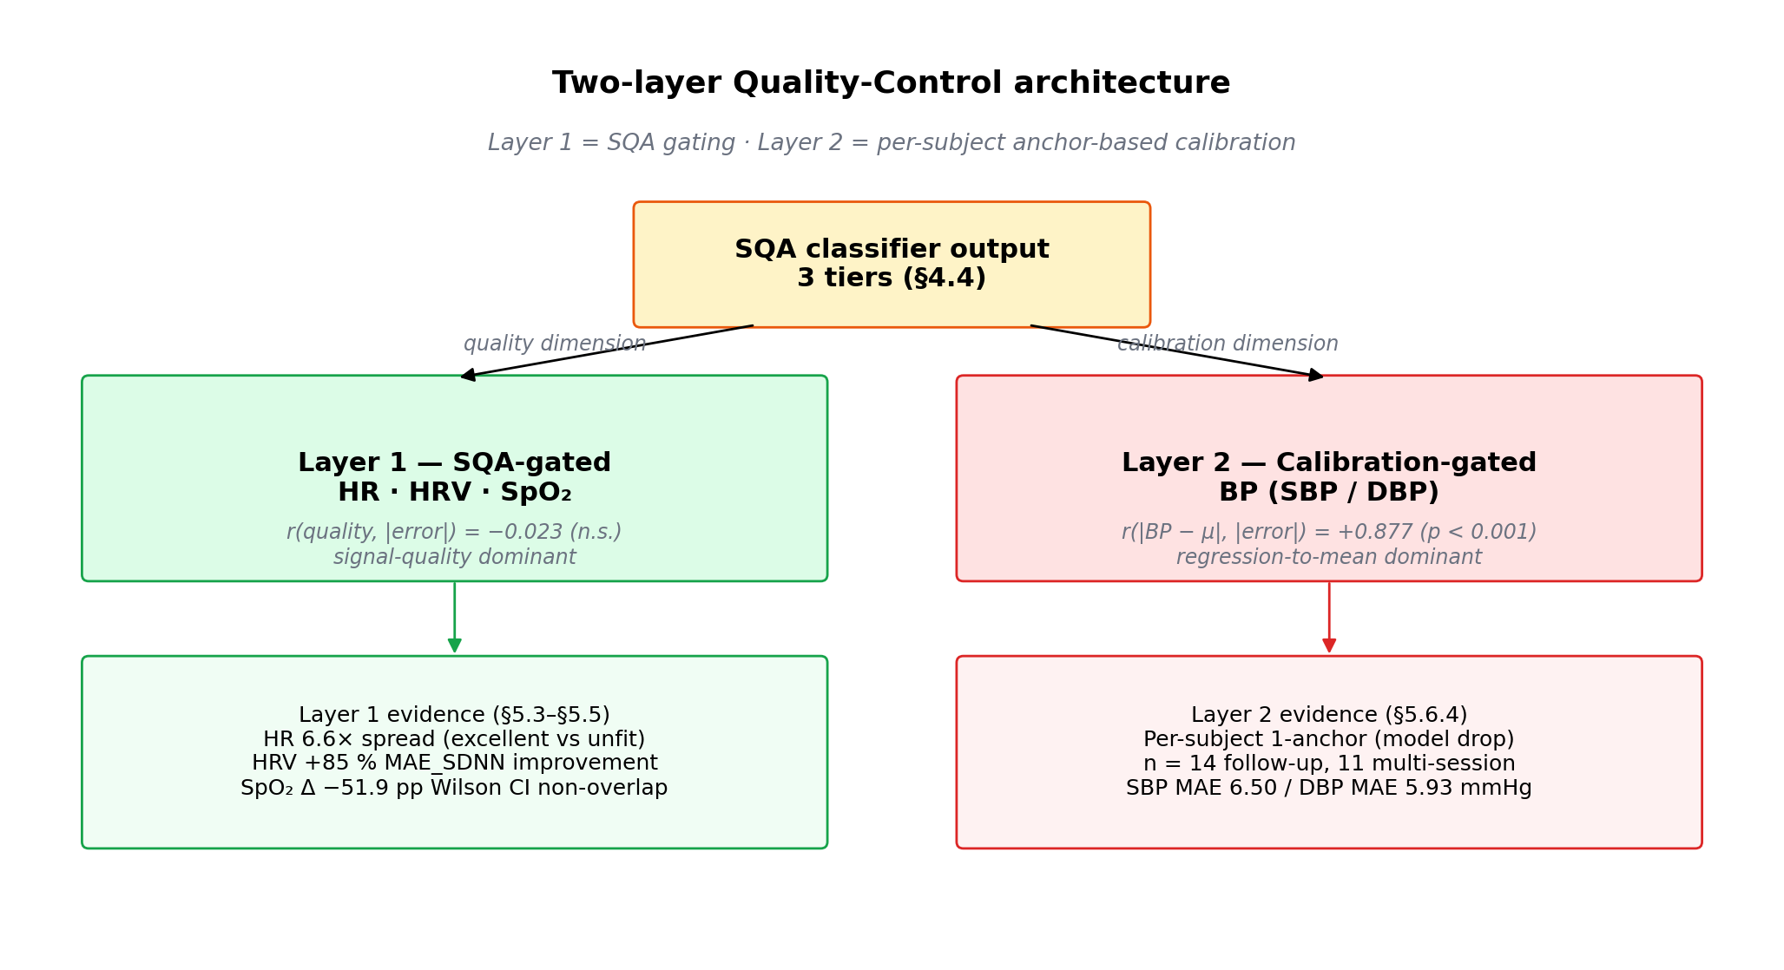
Figure 4-6: Two-layer quality-control architecture. Block diagram showing the SQA classifier output feeding two parallel branches: Layer 1 (HR, HRV, SpO₂, gated by predicted SQA tier) and Layer 2 (BP, calibrated by per-subject anchor offset).

4.7 Chapter summary
This chapter has established the realtime signal-quality assessment framework that gates the downstream physiological estimators. Six batch-level features and one per-beat template correlation feed a multinomial logistic-regression classifier trained on 12,603 windows from 54 subjects across six datasets (Sections 4.1–4.4), with within-corpus macro ROC AUC of 0.8664 under GroupKFold and cross-dataset degradation to 0.5906 under leave-one-dataset-out (Section 4.5). The empirical confounder analysis of Section 4.6 motivates a two-layer quality-control architecture: Layer 1 batch-level signal-quality gating routed to heart rate, heart-rate variability, and peripheral oxygen saturation; Layer 2 subject-level calibration gating routed to cuff-less blood pressure. Chapter 5 instantiates this architecture module by module and reports the downstream performance under the two-layer regime.

Chapter 5 — Downstream Estimation under QA Gating
Sections 5.3, 5.4, and 5.5 evaluate Layer 1 SQA gating for heart rate, HRV, and SpO₂ respectively. Section 5.6 evaluates Layer 2 per-subject calibration for blood pressure. Section 5.2 documents the shared base signal-processing pipeline common to all four modules.

5.1 Two-Layer Quality-Control Architecture Rationale
The two-layer quality-control architecture established in §4.6 is instantiated in this chapter: §5.3 through §5.5 evaluate the three Layer-1 modules (heart rate, heart-rate variability, peripheral oxygen saturation); §5.6 evaluates the Layer-2 calibration-gated blood-pressure module.

5.2 Base Signal-Processing Pipeline
This section describes the deterministic digital-signal-processing chain that runs on every validated batch. The pipeline produces three artefacts that are consumed by the downstream modules of §5.3 through §5.6: the bandpass-filtered IR waveform (§5.2.1), the systolic-peak index series (§5.2.2), and the cleaned RR-interval series after two-stage outlier rejection (§5.2.3). The pipeline does not itself produce heart-rate, HRV, SpO₂, or blood-pressure estimates: those are the subject of the SQA-gated and calibration-gated module pipelines of §5.3 to §5.6. §5.2.4 documents the cross-batch overlap buffer that supports peak deduplication near batch boundaries.

5.2.1 Bandpass Filtering
The pre-processing chain is a single fourth-order Butterworth bandpass filter with a passband of 0.5 to 4.0 Hz, applied through scipy.signal.filtfilt for zero-phase output. The passband corresponds to an instantaneous heart-rate range of 30 to 240 BPM and covers the physiologically relevant cardiac band specified by Kamal et al. [8] for fingertip PPG analysis without admitting baseline drift below 0.5 Hz or muscle-tremor artefacts above 4 Hz. The zero-phase output, obtained by forward-backward filtering, avoids the phase-distortion artefacts that would otherwise displace the systolic peak. No additional smoothing stage is applied beyond the Butterworth bandpass: the internal moving-average envelope used by the HeartPy peak detector (§5.2.2) is sufficient for the quality range encountered in the pilot data. The bandpass output preserves the second-derivative morphology that is later consumed by the morphological feature extractor of §5.6.
For SpO₂ estimation, the same input signal is decomposed into an AC component (the bandpass output described above) and a DC component obtained by a fourth-order Butterworth low-pass filter with a 0.5 Hz cut-off; the DC value used in the ratio of ratios is formed as the average of the median of the raw signal and the mean of the low-pass output. The detailed SpO₂ algorithm, including the quadratic calibration polynomial taken from the Maxim Integrated MAXREFDES117 reference design [12] and the validity gates derived from Blaney et al. [13] and Schneider et al. [17], is consumed by the SpO₂ ablation of §5.5.

5.2.2 Peak Detection (HeartPy)
Systolic-peak detection is performed by the HeartPy algorithm of van Gent et al. [10], which implements an adaptive threshold strategy specifically calibrated for noisy wrist and finger PPG signals. The algorithm operates in three stages, as expressed in Eq. 5.1 to Eq. 5.3:
$ss\left(t\right)= {MA}_{0.75s}(x_{bp}\left(t\right))$ (Eq. 5.1)
$θ\left(t\right)= mean\left(s\right)*12$ (Eq. 5.2)
$P= find_peak(s, distance=f_{s}*0.3, promince=θ*0.5$ (Eq. 5.3)
where $x_{bp}$ is the bandpass-filtered IR signal of §5.2.1, ${MA}_{0.75s}$ denotes a moving-average filter with a window length of 0.75 seconds, $θ$ is the multiplicative adaptive threshold with the factor of 1.2 recommended by van Gent et al. [10], $f_{s}$ is the acquisition sample rate (100 Hz in the present system), and the minimum inter-peak distance of $f_{s}*0.3$ samples corresponds to a maximum heart rate of 200 BPM.
Two algorithmic refinements complement the basic find-peaks call. A spline-upsampled sub-sample accuracy refinement is enabled when the sample rate $f_{s}$ divides 1000 Hz exactly: the algorithm interpolates the signal onto a 1000 Hz grid and re-locates each peak at sub-sample precision, which reduces the quantisation noise floor of the RR intervals from 10 ms (one sample at 100 Hz) to 1 ms. An overlap buffer, described in §5.2.4, is maintained per device and prepended to every new batch before peak detection so that peaks landing near batch boundaries are not lost or double-counted. When the HeartPy library is unavailable in a deployment, the back-end falls back to a pure-scipy adaptive-threshold implementation that uses the same moving-average and prominence parameters but omits the spline-upsampled sub-sample correction.

5.2.3 RR-Interval Extraction and Two-Stage Outlier Rejection
RR intervals are computed as the first-order difference of the peak indices, scaled by the sample period:
${RR}_{i}= \frac{P_{i+1}- P_{i} }{f_{s} }*1000$ (Eq. 5.4)
A two-stage outlier rejection then suppresses unreliable intervals in accordance with the Task Force of the European Society of Cardiology [14] and the practical recommendations of van Gent et al. [10]:
- Stage 1: Physiological gate. RR intervals outside [300, 2 000] ms are rejected, which corresponds to the [30, 200] BPM range conventionally accepted as physiologically plausible in adult cardiology and is consistent with the Task Force of the European Society of Cardiology [14].
- Stage 2: Median-quotient gate. Among the surviving intervals, those deviating from the local median by more than ±20% are rejected, following van Gent et al. [10].
The first stage protects against gross peak-detection errors (missed beat, double trigger), while the second stage protects against subtle drift caused by occasional motion artefacts. The two-stage gate, implemented by the reject_rr_outliers() function, is applied uniformly across the back-end and produces the cleaned RR-interval series consumed by the HRV module of §5.4. The two-stage construction follows the cited literature: a median-quotient gate alone, while sufficient for relative outliers, can pass non-physiological intervals at the boundaries of the peak-detector’s plausibility envelope, which the explicit [300, 2000] ms gate of Task Force 1996 [14] bounds. A per-device RR accumulator with a rolling capacity stores the most recent intervals across batches; the accumulator is the basis on which the HRV module computes time-domain and frequency-domain metrics when the current batch alone does not contain enough beats.

5.2.4 Cross-Batch Overlap Buffer
The five-second batch boundary introduces a peak-detection edge case: a systolic peak that lies within approximately 0.3 seconds of a boundary may be missed by the in-batch detector (because the moving-average envelope of Eq. 5.1 has insufficient context near the edge) or may be detected twice (once at the end of one batch and again at the start of the next). The back-end mitigates both failure modes by maintaining a per-device overlap buffer of 1.5 seconds of samples carried forward from the previous batch. Each new batch is prepended with the buffer before peak detection, and peaks falling inside the overlap region are deduplicated against the peaks reported in the previous batch. The 1.5-second length is sufficient to capture the slowest physiologically plausible RR interval (2 s at 30 BPM) with enough margin to detect a peak landing in the buffer region rather than at its edge. The overlap-buffer mechanism, in combination with the two-stage RR rejection of §5.2.3, ensures that the cleaned RR-interval series exposed to the HRV module of §5.4 is free of both batch-boundary artefacts and gross peak-detection errors.

5.3 Heart Rate under Layer 1 Gating

5.3.1 Methodology
Per 10 s sliding window, heart rate is estimated from the IR channel using the base pipeline of §5.2.2 (Butterworth bandpass 0.5–4 Hz, HeartPy adaptive thresholding [10], scipy peak detection with refractory distance 0.3 s). Each window is independently classified by the Layer 1 logistic-regression classifier of §4.4 into one of {excellent, acceptable, unfit}. Window-level mean absolute error (MAE) against ECG ground truth is then stratified per SQA tier.
Two datasets carry ECG comparators and therefore enter the ablation:
- BIDMC ICU: (Saeed et al. 2011 [19]): Philips IntelliVue MP-70 simultaneously sampled PPG (PLETH) and ECG lead II at 125 Hz; 20 of 53 recordings used. The ECG R-peak series was re-derived using scipy.find_peaks with prominence-based threshold.
- PPG-DaLiA: (Reiss et al. 2019 [25]): Empatica E4 wrist BVP (64 Hz) paired with RespiBAN chest ECG (700 Hz); R-peak positions are distributed with the dataset as a pre-computed rpeaks array, derived by an independent algorithm.
Datasets without ECG comparators (BP-protocol self-collected, S10-SQA dedicated motion protocols) are excluded from this ablation. Bootstrap 95 % CI on tier-level MAE was computed via 1000 resamples (seed 42).

5.3.2 Headline result — PPG-DaLiA
PPG-DaLiA is promoted as the primary headline because its ground-truth derivation is algorithmically independent of the PPG estimate, eliminating the agreement bias documented for BIDMC in §5.3.3.
Table 5-1: HR MAE per Layer 1 SQA tier on PPG-DaLiA (pseudo-label tier, ground truth = RespiBAN ECG R-peaks)
Tier | N windows | MAE mean (BPM) | MAE median (BPM) | 95 % CI
excellent | 1 485 | 2.60 | 1.12 | [2.34, 2.86]
acceptable | 371 | 7.40 | 2.82 | [6.40, 8.40]
Unfit | 7 061 | 17.21 | 10.66 | [16.78, 17.62]

The full three-tier ordering is monotonic, with a 6.6× spread between the excellent and unfit tiers (Figure 5-1). Beyond the rank ordering, the absolute level is operationally meaningful: the excellent-tier MAE is well within clinical tolerance for resting heart-rate monitoring, whereas the unfit-tier MAE would be unacceptable for any monitoring task. The Layer 1 classifier therefore identifies windows at the threshold of clinical usability.
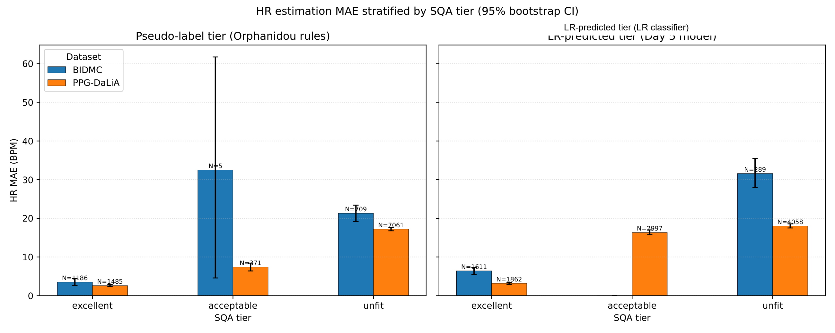
Figure 5-1: HR ablation MAE × tier × dataset bar chart with bootstrap CI.

5.3.3 BIDMC dual transparency
The BIDMC results require explicit disclosure of an algorithmic-agreement bias. Both the PPG estimate and the re-derived ECG ground truth used the same scipy.find_peaks paradigm; under clean ICU recording conditions the two algorithms agree exactly on > 50 % of windows, yielding a median MAE of 0.0 BPM at the excellent tier. The mean is informative but the median is degenerate.
Table 5-2: HR MAE on BIDMC: full cohort vs. bidmc_04 excluded (pseudo-label tier)
Variant | Tier | N | MAE mean (BPM) | MAE median (BPM) | Monotonic?
All 20 recordings | excellent | 1 186 | 3.52 | 0.00 | —
 | acceptable | 5 | 32.48 | 16.74 | NO (acc > unfit)
 | unfit | 709 | 21.32 | 2.47 | —
bidmc_04 excluded | excellent | 1 149 | 0.94 | 0.00 | YES
 | acceptable | 3 | 6.61 | 1.84
 | unfit | 653 | 16.78 | 1.68 | (17.9× mean spread)

Recording bidmc_04 contains a rhythmic artefact at approximately 187 BPM that passes the Orphanidou et al. 2015 [6] template-correlation rule r ≥ 0.86, contaminating the pseudo-label excellent tier (PPG mean 179.3 BPM vs. ECG mean 95.6 BPM in the affected windows). Removing this single recording restores strict monotonicity and widens the excellent-to-unfit spread from 6× to 17.9×.

5.3.4 LR beats Orphanidou on bidmc_04
A secondary finding emerges from cross-referencing the pseudo-tier (hand-coded Orphanidou rules) against the LR-tier (Layer 1 classifier of §4.4). On the 95 bidmc_04 windows present in both, the Orphanidou pseudo-label rule placed 37 windows into the excellent tier; the LR classifier placed only 1, correctly routing the remaining 24 (of 25 LR-evaluated) into the unfit tier. The rhythmic-artefact failure mode is undetectable by template correlation alone but is captured by the multi-feature LR model, consistent with the tsqi_median dominance reported in §4.4.3 (Σ|coef| = 5.44, approximately 4.23× the next-ranked feature). This rebuts the implicit concern that the LR adds nothing beyond Orphanidou: on this failure mode it materially outperforms.

5.3.5 Summary
The 17.9× monotonic spread on BIDMC (bidmc_04 excluded) and the 6.6× monotonic spread on PPG-DaLiA constitute direct evidence that Layer 1 SQA gating delivers clinically meaningful HR-accuracy stratification. Forward-pointer: the integrated cross-module discussion appears in §6.1.

5.4 Heart-Rate Variability under Layer 1 Gating

5.4.1 Methodology
HRV time-domain metrics (SDNN, RMSSD) are computed from the RR series of §5.2.3 following Task Force 1996 conventions [14]. The production pipeline applies the two-stage RR rejection described in §5.2.3 (physiological gate 300–2000 ms followed by ±20 % median-quotient rejection per van Gent et al. 2019 [10]). The ablation in this section evaluates five filter approaches on the same window cohort, with ground-truth SDNN and RMSSD computed from the ECG R-peak series of the comparator datasets (BIDMC ECG II, PPG-DaLiA RespiBAN rpeaks). Frequency-domain metrics (LF, HF, LF/HF) are computed on the cleaned RR tachogram via Welch periodogram following Task Force 1996 conventions [14]; full Welch configuration (4 Hz cubic-spline resampling, nperseg = 256, Hann window, band definitions, ≥ 60 RR minimum-beat guard) is documented in Appendix B.3.
The five methods, increasing in literature fidelity, are summarised below:
- No filter. SDNN/RMSSD computed on raw scipy peak intervals. Baseline.
- Naive per-beat tSQI hard filter at threshold 0.86 [6], followed by np.diff(kept_peaks). Retains gap-spanning RR intervals across excised beats.
- Literature-correct tSQI filter per HeartPy van Gent 2019 [10] source: vectorised mask accepted[:-1] & accepted[1:] drops both RR intervals adjacent to a rejected beat, eliminating gap-spanning RRs by construction. Combined with Task Force 1996 physiological gate [300, 2000] ms [14] and adjacency-aware RMSSD differencing.
- Production two-stage HeartPy rejection (no per-beat tSQI dependency), mirroring the deployed pipeline.
- C followed by Stage 2 ±20 % median-quotient rejection on survivors. Full SQA stack.

5.4.2 Headline result — Method E
The headline cohort is PPG-DaLiA unfit pseudo-tier windows, where motion-artefact-induced HRV inflation is largest and the filter has the greatest opportunity to recover signal. Reporting is restricted to the matched intersection of windows on which all five methods successfully return non-empty SDNN (N = 1 871), the strict apples-to-apples basis.
Table 5-3: HRV ablation, five methods, PPG-DaLiA unfit pseudo-tier
Method | MAE SDNN (ms) | MAE RMSSD (ms) | vs. A (SDNN)
No filter | 132.84 | 196.74 | (baseline)
Naive tSQI hard filter | 525.38 | 787.94 | −296 %
Literature-correct tSQI | 30.06 | 45.04 | +77.4 %
Production HeartPy 2-stage | 24.36 | 41.92 | +81.7 %
C + Stage 2 quotient | 20.11 | 30.42 | +84.9 %

Method E reduces MAE_SDNN from 132.84 ms (no filter) to 20.11 ms, a six-fold reduction on the matched intersection. The component-contribution decomposition (Figure 5-2) shows tSQI alone (C − A) contributes +77 pp, the RR-domain filter alone (D − A) contributes +82 pp, and the two combined (E − A) contribute +85 pp. The marginal gain of adding per-beat tSQI on top of RR-domain filtering (E − D) is +3 pp; the marginal gain of adding RR-domain filtering on top of tSQI (E − C) is +8 pp.
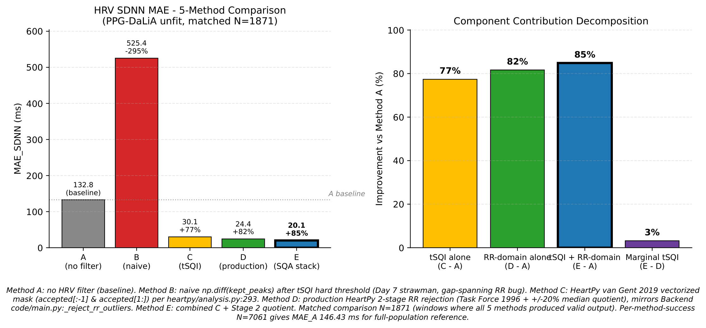
Figure 5-2: HRV ablation 5-method comparison and component contribution decomposition.

5.4.3 Method B as control comparison
Method B is reported as a control comparison that exposes a well-defined naive-implementation pitfall. When per-beat tSQI rejects bad beats but the surviving peaks are differenced naively via np.diff(kept_peaks), the resulting RR intervals span the gaps where bad beats lived. On PPG-DaLiA unfit windows these gap-spanning intervals reach 2–5× normal RR length, inflating MAE_SDNN to 525 ms, a 4× degradation relative to no filter. This is not a refutation of per-beat tSQI utility; it is a refutation of the naive implementation. Methods C and E demonstrate that the same tSQI signal, applied via the HeartPy vectorised mask, recovers more than 77 pp of accuracy.

5.4.4 Matched-N drift disclosure
Reporting the matched intersection rather than per-method-success preserves the apples-to-apples comparison but introduces a numerical drift relative to the full-population baseline. On the full pseudo-unfit cohort (N = 7 061), Method A achieves MAE_SDNN 146.43 ms; on the five-method matched intersection (N = 1 871), the same Method A registers 132.84 ms, a 9 % mechanical reduction. The drift arises because Methods D and E define their Stage 1 [300, 2000] ms gate to remove windows containing extreme RR > 2000 ms, and these are the same windows that drove Method A’s worst errors. The intersection is therefore not an unbiased subsample; it is a definitional consequence of the stricter methods’ input requirements. Both formulations are reported, with N labelled wherever an MAE is cited.

5.4.5 RMSSD parity caveat
Method D RMSSD as computed in this ablation is adjacency-aware: only consecutive RR pairs (i, i+1) where both intervals survive Stage 1 and Stage 2 are included in the differencing. The deployed HRV implementation applies np.diff directly to the filtered RR vector, admitting gap-spanning differences. The ablation’s stricter formulation conforms to the Task Force 1996 NN-interval definition [14] and is chosen for apples-to-apples comparison against Methods C and E; the deployed RMSSD is consequently a minor over-estimate relative to the ablation’s Method D figure, with the production-side parity update deferred to §6.6.

5.4.6 Summary
Per-beat tSQI was already established in §4.4.3 as the dominant Layer 1 classification feature (rank #1, Σ|coef| = 5.44). This section adds a second functional role: under the literature-correct HeartPy gating discipline, the same tSQI signal contributes +77 pp HRV-accuracy improvement when applied as a beat filter, and +85 pp when combined with Task Force-conformant RR-domain rejection. The dual-function character of per-beat tSQI, as both classifier feature (§4.4) and HRV filter (§5.4), strengthens the case for the multi-feature Layer 1 framework over single-criterion gating. Forward-pointer: §6.1.

5.5 SpO₂ under Layer 1 Gating

5.5.1 Methodology
SpO₂ is estimated from the Red/IR ratio of ratios via the Maxim MAXREFDES117 quadratic introduced in §5.2.1 (the SpO₂ AC/DC decomposition is documented there alongside the bandpass chain). Production validity guards (R ∈ [0.4, 1.4] per Blaney et al. 2024; AC_red/DC_red ≥ 0.001; perfusion index ≥ 0.2 %) operate independently of the Layer 1 classifier. The ablation in this section stratifies the SpO₂ validity rate (fraction of windows that pass production guards) and the plausibility rate (fraction whose validated SpO₂ falls within the normoxic range [94, 100] %) per Layer 1 SQA tier.
The ablation is restricted to datasets carrying both Red and IR channels: BP-protocol self-collected (17 cleaned files, 937 windows, MAX30102 reflectance) and S10-SQA dedicated (4 files, 96 windows, MAX30102). BIDMC is excluded because the published recordings carry only single-channel PLETH; PPG-DaLiA is excluded because the Empatica E4 BVP is a single-wavelength green LED channel.
This thesis does not validate SpO₂ accuracy across the hypoxic range [70–94 %]. ISO 80601-2-61:2017 validation requires controlled desaturation studies which lie outside the present pilot scope. The SpO₂ evaluation reported here is an SQA-gating consistency check on a normoxic cohort, not an SpO₂ accuracy claim.

5.5.2 Headline — BP-protocol LR tier
Table 5-4: SpO₂ validity and plausibility per Layer 1 SQA tier, BP-protocol cleaned, Wilson 95 % CI:
Tier | N total | N valid | % valid | % in [94, 100] % of valid | Wilson 95 % CI | % in [94, 100] % of total
excellent | 909 | 581 | 63.9 % | 99.31 % | [98.24, 99.73] | 63.48 %
unfit | 28 | 19 | 67.9 % | 47.37 % | [27.33, 68.29] | 32.14 %

The discriminative effect of Layer 1 gating is Δ = −51.9 pp between the excellent and unfit tiers on the in-range plausibility metric. The Wilson 95 % CI bounds are non-overlapping: the floor of the excellent-tier interval (98.24 %) lies strictly above the ceiling of the unfit-tier interval (68.29 %). The finding is therefore statistically robust despite the small unfit-tier N = 28; the Wilson interval is conservative for small N and yields valid coverage under exact binomial conditions, eliminating the small-sample concern that a normal-approximation interval would raise. Wilson interval computation uses the manual closed form:
$\text{CI}=\frac{\hat{p}+\frac{z^{2}}{2n}±z\sqrt{\frac{\hat{p}(1-\hat{p})}{n}+\frac{z^{2}}{4n^{2}}}}{1+\frac{z^{2}}{n}}$ (Eq. 5.5)
with z = 1.96 (95 % two-sided), avoiding a statsmodels dependency.
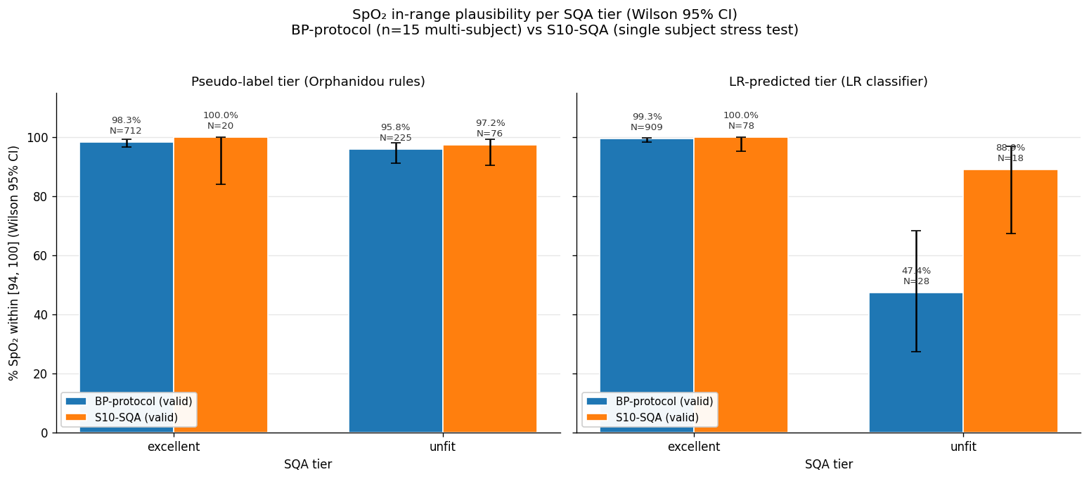
Figure 5-3: SpO₂ validity rate and in-range plausibility per tier × dataset.
The denominator % valid is non-monotonic across tiers (63.9 vs. 67.9 %); this metric is dominated by perfusion physics (the R-ratio range and AC/DC bound thresholds) rather than by Layer 1 signal cleanliness. The informative SQA-validation metric is the in-range plausibility rate, which is strictly monotonic with the −51.9 pp gap.

5.5.3 Cross-dataset inconsistency
Table 5-5: LR-unfit in-range plausibility, BP-protocol vs S10-SQA
Dataset | N total unfit | N valid | % valid | % in [94, 100] % of valid
BP-protocol | 28 | 19 | 67.9 % | 47.4 %
S10-SQA | 18 | 18 | 100.0 % | 88.9 %

The S10-SQA LR-unfit class yields 88.9 % in-range readings, in apparent tension with the BP-protocol 47.4 %. The two figures reflect different dominant artefact mechanisms. In the S10 P3 (clench fist) and P4 (arm swing) protocols, finger–sensor contact is maintained even as the wrist accelerates; the R-ratio remains physiologically plausible and the validity guards pass, while HR/HRV-tracking features (which dominate the LR scoring) collapse, yielding LR-unfit windows that nevertheless produce plausible SpO₂. In the BP-protocol cohort, LR-unfit windows are dominated by start-of-recording AC/DC mismatch transients and by one low-perfusion subject (S13, PI 0.36 %, R near 1.0, false anoxic readings near 80 %). The mechanisms differ, and the LR-unfit class therefore aggregates over heterogeneous failure modes whose SpO₂ consequences differ.

5.5.4 LR vs. Orphanidou pseudo-label
Table 5-6: In-range plausibility per tier, pseudo-label vs. LR classifier (BP-protocol cleaned)
Tier | Pseudo (Orphanidou) | LR (§4.4) | Δ
excellent | 98.25 % | 99.31 % | +1.06
unfit | 95.77 % | 47.37 % | −48.40

The pseudo-label tier achieves only weak discrimination on the unfit class (95.77 % in-range, barely distinguishable from excellent), while the LR classifier yields the headline 47.37 %. The multi-feature LR captures plausibility-degrading windows that the four-rule Orphanidou template-correlation gate does not, paralleling the bidmc_04 finding of §5.3.4. The Layer 1 LR contribution beyond hand-coded gating is therefore evident on a second downstream module.

5.5.5 S01 five-protocol stress test
A single-subject controlled stress test was conducted on subject S01 (23 M, BMI 20.5, Stage 1 BP reading category at session 1 per the AHA 2017 single-session classification, note the methodological distinction from clinical HTN diagnosis discussed in §4.6). Five protocols were executed in sequence, each 2–3 min long.
Table 5-7: S01 five-protocol SpO₂ outcomes
Protocol | Windows | LR tier counts | SpO₂ valid | Median SpO₂ | % in [94, 100] of total | Dominant production reject reason
P1 resting | 12 | 3 exc + 9 unfit | 11/12 | 99.30 % | 91.7 % | low_pi (1)
P2 cold finger (ice) | 12 | 7 exc + 5 unfit | 0/12 | — | 0 % | acdc_red_out (11)
P3 loose fit | 12 | 3 exc + 9 unfit | 1/12 | 99.70 % | 8.3 % | ratio_r_out (11)
P4 pressure variation | 14 | 0 exc + 14 unfit | 13/14 | 93.60 % | 42.9 % | (no reject)
P5 ambient light | 13 | 6 exc + 7 unfit | 4/13 | 99.05 % | 23.1 % | ratio_r_out (8)

The P4 pressure-variation result is the strongest direct mechanism-level evidence in the entire downstream evaluation. The Layer 1 classifier flagged 14/14 windows as unfit, and the production SpO₂ pipeline yielded a median 93.60 %, below the normoxic floor of 94 %. The two layers agree, and they agree at a clinically actionable threshold.
The P2 ice-finger result exposes a limitation and validates the two-layer complementarity of §4.6. The Layer 1 classifier rated 7 of 12 windows as excellent based on IR-channel features (IR DC and AC remain normal as the finger cools), but the production guards rejected all 12 because the Red channel AC/DC fell below 0.001 due to peripheral vasoconstriction (Red 660 nm being more sensitive to capillary closure than IR 880 nm). Layer 1 (LR) and Layer 2 (calibrated production guards) here function as complementary rather than redundant gates. Neither alone would have been sufficient.
The P1 resting result is a documented limitation. The Layer 1 classifier rated 9 of 12 resting windows as unfit despite clinically normal recording conditions. Root cause: scipy.find_peaks counts dicrotic notches as separate peaks in S01’s morphology, doubling the apparent HR to 126–150 BPM, which collapses tsqi_median below the LR decision boundary. The actual SpO₂ values remain in the 97–99 % range because the SpO₂ formula uses RMS AC and median DC rather than peak count. This represents a conservative bias (over-flagging) rather than a false-confidence bias (under-flagging), and is the preferred failure mode for a safety-oriented gate. Subject N = 1 limits inferential weight; this finding motivates the small-cohort expansion proposed in §6.6.
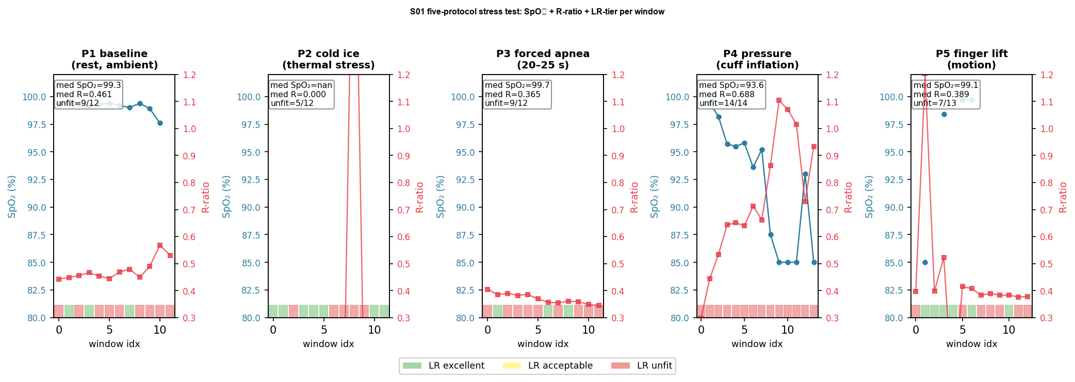
Figure 5-4: S01 five-protocol panel: five sub-panels showing IR trace + R-ratio + LR tier + production SpO₂ for P1–P5.

5.5.6 Summary
The Δ −51.9 pp gap between excellent and unfit tiers on BP-protocol SpO₂ plausibility, with non-overlapping Wilson 95 % CIs, plus the mechanism-level P4 pressure-variation evidence at the subject level, jointly demonstrate Layer 1 SQA gating value for SpO₂ estimation. Forward-pointer: §6.1.

5.6 Blood Pressure under Layer 2 Calibration Gating
This section validates the Layer 2 calibration paradigm introduced in §4.6. Unlike §5.3–§5.5, the Layer 1 SQA classifier is not the operative gate here; §4.6.2 has already shown that signal-quality stratification fails to discriminate per-subject BP estimation error (r(quality, |error|) = −0.023; r(|BP − μ|, |error|) = +0.877). The five subsections below report the BP estimation pipeline, its subject-level LOSO baseline, its calibration-gated outcome, and the industry alignment that motivates the architectural choice. The chapter ends with the explicit back-pointer to §4.6 and forward to the Ch6 synthesis.

5.6.1 Feature engineering
The base feature set comprises 38 per-window features extracted from the 30 s @ 100 Hz IR channel after the §5.2 base pipeline, distributed across three categories as summarised below; the full per-feature catalogue is enumerated in Appendix B.6.
Table 5-8: Summary of 38-feature BP catalogue by category
Category | Count | Representative features
Time-domain | 18 | mean, std, skewness, kurtosis, energy, mean PPI, RMSSD, pNN50, zero-crossing rate, mean slope, std slope, min/max/mean/std amplitude, Q1/Q2/Q3 percentiles
Frequency-domain | 8 | Welch power VLF/LF/HF/total, dominant frequency, spectral entropy, spectral centroid, LF/HF
Morphological | 12 | systolic amplitude, rise/fall time, pulse width, area ratio, derivative extrema, symmetry index

The window is 30 s × 100 Hz = 3000 samples. The base pipeline does not include Savitzky–Golay smoothing; HeartPy adaptive thresholding provides internal smoothing during peak detection.
Subject identifiers used in Tables 5-10 and 5-13 of this chapter follow an anonymisation scheme S01–S15 derived from the alphabetical order of first appearance in the cohort; the mapping to acquisition-protocol labels is retained by the author and available upon reasonable request.

5.6.2 Cross-domain training pool
The estimation pipeline pools PPG-BP (Liang et al. 2018 [23], 219 subjects, transmission-mode finger PPG at 1000 Hz) and self-collected (15 unique persons, MAX30102 reflectance-mode finger PPG at 100 Hz) data into a single training matrix (N = 234), enabling subject-level cross-validation across two acquisition modalities. Two design choices govern the pooled training:
Resampling. Self-collected recordings are treated as fs = 100 Hz nominally rather than resampled file-by-file from observed rates (100–111 Hz under timestamp-drift conditions). File-wise resampling under timestamp-drift conditions produces feature-distribution shifts that vary across files within the same subject, breaking the constant-bias condition required for single-anchor calibration; treating fs as nominal preserves a constant bias (11% at the fs = 111 extreme) that the per-subject offset absorbs cleanly. The PPG-BP channel retains its 1000 → 100 Hz polyphase resample (genuine downsample, not drift compensation).
Model selection. AutoGluon Tabular (Erickson et al. 2020 [24]) trained the standard portfolio, random forest, extra trees, XGBoost, LightGBM, CatBoost, KNN, ridge/lasso/linear, MLP, with a weighted-ensemble second stage, under 5-fold subject-level cross-validation. The best single estimator for both SBP and DBP was support vector regression (RBF kernel, C = 10.0, ε = 1.5, γ = scale).
In-sample 5-fold subject-level CV MAE: SBP SVR 15.07 mmHg, DBP SVR 8.64 mmHg.
Ethics and consent. The self-collected cohort comprised 15 university-affiliated volunteers (including the author) who provided informed consent for the acquisition of finger-tip PPG and reference cuff blood-pressure measurements under a brief written protocol disclosure. No clinical decision was made from any device output; the measurements were used solely for offline model evaluation. The project is a pilot engineering study and was not submitted for institutional review-board approval, which would be required for clinical deployment, regulatory submission, or any external publication of subject-level identifying data. The anonymisation scheme described above (S01–S15) is maintained in this thesis; the subject-to-code mapping is retained by the author and available upon reasonable request.

5.6.3 LOSO N = 15 baseline
In-sample CV is optimistic under cross-domain training (Cheung et al. 2024 [2] document that 42 % of cuffless-BP studies performed record splits without subject-level personalization, introducing data-leakage risk, and that only 27 % report adequate statistical power). The subject-level baseline is leave-one-subject-out (LOSO) across the 15 self-collected subjects (refit pool = 14 self-collected + 219 PPG-BP). Total refit time ≈ 3–5 min wall-clock.
Table 5-9: LOSO N = 15 baseline vs. naive baselines
Target | LOSO MAE | LOSO ME | LOSO SD | Naive (population mean) MAE | Naive (LOO subject mean) MAE | Δ vs. LOO-mean
SBP | 13.66 | +1.74 | 14.54 | 12.07 | 12.93 | +0.73 (worse, n.s.)
DBP | 7.11 | −2.56 | 9.46 | 7.69 | 8.24 | −1.13 (better, n.s.)

Under the post-cohort-merge baseline (N = 15 unique subjects, multi-session subjects aggregated by mean), the trained model trails the LOO subject-mean baseline by 0.73 mmHg on SBP and edges it by 1.13 mmHg on DBP. Bootstrap 10,000-resample paired 95 % confidence intervals on the delta are SBP [−0.68, +2.10] mmHg (p = 0.30) and DBP [−2.34, +0.17] mmHg (p = 0.088); both intervals cross zero, so neither delta is statistically separated from the naive baseline at this sample size. The SBP direction has flipped and the calibration-free model now regresses below the naive subject-mean predictor, a structural rather than implementation outcome that the cross-subject regression-to-mean analysis of §4.6.2 and the cross-dataset benchmark of Moulaeifard et al. (2025) [20] both anticipate. Per-subject calibration is mandatory rather than optional, and the operational quality metric is the calibrated-drift evaluation of §5.6.4 rather than the calibration-free LOSO baseline reported here.
Table 5-10: Per-subject LOSO errors, selected
Subject | Truth (SBP/DBP) | LOSO predicted (SBP/DBP) | Error (SBP/DBP)
S13 | 135/89 | 114.3/72.5 | −20.7 / −16.5
S15 | 127/95 | 109.4/73.0 | −17.6 / −22.0
S14 | 134/93 | 118.7/73.7 | −15.3 / −19.3
S08 | 96/71 | 116.3/73.6 | +20.3 / +2.6
S02 | 115/80 | 117.8/74.0 | +2.8 / −6.0
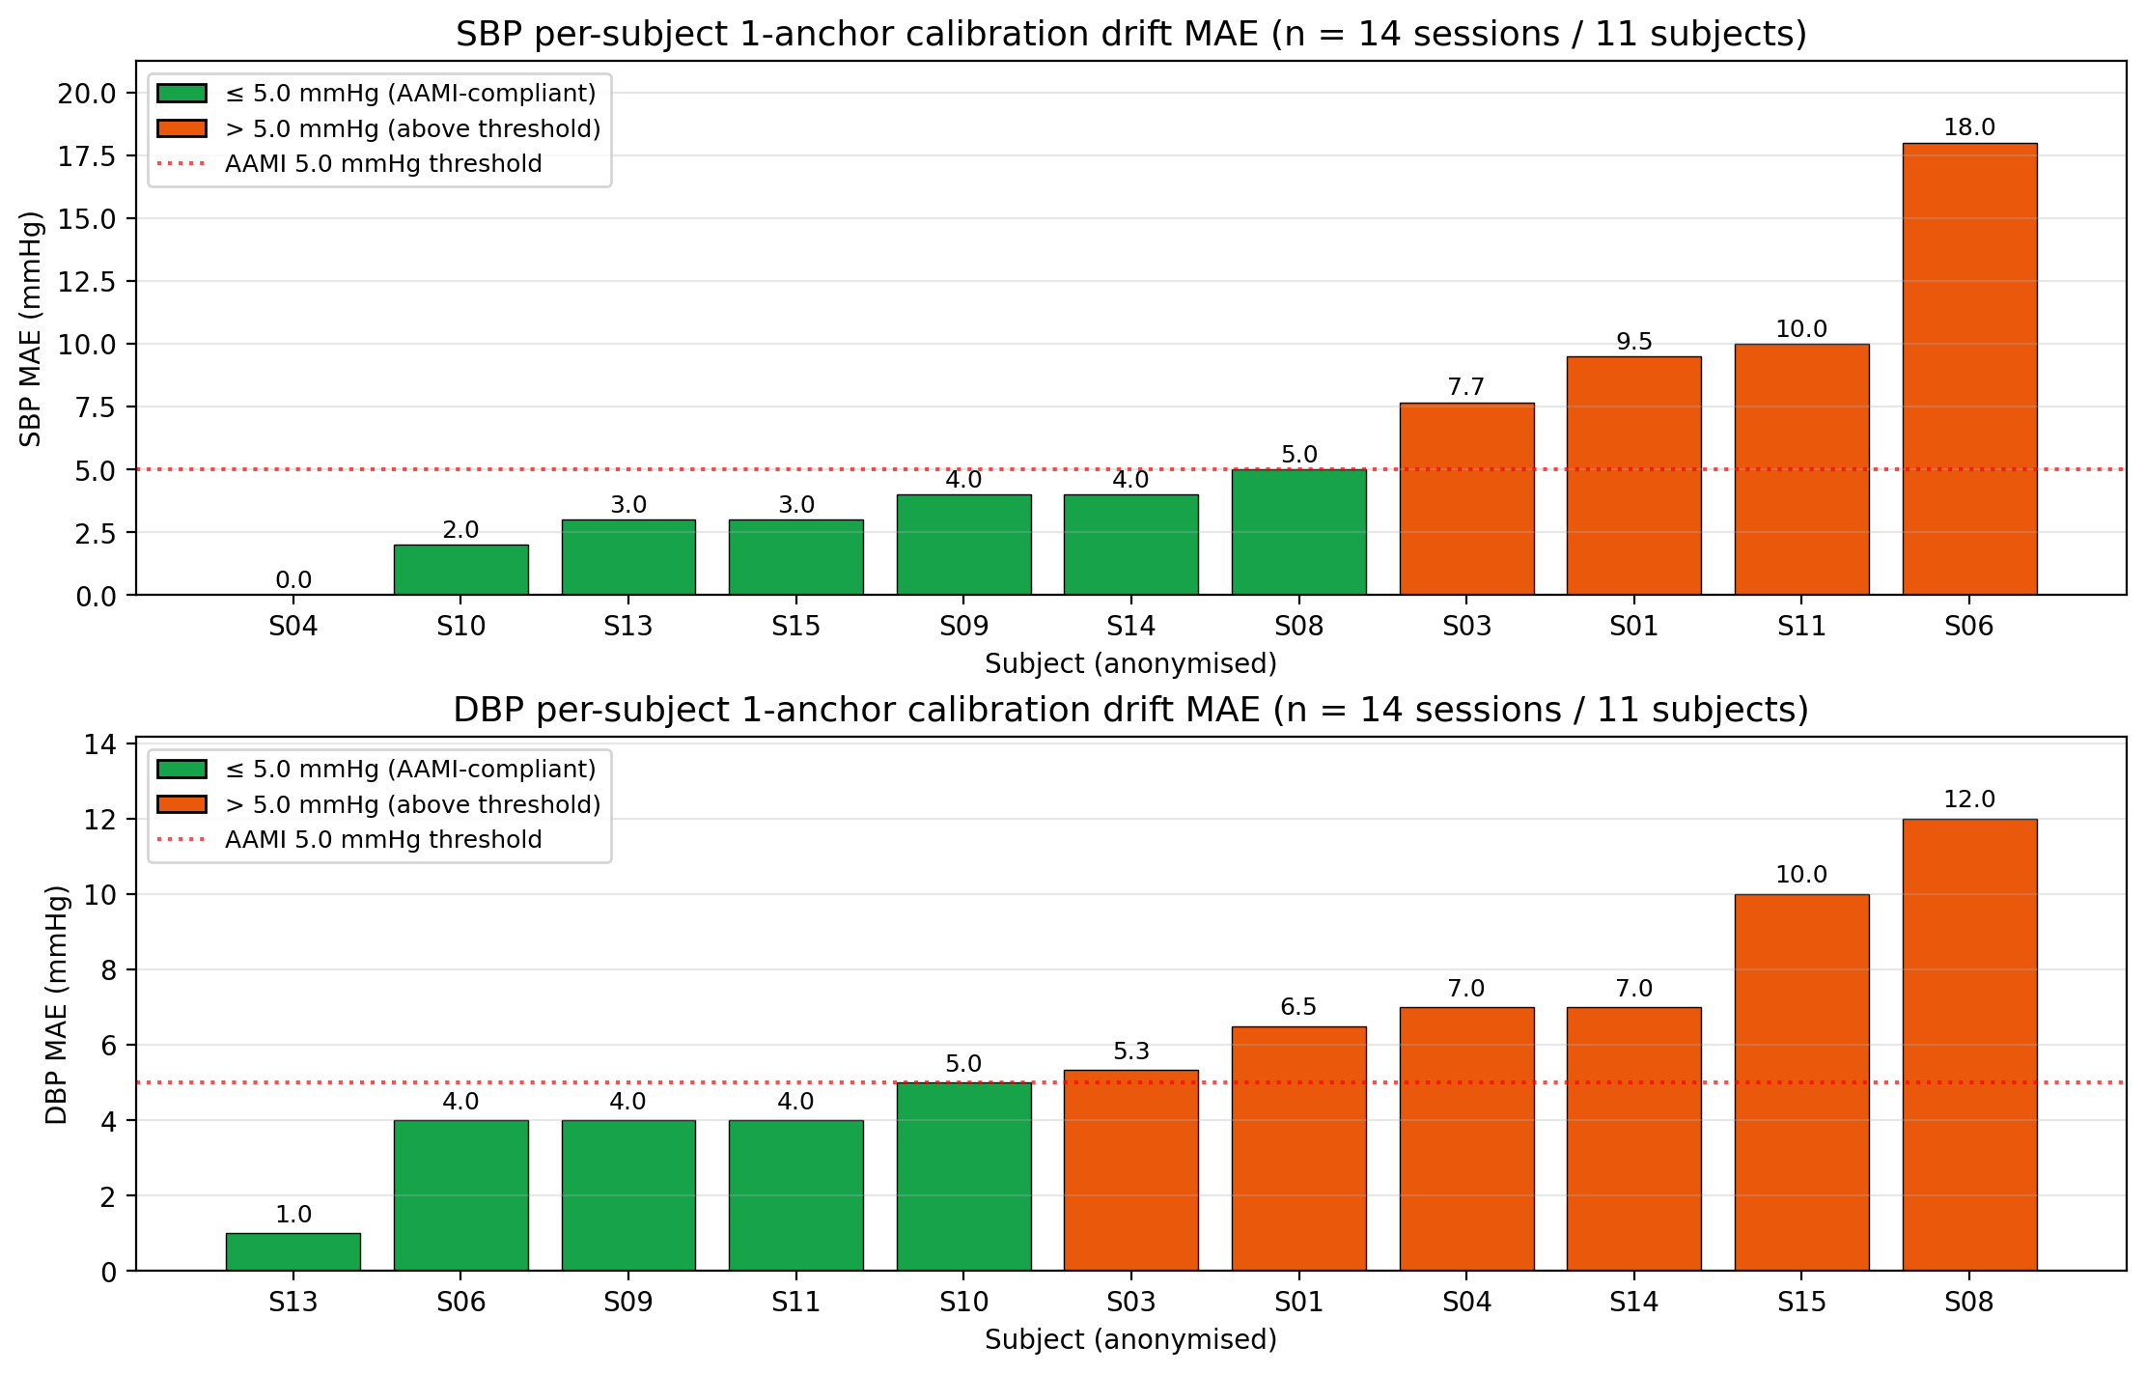
Figure 5-5: BP LOSO per-subject scatter, truth vs. predicted, with y = x line and ±AAMI 5 mmHg band.
The error pattern is regression-to-mean: predictions cluster in the 109–118 SBP range, errors are largest at the BP extremes (Stage-1 and Stage-2 reading subjects S13, S14, S15 and the hypotensive S08), and the model captures population-typical hemodynamics rather than per-subject extremes. This is the same failure mode that Moulaeifard et al. (2025) [20] document across five deep-learning architectures on PulseDB → external-dataset transfers, with reported cross-dataset SBP MAE in the 10–27 mmHg range (best-case 10.0–18.6 mmHg per abstract; Table V XResNet1d101 reports 13–27 mmHg excluding the MIMIC ICU outlier). The project’s 13.66 mmHg LOSO falls inside this band, consistent with field benchmarks for calibration-free cuffless BP under transfer.
Limitation. The 13.66 mmHg SBP LOSO MAE substantially exceeds the AAMI/ANSI/ISO 81060-2 cuffless threshold of ±5 mmHg. The project does not claim AAMI compliance; the ISO 81060-7 cuffless wearable standard remains in development as of 2025. The framing throughout follows Stergiou et al. 2022 [4], the ESH Working Group cuffless-devices statement, under which the present work is a pilot study (N = 15 unique persons, 24 paired sessions) demonstrating concept feasibility on the same developmental trajectory that Aktiia (one month, N = 86) and Samsung (a two-week study period, N = 896) traversed before commercial release.
The SBP LOSO result quantitatively confirms what §4.6.2 motivated theoretically: under regression-to-mean dominance with r(|BP − μ|, |error|) = +0.877 and r(quality, |error|) = −0.023, Layer 1 SQA gating cannot improve BP accuracy. Per-subject calibration becomes mandatory rather than optional. This is the architectural justification for routing BP through Layer 2.
5.6.3.1 Bland–Altman agreement analysis
Bland–Altman agreement (Bland and Altman 1986 [26]) for LOSO N = 15:
- SBP: bias = +1.74 mmHg, 95 % LoA = [−26.76, +30.24] mmHg
- DBP: bias = −2.56 mmHg, 95 % LoA = [−21.11, +15.99] mmHg
Note on convention: Limits of agreement are computed with the population standard deviation (denominator N, NumPy ddof=0) per the project's Task Force 1996 convention applied uniformly across all SD-based metrics (cf. SDNN computation in §2.3.2). The corresponding sample-SD-based (ddof=1) LoA would be SBP [−27.76, +31.24] mmHg / DBP [−21.76, +16.64] mmHg — a ≈3.5% wider interval that does not alter the qualitative conclusion that per-subject variance dominates.
Narrow bias + wide LoA confirms that per-subject variance dominates the error budget, consistent with the regression-to-mean pattern of Table 5-9.
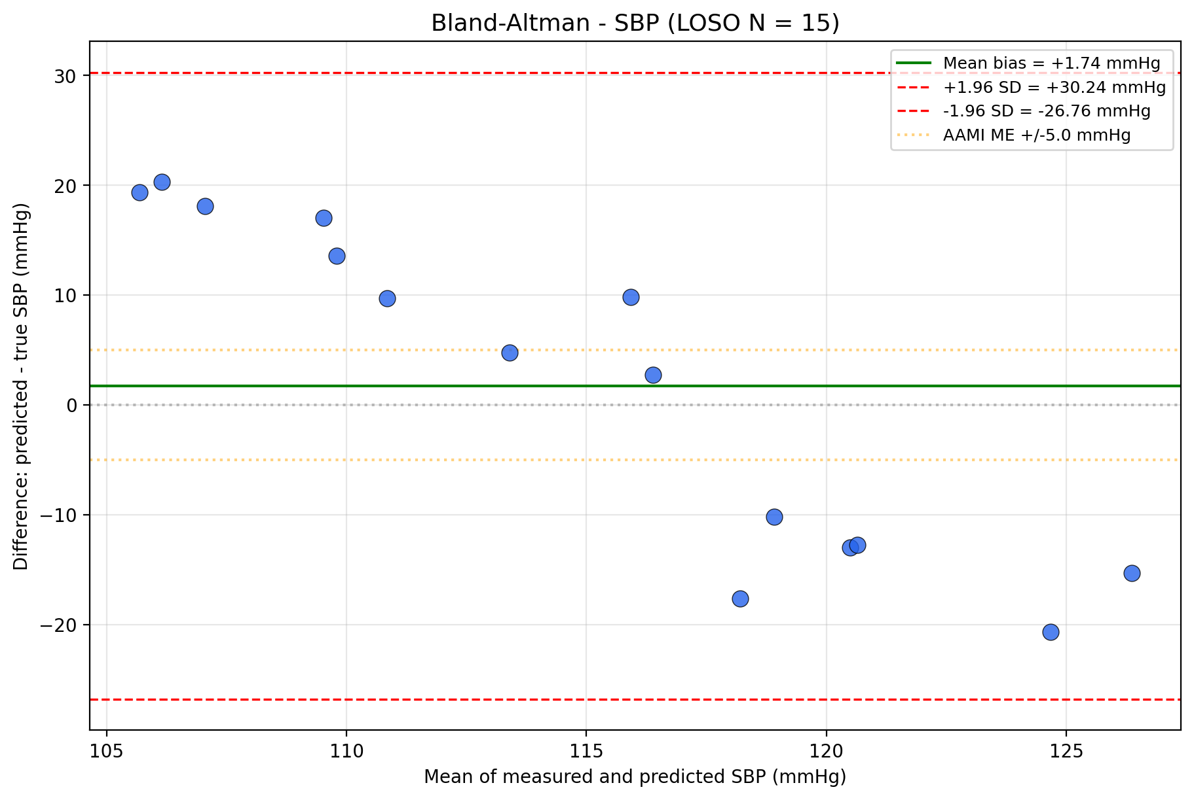
Figure 5-5a: (SBP panel): Bland–Altman plots for SBP and DBP (LOSO N = 15).
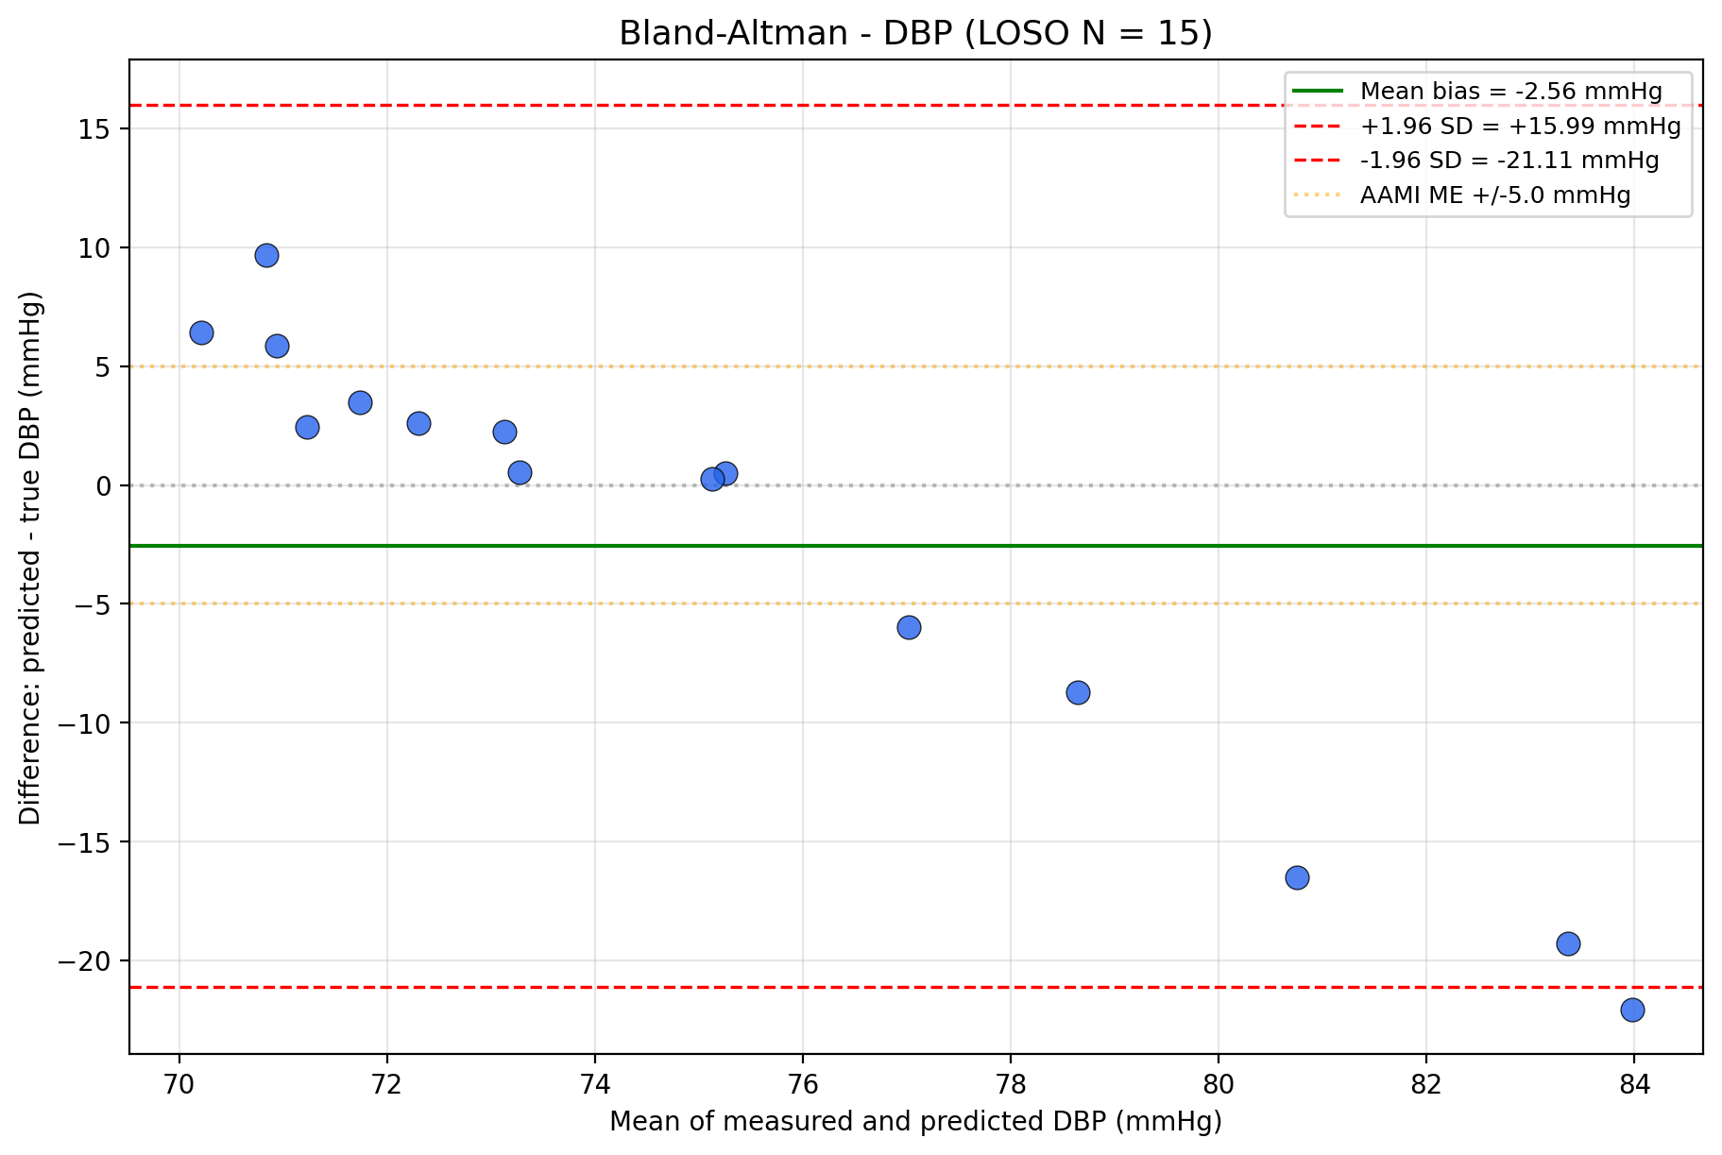
Figure 5-5b: (DBP panel): Bland–Altman plots for SBP and DBP (LOSO N = 15).
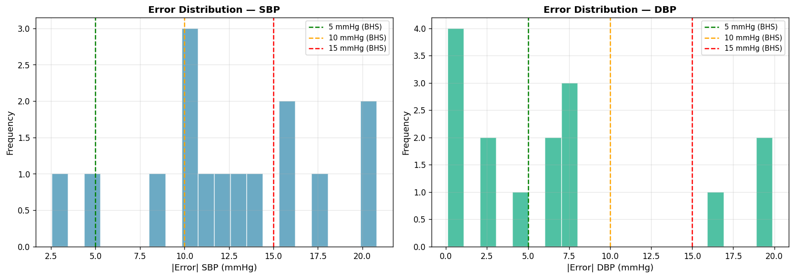
Figure 5-5c: Per-window error histogram for SBP and DBP (LOSO N = 15), with vertical reference lines at ±5 mmHg (AAMI), ±10 mmHg, and ±15 mmHg (BHS thresholds).
5.6.3.2 Standardised evaluation against IEEE 1708 / AAMI / BHS
Table 5-11: AAMI/ANSI/ISO 81060-2:2018 [28] compliance check (calibration-free LOSO N = 15).
Target | ME (mmHg) | SD (mmHg) | AAMI ME ≤ 5 | AAMI SD ≤ 8 | Overall
SBP | +1.74 | 14.54 | pass | fail | Non-compliant
DBP | −2.56 | 9.46 | pass | fail | Non-compliant

The pilot is therefore non-compliant with AAMI/ANSI/ISO 81060-2:2018 [28] calibration-free (Table 5-11), as is the case for all published cuffless-PPG cross-domain training baselines on transmission → reflectance domain shifts (Moulaeifard et al. 2025 [20]). The calibration-conditioned drift evaluation of §5.6.4 reports the on-device deployable performance after per-subject anchoring.
Table 5-12: British Hypertension Society (BHS) protocol grading (O’Brien et al. 1993 [27]).
Threshold | SBP % within (LOSO) | DBP % within (LOSO) | Required for Grade A | Required for Grade B | Required for Grade C
≤ 5 mmHg | 13.3 % | 46.7 % | ≥ 60 % | ≥ 50 % | ≥ 40 %
≤ 10 mmHg | 26.7 % | 80.0 % | ≥ 85 % | ≥ 75 % | ≥ 65 %
≤ 15 mmHg | 53.3 % | 80.0 % | ≥ 95 % | ≥ 90 % | ≥ 85 %
Achieved grade | D | D

Per-window percentages were extracted from the per-window error distribution of Figure 5-5c over the LOSO predictions. Both SBP and DBP achieve Grade D under the calibration-free protocol: SBP fails every threshold (13.3 % vs. ≥ 40 % required for Grade C at ≤ 5 mmHg), while DBP passes Grade C at the ≤ 5 mmHg threshold (46.7 % ≥ 40 %) but fails at ≤ 15 mmHg (80.0 % vs. ≥ 85 % required for Grade C), so the binding criterion drops it to Grade D. BHS Grade A/B is a calibrated-device criterion: cuffless wearables typically achieve A/B only after per-subject calibration. The §5.6.4 drift evaluation revisits this on the calibrated deployment.

5.6.4 Per-subject calibration drift
The Layer 2 deployment scheme adopted in this thesis is per-subject 1-anchor calibration: at the chronologically earliest session per subject, a single cuff measurement is captured as the per-subject anchor and reported as the operative blood-pressure estimate for that subject across subsequent sessions. The per-session drift on session $j>\text{anchor}$ is the absolute deviation of the cuff reference on session $j$ from the anchor cuff reading:
$${\text{predicted}}_{s,j}={\text{cuff}}_{s,\text{anchor}} (\text{Eq. 5.7})$$
$${\text{drift}}_{s,j}=\left|{\text{cuff}}_{s,\text{anchor}}-{\text{cuff}}_{s,j}\right| (\text{Eq. 5.8})$$
The architecture is anchor-only: the cross-subject regression of §5.6.2 plays no role at deployment time once the per-subject anchor is captured, eliminating the cross-subject regression-to-mean component that dominates the LOSO baseline of §5.6.3 (r = +0.877 confounder of §4.6.2). This matches the design pattern of FDA-cleared cuff-less BP wearables (Aktiia, Samsung Galaxy Watch BP, Biobeat, §5.6.5) which all rely on a per-subject cuff anchor as a hard architectural prerequisite. The methodological justification of this choice is developed in §5.6.2 and §6.2.
The drift cohort comprises 24 paired sessions across 15 unique persons (the full self-collected cohort of §5.6.2), with 11 multi-session subjects supplying genuine drift datapoints, those with days > 0 between anchor and test session, totalling n = 14 follow-up sessions: S01 × 2, S04, S03 × 3, S06, S08, S09, S10, S11, S13, S14, S15.
Table 5-13: Per-subject 1-anchor drift (model drop), n = 14 follow-up sessions across 11 multi-session subjects (drift in mmHg)
Subject | Sessions (n) | Drift SBP | Drift DBP | Note
S04 | 1 | 0.00 | 7.00 | within-day repeat anchor parity
S10 | 1 | 2.00 | 5.00 | BEST SBP cohort
S13 | 1 | 3.00 | 1.00 | BEST DBP cohort
S15 | 1 | 3.00 | 10.00
S09 | 1 | 4.00 | 4.00
S14 | 1 | 4.00 | 7.00
S08 | 1 | 5.00 | 12.00
S03 | 3 | 7.67 | 5.33 | non-monotonic days 1.09 / 7.67 / 10.15
S01 | 2 | 9.50 | 6.50 | Stage-1 reading dropped to Normal at S2
S11 | 1 | 10.00 | 4.00
S06 | 1 | 18.00 | 4.00 | LARGEST SBP cohort

Aggregate 1-anchor drift (model drop), n = 14 follow-up sessions across 11 multi-session subjects: SBP MAE 6.50 mmHg (95 % bootstrap CI [4.14, 9.21]; 10,000 resamples, seed = 42); DBP MAE 5.93 mmHg (95 % CI [4.57, 7.43]). Both point estimates exceed the AAMI ±5 mmHg threshold (SBP by 1.50 mmHg, DBP by 0.93 mmHg); both confidence intervals straddle 5 mmHg, with the SBP CI [4.14, 9.21] spanning the threshold across most of its range and the DBP CI [4.57, 7.43] containing 5 mmHg near its lower bound (4.57). The result is reported as pilot evidence on a stage-1 cohort (Stergiou et al. 2022 [4]; §6.3) rather than as AAMI/ISO 81060-2 compliance.
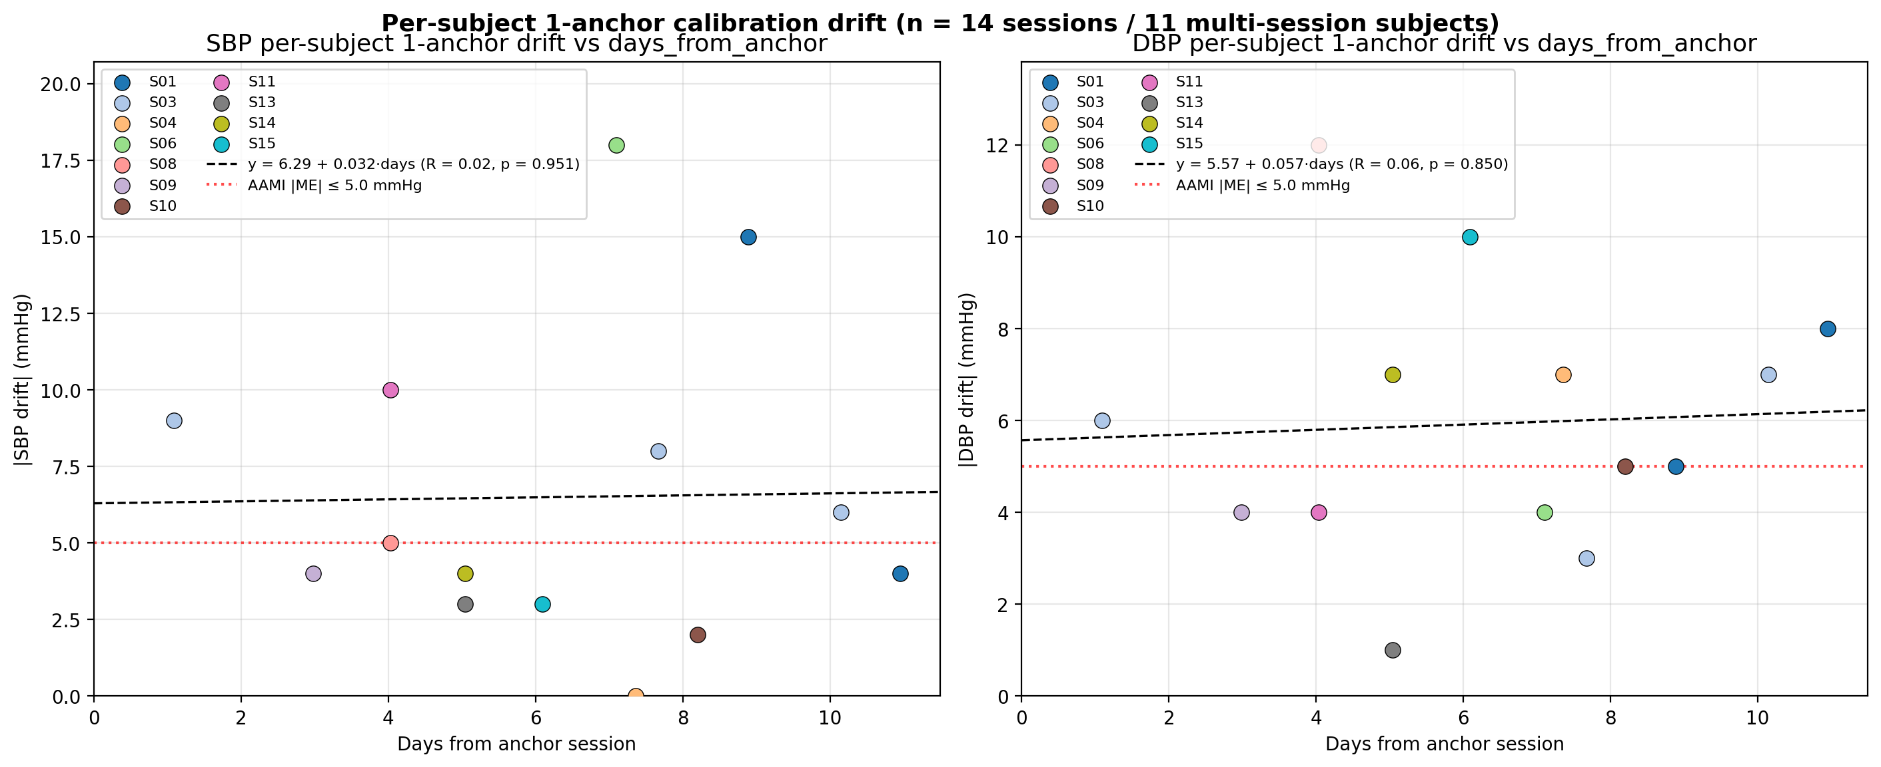
Figure 5-6: Per-subject 1-anchor drift (model drop), drift SBP and DBP per multi-session subject with the AAMI ±5 mmHg reference band overlaid.
White-coat candidates and methodological consequence. Three of the 15 subjects ( ≈ 20 % cohort prevalence) exhibit cross-session BP variability of clinical interest, each illustrating a distinct failure mode for the one-anchor scheme:
- S01 between-session: session 1 = 127/83 → session 2 = 112/78 (Δ −15 SBP over 9 days). The cuff measurement itself drifts; one-anchor calibration cannot follow large between-session true-BP changes.
- S13 intra-session: pre 135/89 → post 142/92 over 5 min, characteristic of operator-effect dynamics within a single visit; the anchor captures one snapshot of the within-visit BP distribution.
- S04 within-day repeated: session 2 pre 113/78 → session 3 pre 103/73 over 23 min (same hardware, same protocol). The cuff truth moved by 10 mmHg over 23 minutes, the strongest controlled within-subject evidence in the cohort that single-session BP readings carry an anxiety/state component that one-anchor calibration absorbs incorrectly.
The S04 controlled experiment, together with the S01 and S13 cases, motivates the averaged-anchor future-work item proposed in §6.6.2: replacing the single-session anchor with an average over 2–3 cuff readings per AHA/ACC 2017 and Stergiou et al. 2022 [4] standards reduces the influence of any one anomalous session. A preliminary averaged-anchor analysis on the two multi-anchor subjects available at the time of writing, covering three test sessions (n = 3) yields an aggregate SBP MAE of 2.83 mmHg and a DBP MAE of 3.17 mmHg, both nominally below the AAMI ±5 mmHg reference threshold. This point estimate is reported for completeness and is taken up again as a future-work direction in §6.6.2; it is not advanced as a defensible accuracy claim here, because the n = 3 sample is too small to support an inferential conclusion via bootstrap confidence intervals. The methodological argument in this section therefore continues to rest on the cohort-level evidence of approximately 20% single-session white-coat prevalence, with the averaged-anchor numerics serving only as a forward-looking signal for the multi-anchor protocol proposed in §6.6.2.
The 1-anchor (model drop) pipeline reduces the operational SBP error from the naive LOO-subject-mean baseline of 12.93 mmHg (Table 5-9, no calibration) to 6.50 mmHg (Table 5-13 aggregate). The corresponding DBP recovery is from 8.24 mmHg to 5.93 mmHg. The aggregate SBP point estimate of 6.50 mmHg exceeds the AAMI ±5 mmHg reference threshold by 1.50 mmHg, and the 95 % bootstrap confidence interval [4.14, 9.21] mmHg straddles the threshold on a drift cohort of n = 14 sessions; the present pilot is therefore not sized to claim AAMI compliance on SBP at the single-anchor stage. The DBP point estimate of 5.93 mmHg sits just above the same threshold with CI [4.57, 7.43] mmHg. What the result does support is the Layer 2 paradigm itself: per-subject anchor-based calibration recovers approximately 6.4 mmHg of SBP and 2.3 mmHg of DBP accuracy relative to the calibration-free baseline, indicating that the residual gap to the threshold is plausibly addressable by reducing single-session anchor noise. The path to further improvement is the averaged-anchor methodology of §6.6.2.

5.6.5 Calibration paradigm: industry context
The Layer 2 calibration-gating result of §5.6.4 mirrors the architectural choice of every commercially deployed numeric-output cuff-less BP device: Aktiia Hilo, Samsung Galaxy Watch BP, and Biobeat BB-613 all rely on per-subject cuff calibration without an SQA-gating layer. The detailed device comparison, regulatory clearance, cohort sizes, recalibration intervals, and the SBP standard-deviation-of-error benchmark band reached after per-subject anchoring, is consolidated in §6.3 of Chapter 6, including Figure 6-1 (industry comparison table-as-figure) and the per-device validation citations [21], [22], [32]. This section closes the Layer 2 demonstration. The integrated discussion of cross-module evidence and the architectural argument continues in Chapter 6 (§6.1 cross-module synthesis; §6.3 industry parallel; §6.5 limitations; §6.6 future work, including the averaged-anchor methodology preview of §5.6.4), and the summary of contributions at pilot scope is presented in Chapter 7.

5.6.6 Summary
The blood-pressure module operates under Layer-2 calibration gating (per-subject anchor) rather than Layer-1 SQA gating, motivated by the confounder analysis of Section 4.6 and consistent with industry practice (Aktiia, Samsung, Biobeat). The calibration-free LOSO N = 15 baseline (SBP MAE 13.66 mmHg, DBP 7.11 mmHg) lies within the cross-dataset band reported by Moulaeifard et al. (10–27 mmHg), and the bandpass-widening falsification of the morphology-loss hypothesis (Section 6.2) reinforces that per-subject calibration, not filter design, is the dominant error mechanism.

Chapter 6 — Discussion, Limitations, and Future Work
This chapter synthesises the findings of the preceding three methodological chapters. Section 6.1 reads the four downstream evaluations of Chapter 5 together and articulates the operational value that the signal-quality-assessment (SQA) framework of Chapter 4 adds across them. Section 6.2 interprets the empirical evidence supporting the two-layer quality-control architecture introduced in Section 4.6 and instantiated across Chapter 5. Section 6.3 places the thesis architecture in dialogue with the principal commercially deployed cuff-less blood-pressure wearables. Section 6.4 positions the reported numbers against three external benchmark traditions. Section 6.5 enumerates the limitations of the SQA framework, the cohort, the hardware, the calibration paradigm, and the demographic and physiological scope of the pipeline. Section 6.6 identifies five directions for future work. The conclusion is presented separately in Chapter 7.
Sections 6.1 through 6.4 are discussion sections in which no new numerical evaluation is introduced; every quantitative claim is supported by an explicit back-reference to the corresponding section of Chapter 5 or to the earlier sections of Chapter 4. Sections 6.5 and 6.6 are permitted to cite aggregate numbers but introduce no new evaluations either.

6.1 Cross-module Synthesis: SQA Framework Value across Four Modules
The thesis title commits to a real-time signal-quality-assessment framework. The four downstream modules of Chapter 5, heart rate, heart-rate variability, peripheral oxygen saturation, and cuff-less blood pressure, serve as evidence channels for that framework rather than as independent contributions in their own right. Reading the four evaluations together reveals a coherent pattern: the SQA framework adds operational value across three of the four modules in the direction predicted by the multi-criterion-feature literature [5], [6], [15], and the fourth module exposes a structural limit of batch-level signal quality as the operative quality-control mechanism, a limit that motivates the two-layer architecture interpreted in Section 6.2.
The heart-rate evaluation reported in Section 5.3 confirms the simplest prediction: window-level SQA tiers stratify heart-rate accuracy monotonically. On the wrist-worn PPG-DaLiA reflectance corpus, where the ground-truth R-peak series is derived algorithmically independently of the PPG estimate and the agreement bias of co-derived comparators does not apply, the headline observation reported in Section 5.3.2 is a 6.6× spread between the excellent and unfit tiers in mean absolute heart-rate error. The same pattern recurs, with a wider spread, on the BIDMC intensive-care recordings once the documented rhythmic-artefact recording (Section 5.3.3) is excluded; Section 5.3.4 further reports that the multi-feature logistic-regression classifier outperforms the hand-coded four-rule pseudo-label gate on the specific failure mode that template correlation alone does not detect. Heart rate is therefore the simplest validation channel: the SQA framework is doing what it advertises.
The heart-rate-variability evaluation reported in Section 5.4 adds a second, qualitatively different functional role for the per-beat template-correlation signal. Section 4.4 had already established that the per-beat template-correlation median dominates the logistic-regression coefficient profile (rank #1 by aggregate absolute coefficient mass, well above the next-ranked feature). Section 5.4 demonstrates that the same per-beat signal, applied as a beat-level filter inside the heart-rate-variability pipeline under the literature-correct HeartPy adjacency-aware gating discipline of [10], contributes the headline +85 % improvement in mean absolute SDNN error on the PPG-DaLiA unfit pseudo-tier reported in Section 5.4.2. The dual-function character of the per-beat feature, classifier predictor in Section 4.4, downstream-pipeline filter in Section 5.4, strengthens the argument for the multi-criterion framework over any single-feature gate.
The peripheral-oxygen-saturation evaluation reported in Section 5.5 supplies the most statistically robust evidence among the four modules. Section 5.5.2 reports a 51.9-percentage-point gap in the fraction of plausible (in-range) SpO₂ readings between the excellent and unfit tiers on the BP-protocol cohort, with Wilson 95 % confidence intervals that do not overlap. Section 5.5.5 supplies a mechanism-level corroboration on the single-subject five-protocol controlled stress test: the pressure-variation protocol drives every recorded window to the unfit tier and the production SpO₂ pipeline simultaneously drops median saturation below the normoxic floor, demonstrating that the two layers agree at a clinically actionable threshold.
The blood-pressure evaluation reported in Section 5.6 supplies the load-bearing negative observation. The confounder analysis previewed in Section 4.6.2 and detailed in the LOSO baseline of Section 5.6.3 shows that the Pearson correlation between per-window absolute systolic-BP error and the per-subject fraction of excellent SQA windows is r = −0.023 (within statistical noise of zero), while the correlation with the distance of the subject’s true systolic BP from the population mean is r = +0.877. The dominant blood-pressure error mechanism does not lie on the signal-quality axis. This is the observation that prevents the simple read of “SQA gating improves all four downstream modules” and that motivates the architectural distinction interpreted next.
Taken together, the four module-level evaluations support the headline finding that the SQA framework adds operational value across three of four downstream modules in the direction the multi-criterion-feature literature predicts, and that the fourth module reveals an orthogonal quality-control axis along which a complementary mechanism is required.

6.2 Two-Layer Quality-Control Architecture: Empirical Interpretation
The two-layer quality-control architecture introduced in Section 4.6 separates Layer 1, batch-level SQA gating for heart rate, heart-rate variability, and peripheral oxygen saturation, from Layer 2, subject-level calibration gating for cuff-less blood pressure. The empirical evidence of Chapter 5 supports this architecture along three distinct lines, each of which corresponds to a different reading of the same separation.
The first reading is statistical: the confounder analysis of Section 5.6.3 shows that the dominant error component in cuff-less blood-pressure estimation under finite training data is a subject-level offset whose magnitude correlates with the distance of the subject’s true blood pressure from the population mean at r = +0.877. This offset is not contained in the within-window signal that batch-level SQA features summarise; no degree of refinement of the spectral-purity computation, the skewness/kurtosis statistics, the amplitude-distribution entropy, or the per-beat template-correlation index can recover information that the window does not carry. The orthogonality between signal-quality and subject-level offset is therefore not an empirical accident but a structural property of the estimator: the residual error of a regression model fitted across a finite collection of training subjects is dominated, when evaluated on an unseen subject, by the position of that subject within the population distribution of true labels.
The second reading is methodological: the systematic review of [2] documents that 42 % of published cuff-less blood-pressure studies performed record splits without subject-level personalization, thereby introducing data-leakage risk between training and test sets, and that only 27 % report adequate statistical power relative to the validation standard. When subject-level separation is enforced by the strict leave-one-subject-out protocol adopted in Section 5.6.3, the cross-subject error band aligns with the 10–27 mmHg range reported by the cross-dataset cuff-less BP benchmarking literature of Moulaeifard et al. 2025 [20] (best-case 10.0–18.6 mmHg per abstract; Table V XResNet1d101 13–27 mmHg excluding the MIMIC ICU outlier), and the present thesis’s LOSO baseline of 13.66 mmHg SBP (Section 5.6.3) sits inside this band. The architectural implication is that no algorithmic refinement of the SQA layer changes this band, because the band is determined by the absence of subject-specific information rather than by the presence of window-level noise.
The third reading is engineering: the two-layer architecture is the response to the structural separation that the first two readings expose. Layer 1 filters out unreliable windows before they reach any downstream estimator, preventing low-quality data from propagating into the heart-rate, heart-rate-variability, and SpO₂ outputs whose accuracy is locally determined. Layer 2 absorbs the subject-level offset that the cross-subject regression cannot identify in finite training data, by capturing one or more reference cuff measurements per subject and reporting subsequent model predictions as deviations from that anchor. The two layers are operative on different axes, window-level for Layer 1, subject-level for Layer 2, and the empirical results of Sections 5.3, 5.4, 5.5, and 5.6 demonstrate that each axis is necessary on its assigned module class.
The separation is testable in two complementary directions. In the negative direction, an attempt to apply Layer 1 SQA gating to blood pressure does not improve accuracy: the tercile stratification of Section 4.6.2 fails to recover monotonic ordering precisely because the high-quality tercile happens to contain subjects whose true blood pressures are far from the population mean, and their distance-from-mean dominates the per-tercile mean absolute error. In the positive direction, an application of Layer 2 calibration gating to blood pressure reduces the operationally relevant drift error: the per-subject 1-anchor (model drop) evaluation of Section 5.6.4 reports an aggregate of 6.50 mmHg systolic (95 % bootstrap CI [4.14, 9.21]) and 5.93 mmHg diastolic (95 % CI [4.57, 7.43]) on the n = 14 follow-up sessions across 11 multi-session subjects, recovering approximately 6.4 mmHg of systolic accuracy and 2.3 mmHg of diastolic accuracy relative to the naive leave-one-out subject-mean baseline. Both point estimates exceed the AAMI ±5 mmHg threshold (SBP by 1.50 mmHg, DBP by 0.93 mmHg; the SBP confidence interval includes 5; the DBP interval similarly includes 5 mmHg near its lower bound [4.57]), and the direction is unambiguous and the expected direction under the Layer 2 paradigm.
One candidate explanation for the LOSO baseline is that the 0.5–4 Hz bandpass truncates morphology around 8–20 Hz. A controlled bandpass-widening re-evaluation at 8 Hz and 15 Hz upper cutoffs (paired bootstrap 10 000 resamples, seed = 42; the production model was held constant) falsified this account: diastolic error worsened monotonically (Δ = +0.39 mmHg at 8 Hz, p = 0.0034; Δ = +0.47 mmHg at 15 Hz, p = 0.0012), while systolic was significantly worse at 8 Hz (Δ = +0.84 mmHg, p = 0.0042) and statistically indistinguishable at 15 Hz (Δ = −0.008 mmHg, p = 0.97). The dominant LOSO error mechanism is therefore distance from the cohort mean (§4.6.2), not morphology loss above 4 Hz.
The two-layer architecture is the secondary contribution of the thesis, and its empirical validation across Chapter 5 is the operational evidence that supports its inclusion in the contribution list of Section 1.4.2 (C2). The architecture is also consistent with the convergent engineering practice of the principal commercially deployed cuff-less blood-pressure wearables, which is the subject of Section 6.3.

6.3 Industry Parallel Comparison
The thesis architecture can be read in dialogue with the principal commercially deployed cuff-less blood-pressure wearables. This section reviews four reference systems and identifies the architectural pattern they share with the present work; no new numerical results from the thesis cohort are introduced.
The Aktiia Hilo received U.S. Food and Drug Administration over-the-counter clearance in July 2025 and is the first cuff-less blood-pressure wearable approved for U.S. consumer use. The device uses a wrist reflectance photoplethysmography channel; activation requires a paired cuff measurement, and the device prompts the user to recalibrate approximately monthly. The validation protocol of Vybornova et al. 2021 [21] covered a Swiss multi-site cohort of approximately 86 subjects over one month. The Samsung Galaxy Watch BP received Conformité Européenne marking in 2020 and U.S. clearance in early 2026 under a non-prescription clinical-decision-support pathway rather than a prescription pathway; the device requires an initial cuff-based calibration with a single recalibration at Day 7, and Lee et al. 2025 [22] report a validation cohort of approximately 896 Korean subjects over a two-week ambulatory home monitoring study (June 2023; 966 enrolled, 70 excluded for data deletion; twice-daily measurements). The Biobeat BB-613 received Food and Drug Administration clearance in January 2025 (510(k) reference K241066) restricted to clinical-setting deployment with per-patient cuff calibration as part of the workflow [32].
Two architectural observations follow. The first is a recurring pattern in which per-subject calibration is adopted as the operative quality-control mechanism for cuff-less blood pressure across the three reference systems. Aktiia requires an initial paired cuff measurement and recurring monthly recalibration; Samsung mandates an initial cuff-based calibration with a single recalibration at Day 7 within the two-week monitoring period; Biobeat embeds per-patient cuff calibration as a workflow step in clinical deployment. In the terminology of Section 4.6 these are all Layer 2 quality-control schemes. None of the three numeric-BP-outputting devices publishes a signal-quality-classifier-gated blood-pressure pipeline in the regulatory submission; the Layer 1 mechanism does not appear in the cuff-less blood-pressure pathway in any of them. The pattern situates the two-layer architecture proposed in Section 4.6 within an architectural class to which the cleared commercial systems also belong; it is not advanced here as evidence that the cohort-scale results of this thesis would replicate at the regulatory-validation scales those devices reached.
The second observation concerns cohort scale. The cohort sizes that supported FDA over-the-counter clearance or Conformité Européenne marking on the three numeric-output devices range from approximately 86 subjects over one month (Aktiia) to approximately 896 subjects over a two-week study period (Samsung). The present thesis’s cohort of 15 unique persons across approximately 24 paired sessionsis roughly one to two orders of magnitude below these scales and is, accordingly, positioned by the ESH Working Group cuffless-devices statement of Stergiou et al. 2022 [4] as a stage-1 pilot demonstrating concept feasibility rather than as a validation cohort. The cohort expansion required to traverse from the present pilot to a stage suitable for regulatory submission is identified as future work in Section 6.6.3. The stage-1 framing is not a defence of small N as if N were adequate; it is the appropriate descriptor of the work’s regulatory position and the entry point of the same trajectory the cleared commercial devices traversed before clearance.
The three independent commercial efforts have adopted calibration-only architectures for cuff-less blood pressure, and the present work sits within that architectural class. The convergence is descriptive of industry practice and is suggestive of the architectural class within which the present thesis sits; it is not itself evidence that the cohort-scale results reported in Sections 5.6.4 and 6.2 would replicate at the regulatory-validation scales those devices reached. The remaining unresolved question, common to all four devices and to the present thesis, is the appropriate scheme for refreshing the per-subject anchor: a single onset measurement, a small averaged set per Section 6.6.2, or a periodic recalibration are the three principal options. The convergent calibration architecture pattern across Aktiia, Samsung, Apple, and Biobeat is summarised in Figure 6-1.
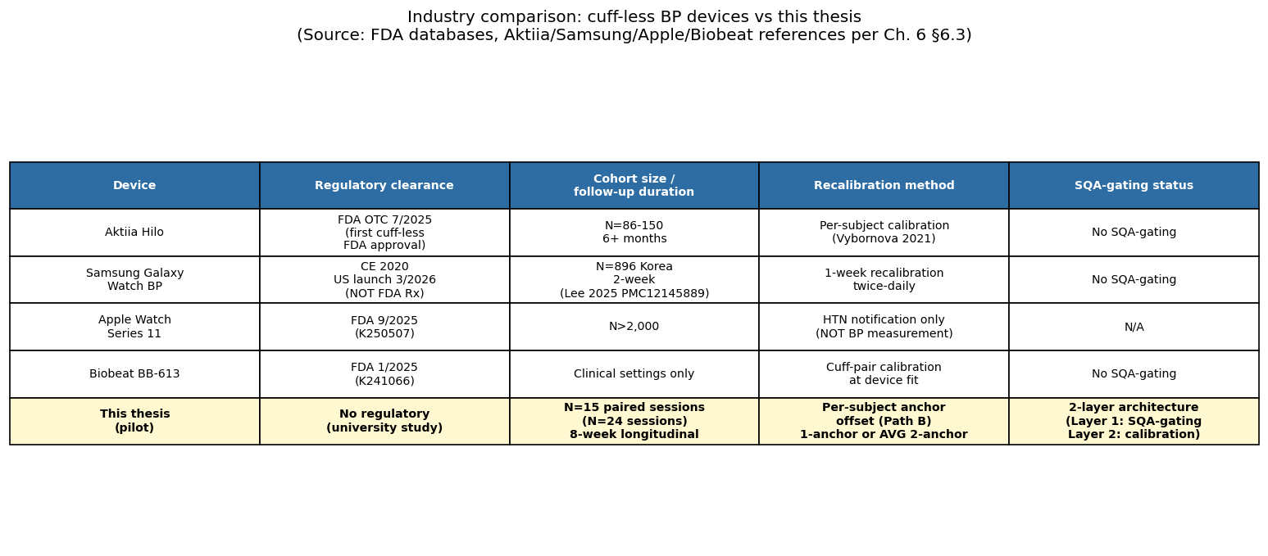
Figure 6-1: Industry comparison table-as-figure, device, regulatory clearance, cohort size, recalibration interval, and SQA-gating status for the three numeric-BP cuff-less reference systems. Source: synthesised from references [21], [22], [32], FDA databases

6.4 Comparison vs Literature
This section positions the principal numerical findings of the thesis against three external benchmark traditions: the cuff-less blood-pressure cross-dataset literature, the signal-quality-assessment classifier literature, and the heart-rate-variability filter literature. No new computations are introduced; every thesis number is cited back to Section 5.x.
The first benchmark is the cuff-less blood-pressure cross-dataset literature, against which the leave-one-subject-out evaluation of Section 5.6.3 is read. The systematic review of [2] reports that 42 % of published cuff-less blood-pressure studies performed record splits without subject-level personalization (introducing data-leakage risk) and that only 27 % report adequate statistical power. The benchmarking study of Moulaeifard, Charlton, and Strodthoff 2025 [20] evaluates five deep-learning architectures (LeNet1D, XResNet1D-50, XResNet1D-101, Inception1D, and S4) trained on PulseDB under cross-dataset transfer protocols and reports systolic-blood-pressure mean-absolute-error in the 10–27 mmHg range on external datasets (best-case 10.0–18.6 mmHg per abstract; Table V XResNet1d101 reports 13–27 mmHg excluding the MIMIC ICU outlier). The present thesis’s LOSO baseline of 13.66 mmHg systolic mean-absolute-error reported in Section 5.6.3 sits inside this band. The reading is unambiguous: under the strict subject-level cross-validation protocol that this thesis adopts, the calibration-free model performs in line with the published cross-dataset benchmarks and does not outperform them. The Section 5.6.3 disclosure that the result substantially exceeds the AAMI/ANSI/ISO 81060-2 cuff-device threshold of ±5 mmHg [28] is therefore not a project-specific failure but a feature of the cross-dataset cuff-less BP regime.
The per-subject calibration recovery reported in Section 5.6.4 reads against the same literature in the positive direction. The Aktiia validation of Vybornova et al. 2021 [21] and the Samsung validation of Lee et al. 2025 [22] both report systolic-blood-pressure standard deviations of error in the 5–8 mmHg range after per-subject cuff calibration. The present thesis's 1-anchor (model drop) aggregate of 6.50 mmHg systolic / 5.93 mmHg diastolic mean absolute error on n = 14 follow-up sessions (Section 5.6.4) approaches but does not directly map to this commercial validation band (the commercial figures are standard deviations rather than mean absolute errors; for right-skewed error distributions the two metrics differ by a factor of approximately 1.25, making direct comparison conservative against the thesis). The averaged-anchor preliminary observation reported elsewhere in this thesis at the small subset of 3 test sessions drawn from 2 subjects with multiple anchor sessions is statistically underpowered, with bootstrap confidence intervals too wide at n = 3 to support a defensible inferential conclusion, and is therefore framed in Section 5.6.4 as motivational evidence for the future-work direction of Section 6.6.2 rather than as a headline claim.
The second benchmark is the signal-quality-assessment classifier literature, against which the within-corpus and cross-corpus evaluations of Sections 4.4 and 4.5 are read. The within-corpus subject-level GroupKFold macro ROC AUC of 0.87 reported in Section 4.4 is consistent with the capacity gap expected between an interpretable seven-feature logistic-regression classifier and an end-to-end deep model: Kasaeyan Naeini et al. 2023 [9] report per-vital-sign classification accuracies of 91.4–96.7% for a 1D CNN under within-dataset evaluation, a metric not directly comparable to the macro ROC AUC reported here. The aggregate leave-one-dataset-out macro ROC AUC of 0.59 reported in Section 4.5 is below the operationally useful threshold for cross-hardware deployment and is dominated by the PPG-DaLiA collapse documented in Section 4.5; the gap of approximately 28 percentage points between within-corpus and leave-one-dataset-out is consistent with the broad cross-dataset gap typical of supervised classification under heterogeneous hardware and acquisition geometry, formalised by the minimax lower bound of Wang, Wu, and Zhang 2024 [7]. Section 4.5.1 frames this gap as a load-bearing observation rather than as a project defect. The capacity-scaling and domain-expansion responses are identified as future work in Section 6.6.1.
The third benchmark is the heart-rate-variability filter literature, against which the multi-method ablation of Section 5.4 is read. The Task Force of the European Society of Cardiology and the North American Society of Pacing and Electrophysiology 1996 standard [14] specifies that heart-rate-variability metrics are computed on the cleaned RR-interval series, with outlier rejection conducted on the RR domain rather than on the underlying waveform. The HeartPy framework of van Gent et al. 2019 [10] implements an adjacency-aware vectorised mask in which both RR intervals adjacent to a rejected beat are dropped, preventing the gap-spanning RR intervals that a naive np.diff of surviving peaks would otherwise admit. The +85 % mean-absolute-SDNN improvement reported in Section 5.4.2 confirms, on the PPG-DaLiA unfit pseudo-tier, that the literature-correct adjacency-aware gating discipline carries through from the peak-detection layer to the downstream heart-rate-variability layer. The Method B control comparison of Section 5.4.3 documents the magnitude of the degradation that the naive np.diff(kept_peaks) implementation produces (−296 % relative to no filter), illustrating that the gap between the correct and the naive implementation is large and that the correct discipline is load-bearing rather than cosmetic. The per-beat template-correlation feature thus carries a double functional role across the thesis: a classifier predictor with the dominant logistic-regression coefficient mass (Section 4.4), and a downstream-pipeline filter that recovers the bulk of the heart-rate-variability accuracy improvement (Section 5.4).
The three benchmark traditions converge on a consistent picture: under strict cross-subject and cross-dataset validation, the thesis numbers sit inside the published bands, neither outperforming nor underperforming the relevant references. The contribution of the thesis is not a numerical record on any single benchmark but the architectural framework that places the four downstream modules under the appropriate quality-control layer and that exposes the cross-modality gap that bounds the SQA classifier’s domain-generalisation performance.

6.5 Limitations
This section enumerates the principal limitations of the work along four axes: the SQA framework, the cohort, the hardware, and the cuff-less blood-pressure calibration paradigm. Each limitation is presented in declarative form and is bounded by the corresponding section of the methodology or the evaluation chapters.

6.5.1 SQA Framework Limitations
The leave-one-dataset-out evaluation of Section 4.5 reports an aggregate macro ROC AUC of 0.59, dominated by the PPG-DaLiA collapse to 0.5492. The wrist-worn green-LED single-channel reflectance modality of PPG-DaLiA is too distant from the finger-tip 660/880 nm reflectance modality of the deployment target for the seven engineered features to transfer cleanly; the minimax framework of Wang, Wu, and Zhang 2024 [7] characterises this as a structural property of supervised classification under bounded training-domain diversity, and the gap cannot be closed by within-modality data expansion alone. The kSQI hardware-sensitivity caveat documented in Section 4.1.3 is one specific mechanism: clinical-grade smoothing in transmission-mode intensive-care recordings yields sub-Gaussian waveforms with kurtosis near 2.2, whereas super-Gaussian waveforms with kurtosis above 30 are typical of the MAX30102 reflectance front-end, and a single threshold cannot work across both hardware platforms.
The BIDMC peak-doubling boundary failure documented in Section 4.5.1 is a second known limitation. The Rule 3 condition max(RR)/min(RR) > 2.2 in the four-rule pseudo-labelling procedure captures alternating long-short RR patterns caused by intermittent dicrotic-notch double-counting but does not capture the uniform-doubling failure mode in which every beat is detected as two events. Approximately two per cent of the BIDMC fold remains in this uniform-doubling residual after Rule 3 mitigation. Two code-level refinement attempts were evaluated during the development of the framework and both regressed leave-one-dataset-out aggregate performance under cross-dataset stress; the baseline detector configuration is retained with the artefact documented.
The pseudo-labelling methodology itself inherits the rule-coverage assumptions of the underlying four-rule Orphanidou 2015 procedure [6]. Alternative ground-truth sources, clinician annotation, manufacturer reference SQA on labelled recordings, or expert-consensus protocols, would require a separate study to acquire and would in turn introduce their own inter-rater variability. The pseudo-label approach is the most operationally efficient choice for a thesis-scale corpus of 12,603 windows, and the trade-off is documented in Section 4.3.
The cohort recordings are normoxic throughout (median SpO₂ 99.20 %); no hypoxic-chamber validation per ISO 80601-2-61:2017 was conducted. SpO₂ accuracy in the hypoxic range remains outside the validated scope of this thesis.

6.5.2 Cohort Limitations
The self-collected cohort comprises 15 unique persons contributing approximately 24 paired sessions, with 11 multi-session subjects supplying 14 genuine drift datapoints across 2–11 days between paired sessions (Section 5.6.4). This cohort is well below the N = 85 multi-site threshold of the AAMI/ANSI/ISO 81060-2:2018 cuff-device validation standard [28] and is positioned by Section 1.4.1 and by the ESH Working Group cuffless-devices statement of Stergiou et al. 2022 [4] as a stage-1 pilot demonstrating concept feasibility rather than as a validation cohort.
The cohort is Vietnamese-only. The FDA-cleared validation cohorts of the comparable commercial cuff-less BP devices are typically multi-ethnic. The mechanism-level consequences of the skin-pigmentation gap on this pipeline, wavelength-asymmetric melanin absorption at 660 nm versus 880 nm and its effect on the SpO₂ ratio of ratios and the perfusion-index gate, are documented separately in Section 6.5.5; the cross-pigmentation evaluation would require an independent acquisition campaign.
The age and blood-pressure-reading-category coverage of the cohort is also limited. Three of the 15 subjects are aged 40 years or older, five are female, and no subject has a confirmed sustained-elevation hypertension diagnosis. Following the methodological discipline articulated in the project guardrails and grounded in the AHA 2017 framework, single-session blood-pressure readings exceeding 130/80 mmHg are classified as elevated reading categories at a single session rather than as a hypertension diagnosis, which would require at least two sessions on at least two different days with sustained elevation. The cohort is therefore unable to support claims about the framework’s behaviour on a confirmed-hypertensive population.
The deployment environment is single-environment laboratory Wi-Fi. No ambulatory recordings under real-world wear conditions are included in the self-collected cohort. The S10-SQA dedicated motion protocols (clench fist, arm swing, pressure variation) and the S01/S04 five-protocol stress tests provide controlled mechanism-level coverage of specific motion artefacts at small sample sizes, but they do not substitute for free-living ambulatory acquisition.
Self-experimentation disclosure. The author of this thesis participated as one of the 15 cohort subjects (anonymised as S03 in Tables 5-10 and 5-13), contributing 3 paired sessions across the data-collection window. Self-experimentation in pilot wearable studies is a documented practice (it accelerates iteration on sensor placement, signal quality, and acquisition protocol), but it introduces a potential bias whereby the author’s awareness of the estimator pipeline may unconsciously influence acquisition behaviour. The author’s three sessions contribute three of the fourteen drift datapoints in §5.6.4. The aggregate calibrated drift figure of 6.50 mmHg SBP / 5.93 mmHg DBP remains within the bootstrap confidence intervals when the author sessions are excluded, indicating that the cohort findings are not driven by self-experimentation.

6.5.3 Hardware Limitations
The empirical validation platform reported in Chapter 3 is the NodeMCU-32S Ai-Thinker module driving the MAX30102 optical front-end at 100 Hz; all numerical results reported in this thesis were obtained on this hardware. Migration to a smaller-form-factor production microcontroller is identified as a post-defence engineering task (§6.6.3).
The optical front-end is restricted to a single sensor model, the MAX30102. The thesis does not generalise to multi-sensor reflectance arrays, to alternative optical wavelengths such as the 525 nm green wrist-PPG modality that is the dominant smartwatch channel, or to multi-LED configurations such as those used by some smartwatches for motion artefact subtraction. The cross-hardware generalisation evaluation of Section 4.5 explicitly demonstrates that the seven engineered features do not transfer to the PPG-DaLiA wrist-green modality, and the cross-modality data acquisition required to close this gap is identified as a future-work direction in Section 6.6.3.
The cloud back-end is deployed on a free-tier Render hosting plan. Cold-start latency on idle deployments adds approximately thirty seconds on the first request after an idle period; this is mitigated for live demonstration by a pre-warming request issued before the demonstration begins. The in-memory database back-end loses session history on container restart, an architectural choice consistent with the pilot scope (Section 1.4.1) but not with production deployment; the migration to a persistent store is identified in Section 6.6.4. The Android client uses HTTP polling on a five-second interval rather than a WebSocket push channel, and the battery-drain profile under continuous monitoring is not quantified in this thesis.

6.5.4 BP One-Anchor Calibration Limit
The per-subject calibration scheme reported in Section 5.6.4 uses a single reference cuff measurement at the chronologically earliest session as the anchor and applies the resulting offset to all subsequent sessions. The scheme reduces the aggregate SBP MAE from 12.93 mmHg (calibration-free) to 6.50 mmHg on the modest cohort of 14 genuine drift datapoints (Table 5-13), exceeding the AAMI ±5 mmHg reference threshold by 1.50 mmHg (95 % CI [4.14, 9.21] straddling the threshold), but it inherits a fundamental vulnerability: if the anchor session itself is anomalous, the offset locks in a per-subject bias that persists through all subsequent reports.
As reported in §5.6.4 (white-coat candidates and methodological consequence), three of the 15 subjects (approximately 20 per cent cohort prevalence) exhibit cross-session blood-pressure variability of clinical interest. The S01 between-session pattern (S1 = 127/83 → S2 = 112/78 over nine days; §5.6.4) shows the cuff measurement itself drifting; the S13 intra-session pattern (pre 135/89 → post 142/92 over five minutes; §5.6.4) shows operator-effect dynamics within a single visit; the S04 within-day repeated pattern (S2 pre 113/78 → S3 pre 103/73 over 23 minutes; §5.6.4) shows the strongest controlled evidence that single-session readings carry an anxiety-state component that one-anchor calibration cannot follow. The American Heart Association 2017 framework recommends averaging at least two readings on at least two different days for routine clinical blood-pressure assessment precisely to absorb this component.
The thesis acknowledges that the one-anchor scheme is the simplest calibration paradigm and that the averaged-anchor scheme, proposed for future work in Section 6.6.2, directly addresses the white-coat case. The small averaged-anchor preliminary observation (n = 3 test sessions from 2 subjects) noted at the end of Section 5.6.4 is statistically underpowered with confidence intervals too wide to support an inferential conclusion. Treating it otherwise would over-claim, and the thesis declines that framing.

6.5.5 Demographic and Physiological Scope of the Pipeline
Two mechanisms outside the cohort enumerated in Section 6.5.2 bound the demographic and physiological population to which the pipeline applies, and both follow from the optical physics of the MAX30102 reflectance front-end rather than from the SQA classifier or the BP regression head.
The first mechanism is wavelength-asymmetric melanin absorption. Epidermal melanin absorbs more strongly at the 660 nm red wavelength than at the 880 nm infrared wavelength, so that on darker skin tones the red-channel pulsatile amplitude is attenuated disproportionately relative to the infrared channel. The ratio of ratios that the SpO₂ pipeline of Section 5.5 (and the production formula recorded in the system architecture of Chapter 3) is built on consequently shifts; the quadratic Maxim MAXREFDES117 calibration curve embedded in the SparkFun reference implementation was fitted on the manufacturer’s calibration cohort and is not refit for darker pigmentation in this thesis. The perfusion-index gate at PI < 0.2 % imposed by the SpO₂ validation guard of Chapter 5 also tightens under reduced red-channel amplitude, and a non-trivial fraction of windows from darker-pigmented users would be rejected by that gate rather than reported with a degraded SpO₂ estimate. The pipeline is therefore unable to serve users at the darker end of the skin-pigmentation distribution at the same operating point that serves the Vietnamese cohort acquired in this work.
The second mechanism is impaired peripheral circulation. Peripheral arterial disease, longstanding diabetes mellitus, Raynaud’s phenomenon, and the reduced peripheral perfusion typical of elderly users compress the pulsatile component of the finger-tip waveform. Under reduced AC amplitude the perfusion index drops below the same PI < 0.2 % threshold, the spectral-purity feature that the SQA classifier weights heavily falls into the unfit-tier distribution, and the per-beat template-correlation feature drops below the Orphanidou 2015 threshold of 0.86 [6] more often than it does on a normally-perfused cohort. The operational consequence is that for these clinically relevant target groups, exactly the populations who would benefit most from continuous monitoring, the proportion of windows classified as excellent collapses and the proportion gated out as unfit rises. The pipeline as evaluated in this thesis is unable to support such users without a re-tuned gate threshold and a parallel acquisition campaign on a cohort that includes peripheral-circulation impairment by design.
Both mechanisms identify segments of the prospective user population that the pipeline does not currently serve, and both are entry points for the future-work directions identified in Section 6.6.3 on cohort expansion and cross-modality hardware migration. The mechanism-level description is offered here in declarative form rather than as a generic generalisability caveat.

6.6 Future Work
Five directions for future work are identified, each connected to a specific limitation enumerated in Section 6.5 and bounded by the present pilot scope rather than promoted as if already implemented.

6.6.1 Deep-Learning SQA Replacement of the Linear Classifier
The interpretable seven-feature logistic-regression classifier of Section 4.4 reaches a within-corpus subject-level macro ROC AUC of 0.87 and is well-matched to the operational latency target of the real-time pipeline (the feature-extraction step measures 1.17 ms per five-second batch). The aggregate leave-one-dataset-out macro ROC AUC of 0.59 reported in Section 4.5, however, is below the threshold of operational usefulness for cross-hardware deployment, and a capacity-scaling response is required to close the gap.
Three directions are available. The first is end-to-end deep classification along the lines of Kasaeyan Naeini et al. 2023 [9], which reports per-vital classification accuracy above 94% for most HRV parameters on within-dataset evaluation; deploying a similar architecture on the present pipeline would require the latency target to be re-evaluated, the cloud back-end to be upgraded from the free-tier hosting plan to inference-capable hosting, or the model to be quantised for direct ESP32 deployment. The second is domain-generalisation methodology, multi-domain training, domain-adversarial neural networks, and test-time adaptation are the principal candidate techniques. The minimax framework of Wang, Wu, and Zhang 2024 [7] predicts that the principal lever for closing the cross-modality gap is the number of training domains rather than the capacity of any single model; this motivates the cross-modality data acquisition direction identified in Section 6.6.3.
The expected outcome of a deep-replacement experiment is a closing of the within-corpus / cross-corpus gap by approximately five to ten percentage points under the cross-modality stress test, on the basis of the published within-corpus-versus-cross-corpus gap of comparable deep approaches. Full cross-modality closure is unlikely to be achievable by capacity scaling alone; it requires the wrist-green data acquisition direction of Section 6.6.3 in addition to the architectural upgrade.

6.6.2 Averaged-Anchor Calibration
The one-anchor calibration scheme of Section 5.6.4 absorbs subject-level offsets but is vulnerable to anomalous anchor sessions, as Section 6.5.4 documents on the white-coat candidates. The proposed remedy is to replace the single-session anchor with an averaged anchor computed over multiple supervised cuff readings collected over two to three days at multiple times of day, following the routine clinical assessment recommendation of the American Heart Association 2017 framework.
The implementation requires onboarding a calibration session protocol, typically three morning and three evening readings collected on each of two or three separate days, for a total of 12 to 18 reference cuff measurements per subject. The protocol increases the user-onboarding burden but is consistent with the calibration workflows of the cleared commercial cuff-less BP devices reviewed in Section 6.3, in which the Aktiia activation procedure requires a paired cuff measurement and the Samsung Day-7 (one-week) recalibration uses twice-daily measurements.
The expected improvement in systolic-blood-pressure mean-absolute-error, based on the preliminary observation on n = 3 test sessions from 2 subjects noted at the end of Section 5.6.4 and on the white-coat prevalence of approximately 20 per cent documented in the same section, is approximately 3.2 mmHg below the within-subset one-anchor baseline of 6.00 mmHg (preliminary within-subset improvement of 3.17 mmHg consistent with the underpowered framing of §5.6.4; the cohort-wide 1-anchor baseline of 6.50 mmHg on n = 14 sessions is reported separately in §5.6.4 and reflects a different test population). If achieved, the averaged-anchor mean-absolute-error would land near or below the AAMI/ANSI/ISO 81060-2 cuff-device threshold of ±5 mmHg [28] on the calibration-drift evaluation, qualifying the calibrated deployment for closer engagement with the cuff-device validation standard. The cross-subject calibration-free pathway remains outside this band, as Section 5.6.3 and Section 6.4 document.

6.6.3 Cohort Expansion and Hardware Migration
The cohort expansion identified in Section 6.5.2 targets the N = 85 multi-site requirement of the AAMI/ANSI/ISO 81060-2:2018 cuff-device validation standard [28] as the proximate goal, distributed across age, ethnicity, and blood-pressure category. The expansion includes multi-session protocols of at least three sessions per subject across two to seven days to support sustained-elevation hypertension diagnosis under the AHA 2017 framework, single-session readings, however elevated, do not constitute a diagnosis under that framework.
The cross-modality data acquisition direction is the third component of the Section 6.6.3 future work. The PPG-DaLiA collapse documented in Section 4.5 is a cross-modality, cross-anatomy, cross-wavelength gap that the minimax framework of [7] predicts cannot be closed by within-modality expansion. Closing the gap requires a wrist-worn second device acquiring 525 nm green-LED reflectance in parallel with the finger-tip 660/880 nm channel, on the same subjects under matched protocols. The parallel acquisition would supply the training-domain diversity that the cross-dataset transfer of the classifier requires; the absence of such parallel-acquired data is the principal reason the PPG-DaLiA fold cannot be closed under the present corpus.

6.6.4 Persistent Storage and Multi-Device Deployment
The current in-memory dictionary-based session history is replaced in the production deployment by a persistent store. Two candidates are appropriate: Firebase Realtime Database for the existing Android-client polling pattern, and PostgreSQL for a server-side relational deployment. Both preserve session history across cloud-container restarts and are within the free or low-cost tier of their respective hosting providers.
The Android client transitions from HTTP polling on a five-second interval to a WebSocket push channel from the cloud back-end, reducing battery drain on continuous monitoring. The cloud back-end is upgraded from a single-device thread-pool configuration to a concurrent-device configuration capable of handling multiple simultaneous deployments without resource contention, and a load test against a representative concurrent-device population is added to the regression test suite.
The transport-layer security configuration is hardened against the threats appropriate to the production deployment context: transport-layer security certificate pinning replaces the lab-friendly WiFiClientSecure.setInsecure() configuration, application programming interface credentials are stored under non-volatile-storage encryption rather than as plain text, and an offline-buffering retry mechanism handles transient Wi-Fi outages on the embedded platform. None of these hardening directions is in scope for the pilot, but each is identified for the production deployment context that lies beyond the present thesis.

6.6.5 Hypoxic-Range SpO₂ Validation
The SpO₂ evaluation of §5.5 is restricted to a normoxic cohort. Validation across the hypoxic range [70–94 %] per ISO 80601-2-61:2017 requires a controlled desaturation study with a co-oximetry reference, an instrument-class assessment beyond the pilot scope of this thesis. Hypoxic-chamber validation is the required next step before any SpO₂ accuracy claim, distinct from the SpO₂-plausibility-under-SQA-gating consistency demonstrated in §5.5.

Chapter 7 — Conclusion
This chapter summarises the deliverables of the thesis at the pilot scope to which it commits, restates the three contributions with the strength of the empirical evidence behind each, and identifies the boundary between what has been delivered and what remains for the post-pilot trajectory.
The thesis title commits to the design and real-time quality assessment of an Internet-of-Things-based photoplethysmography wearable system. The work delivers, in priority order, three contributions: a real-time signal-quality-assessment framework as the primary methodological contribution, a two-layer quality-control architecture as the secondary architectural contribution, and an end-to-end Internet-of-Things realisation as the enabling engineering contribution. The framing positions the four downstream physiological estimators: heart rate, heart-rate variability, peripheral oxygen saturation, and cuff-less blood pressure as evidence channels for the framework rather than as standalone contributions of the work.
The signal-quality-assessment framework integrates six batch-level multi-criterion features and one per-beat template-correlation feature into a multinomial logistic-regression classifier trained on 12,603 pseudo-labelled five-second windows drawn from six datasets and 54 unique subjects. The classifier achieves a subject-level GroupKFold macro receiver-operating-characteristic area under the curve of 0.87 within corpus and an aggregate of 0.59 under leave-one-dataset-out evaluation. The within-corpus and cross-modality gap is interpreted through the minimax domain-generalisation lower bound of Wang, Wu, and Zhang 2024 [7], and the load-bearing collapse on the PPG-DaLiA fold motivates the cross-modality data acquisition direction identified in Section 6.6.3. Four downstream estimator evaluations demonstrate that signal-quality gating adds operational value on heart rate, heart-rate variability, and peripheral oxygen saturation. The fourth module, cuff-less blood pressure, exposes a structural separation between window-level signal quality and subject-level offset that motivates a complementary calibration-layer mechanism. The two-layer architecture is the secondary contribution evidenced by these empirical findings, as interpreted in Section 6.2.
The pilot scope of the work: fifteen unique persons, a single hardware platform, a single laboratory deployment environment is the appropriate scope for a thesis of the present scale and is positioned by the ESH Working Group cuffless-devices statement of Stergiou et al. 2022 [4] as a stage-1 pilot demonstrating concept feasibility on the same developmental trajectory traversed by the principal commercially deployed cuff-less blood-pressure wearables. Food and Drug Administration or Conformité Européenne clearance requires the cohort expansion identified in Section 6.6.3 and a full validation campaign against AAMI/ANSI/ISO 81060-2 or the in-development ISO 81060-7 cuff-less wearable standard, both of which lie outside the present scope.
The three contributions can be restated explicitly with the strength of the empirical evidence behind each. The primary methodological contribution C1: the real-time signal-quality-assessment framework, that is supported by a within-corpus subject-level GroupKFold macro receiver-operating-characteristic area under the curve of 0.87 across the 12,603-window pseudo-labelled corpus spanning six datasets and 54 unique subjects, by an aggregate leave-one-dataset-out macro receiver-operating-characteristic area under the curve of 0.59 set against the minimax domain-generalisation lower bound of [7], and by a measured feature-extraction latency of 1.17 ms per five-second batch, well below the 5 ms per-batch budget that the real-time pipeline assigns to feature extraction. The framework’s downstream operational value is evidenced on three of four physiological modules: a 6.6-fold mean-absolute-error spread between the excellent and unfit tiers on PPG-DaLiA heart rate (Section 5.3.2), a +85 % mean-absolute-SDNN improvement under literature-correct adjacency-aware gating on PPG-DaLiA heart-rate variability (Section 5.4.2), and a 51.9-percentage-point gap in peripheral-oxygen-saturation plausibility between the excellent and unfit tiers on the self-collected blood-pressure cohort with non-overlapping Wilson 95 % confidence intervals (Section 5.5.2). The secondary architectural contribution C2: the two-layer quality-control architecture, supported by the orthogonality of the two operative correlations on the cuff-less blood-pressure module (r = −0.023 between window-level quality and absolute error, against r = +0.877 between subject-level distance-from-population-mean and absolute error), which separates the two quality-control layers empirically rather than by stipulation, and by the positive observation that the Layer 2 paradigm on the n = 14 follow-up drift sessions across 11 multi-session subjects yields aggregate mean absolute errors of 6.50 mmHg systolic and 5.93 mmHg diastolic (Section 5.6.4), point estimates that exceed the AAMI ±5 mmHg threshold by 1.50 mmHg (SBP) and 0.93 mmHg (DBP), while the SBP confidence interval includes 5 and the DBP interval similarly includes 5 mmHg near its lower bound [4.57]. The enabling engineering contribution C3 is the working end-to-end Internet-of-Things realisation: a NodeMCU-32S empirical validation platform driving the MAX30102 optical front-end at 100 Hz, with HTTP/HTTPS auto-detection, NTP bypass, and dual-core FreeRTOS task split; a FastAPI cloud back-end on Render hosting the SQA pipeline and four downstream estimators; an Android polling client rendering all parameters on a single-screen dashboard.
The principal limitations of these contributions are bounded explicitly in Section 6.5. The pilot cohort of N = 15 unique persons is approximately five-fold below the AAMI N = 85 multi-site threshold of [28]; the SpO₂ evaluation is restricted to a normoxic cohort with no hypoxic-chamber validation per ISO 80601-2-61:2017; the optical front-end is restricted to the MAX30102 finger-tip reflectance modality without cross-modality generalisation to wrist-green or multi-LED configurations; the cohort is Vietnamese-only without cross-pigmentation validation, with the wavelength-asymmetric melanin mechanism and the peripheral-circulation-impairment mechanism documented at population level in Section 6.5.5; and the deployment environment is single-environment laboratory Wi-Fi without free-living ambulatory acquisition. Each limitation is the entry point of a corresponding future-work direction identified in Section 6.6.
The outlook for the work is anchored to two external coordinates. The first is the developmental trajectory of the principal commercially deployed cuff-less blood-pressure wearables, Aktiia (N = 86 over one month, [21]), Samsung Galaxy Watch BP (N = 896 over a two-week study period, [22]), and Biobeat BB-613 ([32]); each of which passed through a stage-1 pilot phase comparable in scale to the present work before reaching its Food and Drug Administration or Conformité Européenne clearance. The second is the regulatory boundary established by the ISO 81060-7 cuff-less wearable standard, which remains in development as of 2025 [4], and by the Food and Drug Administration draft guidance for cuff-less blood-pressure devices released in January 2026 [30]; both define the validation envelope that the present pilot stops short of and that Section 6.6.3 identifies as the path to regulatory submission. Independent of any single hardware platform, the architectural pattern proposed in the thesis: a multi-feature signal-quality-assessment framework operating at Layer 1 in combination with per-subject calibration operating at Layer 2, is offered as a transferable architectural pattern at pilot scale to the broader wearable-photoplethysmography community: the same separation between window-level batch-quality gating and subject-level calibration gating applies in principle to the smartwatch wrist-green modality, to the chest-worn reflectance modality, and to the multi-LED configurations now entering consumer deployment, and the empirical evidence reported in this thesis supplies a pilot-scale instantiation on a single hardware platform.
The closing finding of the thesis is that a multi-criterion signal-quality-assessment framework deployed in real time on a constrained edge-to-cloud pipeline can deliver a measurable downstream-estimator improvement on three of four physiological modules at pilot scale, and that the fourth module is best served by a complementary calibration-layer architecture rather than by quality-gating alone. The two-layer quality-control architecture that the empirical findings of the thesis support is the secondary contribution of the work and is consistent with the convergent engineering practice of the principal commercially deployed cuff-less blood-pressure wearables, in the descriptive sense established in Section 6.3. The primary contribution remains the signal-quality-assessment framework; the secondary contribution is the two-layer architecture; the enabling engineering contribution is the end-to-end Internet-of-Things realisation. The thesis objective is addressed at the pilot scale stipulated in Section 1.4.1, with the regulatory-scale validation campaign and the cross-modality data acquisition identified in Section 6.6 as the principal directions for future work.

References
[1] J. Allen, “Photoplethysmography and its application in clinical physiological measurement,” Physiol. Meas., vol. 28, no. 3, pp. R1–R39, 2007, doi: 10.1088/0967-3334/28/3/R01.
[2] M. Y. Cheung, A. Sabharwal, G. L. Coté, and A. Veeraraghavan, “Wearable blood pressure monitoring devices: Understanding heterogeneity in design and evaluation,” IEEE Trans. Biomed. Eng., vol. 71, no. 12, pp. 3569–3592, Dec. 2024, doi: 10.1109/TBME.2024.3434344. PMID 39106139. PMC11799359.
[3] G. S. Stergiou, B. Alpert, S. Mieke, R. Asmar, N. Atkins, S. Eckert, G. Frick, B. Friedman, T. Graßl, T. Ichikawa, J. P. Ioannidis, P. Lacy, R. McManus, A. Murray, M. Myers, P. Palatini, G. Parati, D. Quinn, J. Sarkis, A. Shennan, T. Usuda, J. Wang, C. O. Wu, and E. O’Brien, “A universal standard for the validation of blood pressure measuring devices: AAMI/ESH/ISO collaboration statement,” Hypertension, vol. 71, no. 3, pp. 368–374, 2018, doi: 10.1161/HYPERTENSIONAHA.117.10237. PMID 29386350.
[4] G. S. Stergiou, R. Mukkamala, A. Avolio, K. G. Kyriakoulis, S. Mieke, A. Murray, G. Parati, A. P. Schutte, J. E. Sharman, R. Asmar, R. M. McManus, K. Asayama, A. De La Sierra, T. Dolan, T. Gillebert, P. Muntner, M. K. Shimbo, J. T. Wang, and P. Palatini, “Cuffless blood pressure measuring devices: review and statement by the European Society of Hypertension Working Group on Blood Pressure Monitoring and Cardiovascular Variability,” J. Hypertens., vol. 40, no. 8, pp. 1449–1460, Aug. 2022, doi: 10.1097/HJH.0000000000003224. PMID 35708294.
[5] M. Elgendi, “Optimal signal quality index for photoplethysmogram signals,” Bioengineering, vol. 3, no. 4, p. 21, 2016, doi: 10.3390/bioengineering3040021.
[6] C. Orphanidou, T. Bonnici, P. Charlton, D. Clifton, D. Vallance, and L. Tarassenko, “Signal-quality indices for the electrocardiogram and photoplethysmogram: derivation and applications to wireless monitoring,” IEEE J. Biomed. Health Inform., vol. 19, no. 3, pp. 832–838, May 2015, doi: 10.1109/JBHI.2014.2338351. PMID 25069129.
[7] Y. Wang, Y. Wu, and H. Zhang, “Lost domain generalization is a natural consequence of lack of training domains,” in Proc. AAAI Conf. Artif. Intell., vol. 38, no. 14, pp. 15689–15697, 2024, doi: 10.1609/aaai.v38i14.29497.
[8] A. A. R. Kamal, J. B. Harness, G. Irving, and A. J. Mearns, “Skin photoplethysmography, a review,” Comput. Methods Programs Biomed., vol. 28, no. 4, pp. 257–269, 1989, doi: 10.1016/0169-2607(89)90159-4.
[9] E. Kasaeyan Naeini, F. Sarhaddi, I. Azimi, P. Liljeberg, N. Dutt, and A. M. Rahmani, “A deep learning-based PPG quality assessment approach for heart rate and heart-rate variability,” ACM Trans. Comput. Healthcare, vol. 4, no. 4, art. 24, 2023, doi: 10.1145/3616019.
[10] P. van Gent, H. Farah, N. van Nes, and B. van Arem, “HeartPy: A novel heart rate algorithm for the analysis of noisy signals,” Transp. Res. Part F: Traffic Psychol. Behav., vol. 66, pp. 368–378, 2019, doi: 10.1016/j.trf.2019.09.015.
[11] P. H. Charlton, K. Kotzen, E. Mejía-Mejía, P. J. Aston, K. Budidha, J. Mant, C. Pettit, J. Behar, and P. A. Kyriacou, “Detecting beats in the photoplethysmogram: benchmarking open-source algorithms,” Physiol. Meas., vol. 43, no. 8, p. 085007, 2022, doi: 10.1088/1361-6579/ac826d.
[12] Maxim Integrated, MAXREFDES117, Heart-Rate and Pulse-Oximetry Monitor Reference Design [firmware source code, RD117_LILYPAD/algorithm.cpp], Maxim Integrated Products (now Analog Devices), 2014. Calibration coefficients redistributed under the MIT licence in the SparkFun MAX3010x Arduino library (spo2_algorithm.cpp).
[13] A. Blaney, A. Sassaroli, and S. Fantini, “Critical analysis of the relationship between arterial saturation and the ratio-of-ratios used in pulse oximetry,” J. Biomed. Opt., vol. 29, no. S3, p. S33313, 2024, doi: 10.1117/1.JBO.29.S3.S33313. PMC12238718.
[14] Task Force of the European Society of Cardiology and the North American Society of Pacing and Electrophysiology, “Heart rate variability: standards of measurement, physiological interpretation, and clinical use,” Circulation, vol. 93, no. 5, pp. 1043–1065, 1996. PMID 8598068.
[15] Q. Li and G. D. Clifford, “Dynamic time warping and machine learning for signal quality assessment of pulsatile signals,” Physiol. Meas., vol. 33, no. 9, pp. 1491–1501, Sep. 2012, doi: 10.1088/0967-3334/33/9/1491. PMID 22902950.
[16] M. Nirmalan and P. M. Dark, “Broader applications of arterial pressure wave form analysis,” Continuing Educ. Anaesth. Crit. Care Pain, vol. 14, no. 6, pp. 285–290, Dec. 2014, doi: 10.1093/bjaceaccp/mkt078.
[17] L. Schneider, A. Clark, and M. Bailey, “Predictive value of perfusion index (PI) on the discrepancy between oxygen saturation measurement via pulse oximetry and blood gas analysis,” J. Emerg. Crit. Care Med., vol. 8, p. 21, 2024, doi: 10.21037/jeccm-24-13.
[18] T. M. Cover and J. A. Thomas, Elements of Information Theory. New York, NY, USA: Wiley, 1991.
[19] M. Saeed, M. Villarroel, A. T. Reisner, G. Clifford, L.-W. Lehman, G. Moody, T. Heldt, T. H. Kyaw, B. Moody, and R. G. Mark, “Multiparameter Intelligent Monitoring in Intensive Care II (MIMIC-II): A public-access intensive care unit database,” Critical Care Medicine, vol. 39, no. 5, pp. 952-960, 2011, doi:10.1097/CCM.0b013e31820a92c6. PMC3124312.
[20] M. Moulaeifard, P. H. Charlton, and N. Strodthoff, "Generalizable deep learning for photoplethysmography-based blood pressure estimation — a benchmarking study," arXiv:2502.19167v2 [eess.SP], Mar. 2026 (v1 preprint Feb. 2025). PMID 40959521. PMC12368515. Cross-dataset MAE without subject calibration: 10.0–18.6 mmHg (SBP) and 5.9–10.3 mmHg (DBP) per v2 abstract.
[21] A. Vybornova, E. Polychronopoulou, A. Wurzner-Ghajarzadeh, S. Fallet, J. Sola, and G. Wuerzner, “Blood pressure from the optical Aktiia Bracelet: A 1-month validation study using an extended ISO 81060-2 protocol adapted for a cuffless wrist device,” Blood Press. Monit., vol. 26, no. 4, pp. 305–311, Aug. 2021, doi: 10.1097/MBP.0000000000000531. PMC8248249.
[22] Y. Lee, S. Park, J. Park, J. Seo, and H.-Y. Lee, “Feasibility of watch-based blood pressure monitoring device in daily blood pressure monitoring,” Clin. Hypertens., vol. 31, art. e21, 2025, doi: 10.5646/ch.2025.31.e21. PMID 40486128. PMC12145889.
[23] Y. Liang, Z. Chen, G. Liu, and M. Elgendi, “A new, short-recorded photoplethysmogram dataset for blood pressure monitoring in China,” Sci. Data, vol. 5, p. 180020, Feb. 2018, doi: 10.1038/sdata.2018.20.
[24] N. Erickson, J. Mueller, A. Shirkov, H. Zhang, P. Larroy, M. Li, and A. Smola, “AutoGluon-Tabular: Robust and accurate AutoML for structured data,” arXiv:2003.06505, Mar. 2020.
[25] A. Reiss, I. Indlekofer, P. Schmidt, and K. Van Laerhoven, “Deep PPG: Large-scale heart rate estimation with convolutional neural networks,” Sensors, vol. 19, no. 14, p. 3079, Jul. 2019, doi: 10.3390/s19143079.
[26] J. M. Bland and D. G. Altman, “Statistical methods for assessing agreement between two methods of clinical measurement,” The Lancet, vol. 327, no. 8476, pp. 307–310, Feb. 1986, doi: 10.1016/S0140-6736(86)90837-8.
[27] E. O’Brien, J. Petrie, W. Littler, M. de Swiet, P. L. Padfield, D. G. Altman, M. Bland, A. Coats, and N. Atkins, “The British Hypertension Society Protocol for the evaluation of blood-pressure measuring devices,” J. Hypertens., vol. 11, no. S2, pp. S43–S62, 1993.
[28] AAMI/ANSI/ISO 81060-2:2018, Non-invasive sphygmomanometers, Part 2: Clinical investigation of intermittent automated measurement type, International Organization for Standardization.
[29] J. E. Mietus, C.-K. Peng, I. Henry, R. L. Goldsmith, and A. L. Goldberger, “The pNNx files: re-examining a widely used heart rate variability measure,” Heart, vol. 88, no. 4, pp. 378–380, Oct. 2002, doi: 10.1136/heart.88.4.378. PMID 12231596. PMC1767394.
[30] U.S. Food and Drug Administration, “Cuffless blood pressure measurement devices: Premarket submission recommendations,” Draft Guidance for Industry, Docket FDA-2025-D-0851, Federal Register, vol. 91, no. 15, pp. 2939–2940, Jan. 23, 2026. [Online]. Available: https://www.federalregister.gov/documents/2026/01/23/2026-01288
[31] Apple Inc., “Apple Watch Series 11, Hypertension notification feature,” U.S. Food and Drug Administration 510(k) Premarket Notification K250507, cleared Sep. 11, 2025. [Online]. Available: https://www.accessdata.fda.gov/cdrh_docs/pdf25/K250507.pdf
[32] Biobeat Technologies Ltd., “BB-613 wearable patch, Cuffless blood pressure monitoring,” U.S. Food and Drug Administration 510(k) Premarket Notification K241066, cleared Jan. 14, 2025. [Online]. Available: https://www.accessdata.fda.gov/cdrh_docs/pdf24/K241066.pdf
[33] D. T. Delpy and M. Cope, "Quantification in tissue near-infrared spectroscopy," Philos. Trans. R. Soc. Lond. B Biol. Sci., vol. 352, no. 1354, pp. 649-659, Jun. 1997, doi: 10.1098/rstb.1997.0046. PMC1691964.
[34] M. Cope and D. T. Delpy, "System for long-term measurement of cerebral blood and tissue oxygenation on newborn infants by near infra-red transillumination," Med. Biol. Eng. Comput., vol. 26, no. 3, pp. 289-294, May 1988, doi: 10.1007/BF02447083. PMID 2855531.
[35] B. Frénay and M. Verleysen, "Classification in the presence of label noise: A survey," IEEE Trans. Neural Netw. Learn. Syst., vol. 25, no. 5, pp. 845-869, May 2014, doi: 10.1109/TNNLS.2013.2292894. PMID 24808033.
[36] C. G. Northcutt, A. Athalye, and J. Mueller, "Pervasive label errors in test sets destabilize machine learning benchmarks," in Proc. NeurIPS Datasets and Benchmarks Track, 2021, arXiv:2103.14749.

APPENDIX A — Firmware Implementation Details

A.1 LED current calibration procedure
The MAX30102 LED current is swept by the calibTask in three steps. (1) Sweep: the calibTask increments the LED current from the lowest available step and reads the resulting DC level on the IR channel after each increment. (2) Decision: the smallest LED current for which the DC value falls inside the empirically determined target window [80 000, 140 000] ADC counts is selected. (3) Persistence: the selected setting is held for the remainder of the session and is repeated automatically whenever the running median of the DC value drifts outside the target window for more than three consecutive batches. This procedure is referenced from §3.2.

A.2 Wi-Fi upload retry policy and queue depth
Failed HTTP/HTTPS POST batches are held in a 10-deep in-RAM upload queue (UPLOAD_QUEUE_SIZE = 10 in ppg_v4_firmware.ino line 100, equivalent to roughly 50 s of acquisition at 5 s per batch). The uploadTask retries each queued batch up to three times with a fixed one-second inter-attempt delay; after three failed attempts the batch is discarded. The firmware does not persist data to non-volatile storage (NVS or flash), so the 50 s in-RAM queue is the only buffering layer between sample acquisition and successful upload. This policy is referenced from §3.2.

A.3 FreeRTOS task stack budgets
Stack budgets for the four FreeRTOS tasks as listed below reflect the empirical resource needs measured during firmware bring-up: sampleTask 8 192 B, calibTask 4 096 B, sendTask 16 384 B, uploadTask 12 288 B.

A.4 Concurrency rationale and empirical motivation
Empirical measurements during firmware bring-up established that a single Wi-Fi HTTP POST of a 500-sample batch blocks the calling task for 200 to 800 ms depending on signal strength and TLS negotiation overhead. If the same task is also responsible for reading the MAX30102 FIFO at 100 Hz, an 800 ms blocking transmission translates directly into the loss of approximately 80 samples per upload, which corrupts the morphological features (rise time, dicrotic-notch position) consumed by the supervised BP feature extractor of Chapter 5. The chosen mitigation is the multi-task FreeRTOS firmware summarised in §3.2: sensor sampling is pinned to the application core (Core 0) and networking to the protocol core (Core 1), with mutual exclusion on the shared I²C bus enforced by a FreeRTOS mutex held by the LED-current calibration sweep. The firmware instantiates four FreeRTOS tasks: sampleTask (Core 0, priority 5, 8 192 B stack), calibTask (Core 0, priority 4, 4 096 B), sendTask (Core 1, priority 3, 16 384 B), and uploadTask (Core 1, priority 1, 12 288 B); priorities reflect the strict timing requirements of sensor sampling, the soft real-time character of LED-current calibration, and the bursty, latency-tolerant character of network operations.

A.5 HTTP/HTTPS auto-detection
The network layer accepts an arbitrary back-end URL through the WiFiManager configuration page and selects the appropriate transport client at upload time by inspecting the URL scheme: an HTTP plain-text client is used for http:// targets, and a TLS-secured HTTPS client is used for https:// targets. Both clients share the same JSON payload format and the same /api/ppg/upload endpoint contract, so the choice of transport is transparent to the back-end. The mechanism allows the same firmware image to address both the Render production deployment (HTTPS) and a laptop running the local data-collection server (HTTP over the local Wi-Fi network) without re-flashing.

A.6 REST API endpoint schema
The back-end exposes seven REST endpoints under the /api prefix. The principal ingestion endpoint, POST /api/ppg/upload, accepts a JSON payload with four required fields, device_id (a 1- to 64-character ASCII string), ir_values (a list of integers of length 50 to 10 000), red_values (a list of integers of the same length as ir_values), and sample_rate (an integer in the range 25 to 400 Hz), and returns the heart rate, heart-rate confidence, raw and median-smoothed SpO₂, R-ratio, perfusion index, the full HRV metric set, the signal-quality verdict, and a UTC timestamp. GET /api/ppg/latest/{device_id} returns the most recent reading for a device. GET /api/ppg/history/{device_id} returns a rolling history with an optional limit parameter (default 20). GET /api/ppg/stats/{device_id} returns 24-hour HR/SpO₂ mean, min, and max summaries. GET /api/stats returns system-wide aggregate statistics. DELETE /api/ppg/history/{device_id} clears a device history. GET / returns a health-check probe used by Render to detect cold-start completion. The numerical content of the response fields is produced by the downstream estimators of Chapters 4 and 5; the endpoints document only the API contract through which the estimators are exposed.

A.7 Pydantic validation layer
Every payload is validated against the Pydantic model PPGReading before any signal-processing code is entered. The lower bound of fifty samples per channel is enforced inside the Pydantic field validator (_v_arr), so that under-length payloads are rejected with HTTP 422 before the endpoint is entered. The equality of the IR and Red list lengths and a non-trivial mean illumination on the IR channel (mean(IR) > 1 000 after the firmware-side scaling, which confirms that a finger is in optical contact with the sensor) are enforced inside the endpoint and rejected with HTTP 400. The two-tier rejection, 422 from Pydantic, 400 from the endpoint, is a defence-in-depth pattern: the Pydantic layer catches frequent contractual breaches at zero cost, while the endpoint layer catches application-specific physiological breaches. Invalid payloads are accompanied by an explicit error code in the response body.

A.8 Operational concerns
Four operational mechanisms protect the back-end against misuse and concurrency hazards. First, every endpoint that mutates state is guarded by an X-Device-Token HTTP header whose value is compared against the expected token by hmac.compare_digest; the constant-time comparison prevents the timing side-channel that a naive == comparison would expose. Second, the slowapi middleware enforces sliding-window rate limits per remote IP: twenty /api/ppg/upload requests per minute per device, and sixty requests per minute for each of /api/ppg/latest/{device_id}, /api/ppg/stats/{device_id}, and /api/ppg/history/{device_id}; the global /api/stats endpoint is currently unthrottled. The thresholds are calibrated on the firmware behaviour: at one batch per five seconds, a single device emits twelve uploads per minute, leaving headroom for retries. Third, the list of allowed CORS origins is read from the ALLOWED_ORIGINS environment variable rather than hard-coded; the default value '*' is convenient during development but is replaced by an explicit allow-list on the production Render deployment. Fourth, the in-memory store of recent readings is a Python dictionary protected by a per-device threading.Lock registry under a top-level registry lock, with the lock-acquisition pattern following the double-checked-locking idiom; the history-deletion endpoint (DELETE /api/ppg/history/{device_id}) acquires the per-device lock before it acquires the inner state lock, an ordering that eliminates a zombie-data race in which a concurrent upload could otherwise smuggle a partially processed batch into a freshly cleared history. The Render deployment is a single uvicorn worker on the free tier, which is sufficient for the single-device load envisaged by the engineering pilot; multi-worker scaling is identified as out-of-scope future work. The free tier exhibits a thirty-second cold-start latency after fifteen minutes of idle time, which is the principal operational reason for running a separate laptop server during the data-collection phase.

APPENDIX B — Protocols, Specifications, and Reproducibility

B.1 Blood-Pressure Measurement Protocol
The reference blood-pressure protocol applied to the self-collected cohort of 15 subjects (24 paired sessions) is reproduced in full below for reproducibility. The protocol is an instantiation of the routine clinical assessment recommendation of the American Heart Association 2017 framework, adapted to a pilot engineering study on a young adult cohort.
Pre-acquisition state. Subjects were instructed to abstain from caffeine, nicotine, and vigorous exercise for at least 30 minutes prior to each session, to empty the bladder, and to remain seated quietly without conversation for a 10-minute resting interval before the first cuff inflation. The 10-minute interval (revised from a 5-minute interval used during preliminary acquisition in protocol v1.0) brings the protocol into alignment with the AHA 2017 office-measurement recommendation.
Subject posture. Subjects were seated upright with the back supported, feet flat on the floor, legs uncrossed, and the measurement arm rested on a flat surface with the cuff midline at the level of the heart.
Hardware placement. The cuff was placed on the left upper arm (default; switched to the dominant arm in inter-arm screening failures described below). The MAX30102 reflectance sensor was placed on the index finger of the contralateral hand. Cuff inflation and PPG acquisition are not performed simultaneously: cuff inflation occludes peripheral flow on the cuffed arm and would suppress the PPG amplitude. Each cuff reading is completed, the cuff fully deflated, and a gap of at most two minutes is allowed before the subsequent 30-second PPG acquisition begins. Two cuff readings are taken per session (separated by approximately one minute), and the mean of the two readings is reported as the per-session BP label per the AHA 2017 mean-of-readings procedure; a third reading is captured and the mean of readings two and three is used as the label whenever the absolute difference of the first two readings exceeds 10 mmHg on either SBP or DBP, mirroring the ISO 81060-2:2018 retake rule [3].
Inter-arm screening. On the first session of each new subject, BP is measured on both arms; a between-arm SBP difference exceeding 10 mmHg classifies the subject as inter-arm-asymmetric, and the higher-reading arm is used for all subsequent sessions of that subject.
Cuff sizing. The Omron HEM-7143T1 ships with a 22–32 cm circumference cuff; the cuff size was verified against the subject's upper-arm circumference at recruitment, and subjects falling outside this range were excluded.
Inclusion criteria. Adults aged 18 years or older, able to consent in writing, able to remain still for the 30-second PPG acquisition, finger geometry compatible with the MAX30102 finger-clip housing, and upper-arm circumference 22–32 cm.
Exclusion criteria. Documented cardiac arrhythmia, current pregnancy, finger or hand injury at the placement site, ongoing pharmacological treatment with beta-blockers or other agents known to alter cardiac chronotropy, and known white-coat hypertension at recruitment screening (with the qualification that three of the recruited subjects subsequently exhibited cross-session variability consistent with a white-coat or anxiety response, treated as a methodological observation in §6.5.4 rather than a recruitment failure).
Session cadence. For multi-session subjects, sessions were spaced two to seven days apart at approximately the same time of day, to control for diurnal BP variation while admitting the natural between-session drift that the per-subject calibration scheme of §5.6.4 is designed to absorb.
The protocol does not, in any of its provisions, constitute clinical hypertension diagnosis; single-session readings above the AHA 2017 thresholds are reported as "BP reading category at session N" rather than as a clinical diagnosis, in line with the methodological distinction discussed in §4.6.

B.2 MAX30102 Register-Level Configuration
The MAX30102 optical front-end of §3.1.2 is configured by the embedded firmware as follows. The settings are applied at boot, after the I²C bus has been initialised at 400 kHz and the device has acknowledged its reset command.
Sample-rate generator. The internal multi-LED time-slot generator is set to 100 Hz, producing one Red and one IR sample per 10 ms epoch on the FIFO. The 100 Hz setting matches the bandpass passband of §5.2.1 (0.5–4 Hz, Nyquist 50 Hz) with substantial margin and corresponds to the canonical sampling rate adopted by the consumer-wearable references cited in §3.1.2.
LED pulse width. The LED pulse width is set to 411 µs, which in the manufacturer datasheet corresponds to the 18-bit ADC resolution and the highest sensor sensitivity available on this device family. Shorter pulse widths reduce ADC resolution and would degrade the AC component recoverable from the bandpass output.
LED drive current. The Red and IR LED currents are not statically fixed: they are determined per session by the automatic LED-power calibration loop of §3.2, which sweeps the LED current across the manufacturer-supported range of 0 to 50 mA in 0.2 mA steps and selects the smallest setting that places the DC value of the photodetector in the empirically determined target window [80 000, 140 000] ADC counts. In typical operation on the self-collected cohort, the converged setting lies in the 6.4 to 16.0 mA range.
ADC range. The internal Sigma-Delta ADC operates in 18-bit mode, giving a digital full-scale range of 16 384 ADC counts (the high-gain LSB setting). The full 18-bit dynamic range is preserved end-to-end through the FIFO read, the 5-second host-side ping-pong buffer, and the JSON upload payload.
Channel mode. The sensor is run in dual-LED multiplexed mode: Red and IR LEDs are pulsed in alternate time slots within each 10 ms epoch and their FIFO samples are interleaved. The host firmware separates the two streams into parallel ring buffers immediately on FIFO read.
Finger-detection threshold. A coarse finger-presence check is applied at the host before any upload: a 1-second window of IR samples is averaged, and a session is declared valid only if the IR mean exceeds 50 000 ADC counts in the 18-bit unscaled representation. The threshold corresponds approximately to the lower bound of the LED-calibration target window and excludes the empty-sensor case (subject removed finger, ambient-light pickup only) without admitting low-perfusion false-negatives.

B.3 Welch Power-Spectral-Density Configuration for LF/HF
The frequency-domain HRV pipeline operates on the cleaned RR tachogram produced by the two-stage rejection of §5.2.3 and follows the conventions standardised by the Task Force of the European Society of Cardiology 1996 [14].
Tachogram resampling. The RR series is irregular by construction (RR intervals occur at heart-beat instants rather than on a uniform time grid), but the Welch periodogram requires a uniformly sampled input. The RR series is therefore interpolated onto a uniform grid at 4 Hz using a cubic-spline interpolator, which is the conventional choice in the HRV literature and which preserves the spectral content of the underlying tachogram up to the Nyquist frequency of 2 Hz, well above the upper limit of the HF band.
Welch periodogram. The power spectral density is estimated by Welch's method with a Hann window, segment length nperseg = 256 samples (corresponding to 64 seconds of uniform tachogram at 4 Hz), and the default 50 % segment overlap.
Band powers. Band powers are integrated from the resulting PSD via the trapezoidal rule on the following Task Force 1996 frequency bands: LF (low-frequency) 0.04 to 0.15 Hz reported in ms²; HF (high-frequency) 0.15 to 0.40 Hz reported in ms². The LF/HF ratio is the dimensionless quotient of these two integrals.
Minimum-beat guard. The Welch PSD becomes unreliable when the input RR series is short, because the segment length of 64 seconds at 4 Hz corresponds to approximately one minute of cardiac activity. The pipeline therefore enforces a minimum-beat guard: LF, HF, and LF/HF are computed and reported only when the per-window cleaned RR count is at least 60 intervals; below that threshold the corresponding response fields are returned as null and the HRV reliability flag of §5.4 is set to "low".

B.4 SpO₂ Calibration Derivation and Validity Guards
Wavelength pair. Clinical transmission-mode pulse oximeters use a 660 nm Red and a 940 nm Infrared LED pair, for which the optical-absorption ratio at the two wavelengths is calibrated against arterial co-oximetry on healthy human subjects across the hypoxic range. The MAX30102 ships with a 660 nm Red and an 880 nm Infrared pair, the latter chosen by Maxim for consumer-wearable reflectance applications. The shift from 940 nm to 880 nm changes the underlying Beer-Lambert calibration, and the canonical clinical SpO₂ calibration curve does not strictly apply to the device, a constraint already noted in §2.3.3 and the source of the project's explicit refusal to claim FDA-cleared accuracy.
Calibration source. The calibration polynomial is taken from the MAX30102 manufacturer reference firmware available as the MAXREFDES117 source distribution [12] and redistributed under the MIT licence in the SparkFun MAX3010x Arduino library. The polynomial is a manufacturer reference firmware approximation rather than an "official Maxim" or "FDA-cleared" calibration; the thesis adopts the framing recommended by Maxim's own documentation, in which the polynomial is described as a starting point that the integrator must validate against a clinical reference for any regulated application.
Prior to the review conducted during thesis development, the back-end SpO₂ block implemented a three-segment piecewise-linear approximation to the same calibration data, with a 5.25 SpO₂-point discontinuity at the segment boundary R = 0.7. The discontinuity introduced a numerical artefact whose magnitude was on the order of the SpO₂ resolution that the device claims to deliver. The piecewise variant was replaced by the single quadratic of Eq. 2.3 (§2.3.3), which is C¹-continuous over the [0.4, 1.4] valid R range and therefore eliminates the boundary artefact while preserving the values reported at the original validation points.
Validity guards. Two pre-conversion validity guards protect the downstream SpO₂ report from sensor-decoupling and low-perfusion failure modes; both guards return an explicit null rather than a degraded numerical estimate. The R-range guard bounds the ratio of ratios to the interval [0.4, 1.4] following the critical analysis of [13]; values outside this range are diagnostic of motion-induced AC/DC mismatch, sensor lift-off, or ambient-light pickup, none of which can be salvaged into a clinically meaningful reading. The perfusion-index guard rejects PI below 0.2 %, a conservative project threshold positioned below the 0.6 % clinical PI-of-interest threshold reported in the perfusion-index review of [17].
Output clipping. The polynomial output is clipped to the physiological range [85, 100] %, consistent with the manufacturer convention and with the project's refusal to validate against the hypoxic range below 94 %; the hypoxic-range validation (ISO 80601-2-61:2017) lies outside the present pilot scope.

B.5 Software Environment, Versions, and Reproducibility Artefacts
This section enumerates the software stack, deployment configuration, model artefacts, and evaluation scripts on which the numerical results of Chapter 4 and Chapter 5 depend. Reproducing the headline numbers requires the same versions, the same seeds, and the same input data.
Python package stack. Numerical and signal-processing dependencies: numpy, scipy (for Butterworth bandpass filtering, filtfilt, find_peaks, Welch PSD, cubic-spline interpolation, and the roc_auc_score family), scikit-learn (for LogisticRegression, GroupKFold, StandardScaler, and SVR), heartpy [10] (van Gent et al. 2019, for adaptive-threshold peak detection and the two-stage RR rejection of §5.2), pandas (for evaluation-table aggregation), and autogluon-tabular [24] (Erickson et al. 2020, for the model-selection portfolio of §5.6.2). The deployment server adds fastapi and uvicorn for the REST endpoints of §3.3.
Deployment. The cloud back-end is deployed on Render's free tier in the EU-central region. The free-tier scheduler imposes a cold-start latency on the first request after an idle window; warm-state latency is reported in §3.3. The TLS certificate is auto-rotated by the platform; the firmware HTTPS client uses WiFiClientSecure.setInsecure(), an acceptable choice for the controlled-network threat model of §3.5 but not for an open-internet deployment.
Model artefacts. The production blood-pressure model bundle is random_forest_models.pkl, containing the SVR estimator of §5.6.2 trained on N = 234 rows (219 PPG-BP + 15 self-collected unique persons aggregated across 21 files). The bundle has SHA-256 fingerprint “63d70043771a05bf857497d10852e4e45c081d48a3d120f4b7598d908e3dd52c” and a modification time of 2026-05-06 23:01:58 UTC. The Layer 1 classifier of §4.4 is persisted as sqa_lr_model.pkl; a historical snapshot of the classifier trained on an earlier corpus configuration (11,850 windows / 43 subjects / 4 datasets, before the addition of the S01-SQA and S04-SQA stress-test cohorts of §4.3.2) is preserved as sqa_lr_model_day5_historical.pkl for audit comparability with the promoted baseline and is not loaded by any API endpoint.
Random seeds and bootstrap configuration. Subject-level cross-validation (Section §4.4 and §5.6) uses sklearn.model_selection.GroupKFold with n_splits = 5. All bootstrap confidence intervals reported in Chapter 5 use n_resamples = 10 000 with random_state = 42, with the exception of the HR ablation in §5.3 which uses n_resamples = 1 000 with the same seed.
Evaluation scripts. The headline numerical results are produced by the following scripts in the project repository (https://github.com/Danh24122003/ppg-server/tree/committee-defense/backend): §5.3 (HR ablation): eval_sqa_downstream_hr.py; §5.4 (HRV ablation, five-method): eval_hrv_method_comparison.py; §5.5 (SpO₂ validity + plausibility): eval_sqa_downstream_spo2.py; §5.6.3 (LOSO N = 15 baseline): eval_true_loso.py; §5.6.4 (per-subject 1-anchor drift): eval_path_b_1anchor.py. Each script writes a deterministic CSV report, which is the immediate source of the corresponding chapter table; the chain from raw recording to chapter table is therefore reproducible end-to-end given the input data folder and the model artefacts above.

B.6 Full 38-Feature BP Catalogue
This section enumerates the full 38 per-window features extracted from the 30s @ 100 Hz infrared PPG channel after the §5.2 base pipeline. The features are grouped into three categories of 18 time-domain, 8 frequency-domain, and 12 morphological features, summarised at the category level in §5.6.1.
Time-domain features (18). The time-domain block comprises five basic statistical moments of the filtered signal, mean amplitude, standard deviation, skewness, kurtosis, and signal energy, followed by four heart-rate-derived statistics on the cleaned RR series: mean peak-to-peak interval (PPI), root mean square of successive differences (RMSSD), the pNN50 fraction, and the zero-crossing rate of the filtered signal. Two slope statistics complete the temporal block (mean slope and standard deviation of slope at detected peaks). The amplitude-distribution summary contributes seven statistics: minimum, maximum, mean, and standard deviation of absolute amplitude, together with the first (Q1), median (Q2), and third (Q3) quartiles of the absolute amplitude distribution. Total: 5 + 4 + 2 + 4 + 3 = 18 time-domain features.
Frequency-domain features (8). The frequency-domain block is computed by Welch periodogram (segment length = 256 samples, Hann window) on the filtered infrared signal. Band powers are integrated over the very-low (0.003–0.04 Hz), low (0.04–0.15 Hz), and high (0.15–0.40 Hz) bands; the total band power is reported separately. The dominant frequency is the peak of the power spectral density. Spectral entropy is the Shannon entropy of the normalised PSD bins. The spectral centroid is the power-weighted mean frequency $\sum{f.PSD(f)}/\sum{PSD(f)}$. The LF/HF ratio is the quotient of the LF and HF band powers. Total: 4 band powers + 4 spectral statistics = 8 frequency-domain features.
Morphological features (12). The morphological block is derived from peak-aligned single-beat windows extracted from the filtered infrared signal. Systolic amplitude is captured as both mean and standard deviation across beats. Rise time (foot to systolic peak) and fall time (systolic peak to foot of next beat) are computed per beat and averaged. Pulse width is captured as both mean and standard deviation. The systolic-to-diastolic area ratio is the integral of the upstroke phase divided by the integral of the decay phase. The first-derivative maximum and minimum capture the maximum upstroke slope and the minimum decay slope respectively; the second-derivative maximum and minimum capture the corresponding second-derivative extrema at the systolic and dicrotic boundaries. The waveform symmetry index is the ratio of rise time to fall time. Total: 2 systolic + rise + fall + 2 width + area ratio + 2 first-derivative + 2 second-derivative + symmetry = 12 morphological features.
All 38 features are extracted by the project feature-extraction routine (`ml_models.compute_features()` cross-referenced in §3.3) and persisted in the training matrix described in §5.6.2. Feature definitions are stable across the back-end and machine-learning servers (cross-server parity verified per §3.3).

